

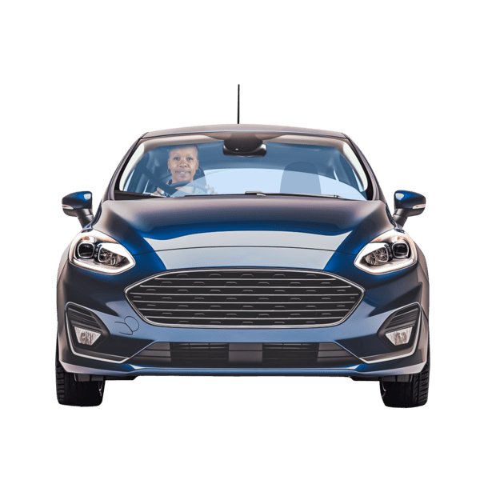
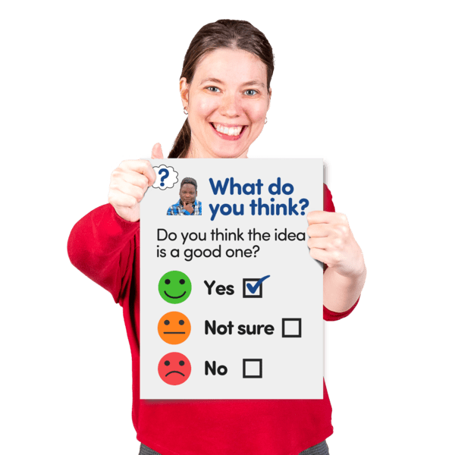
Tell us what you think about Motability


Easy Read





What this survey is about
The Motability scheme is a service which gives disabled people a way to rent a car, scooter, e-bike or powered wheelchair using their disability benefits.

Many people need the scheme for independence, travel and daily life.

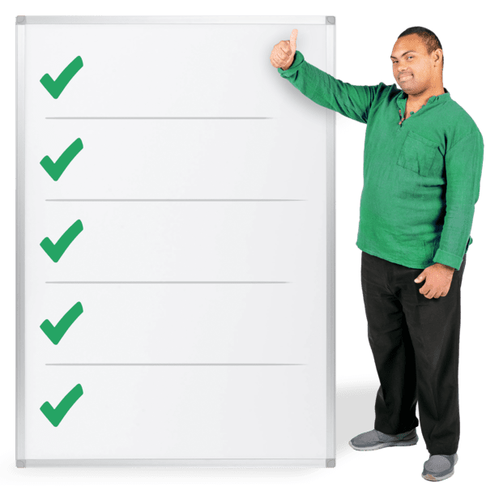     | Next year UK Minister for Social Security and Disability Sir Stephen Timms will lead a review of how disability benefits are designed, checked and delivered.  Inclusion Scotland have made this survey to find out what disabled people think about:  - the good things about the Motability scheme  - what you think should change  - how recent and future changes to the scheme might affect you
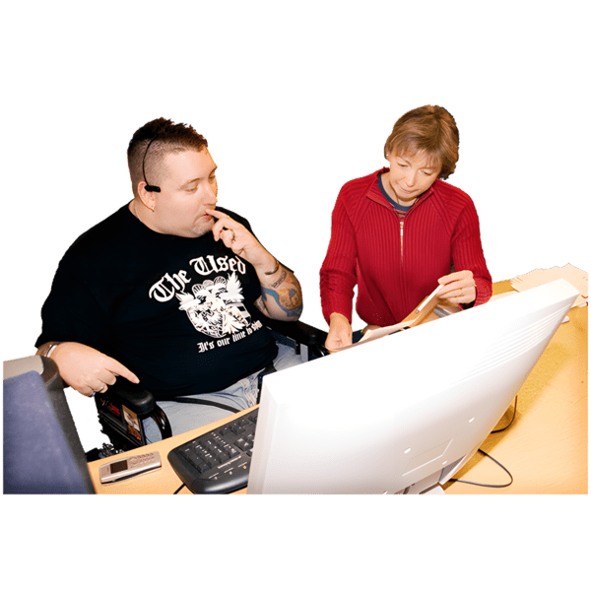  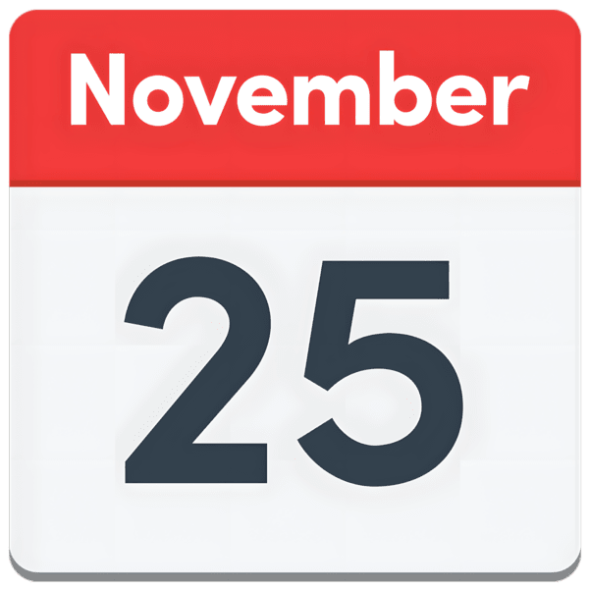  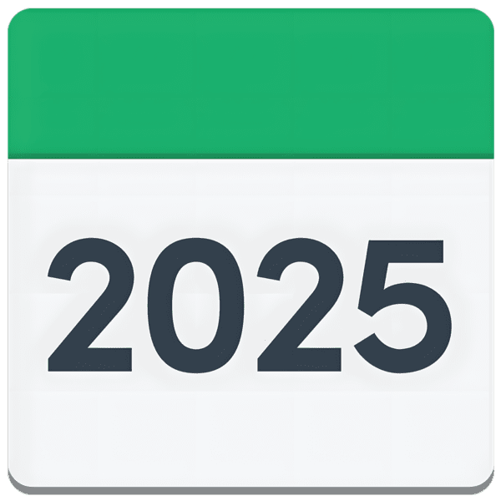 | Recent changes to Motability include:  - people will apply using the Scottish Government Vehicle and Equipment (AVE) scheme  AVE is replacing Motability in Scotland.  - taking top range cars and cars that are not made in the UK out of the scheme including BMW, Mercedez-Benz, Audi and Lexus  This will happen for new applications after 25 November 2025.  More changes to Premium Insurance Tax and VAT are coming later this year.
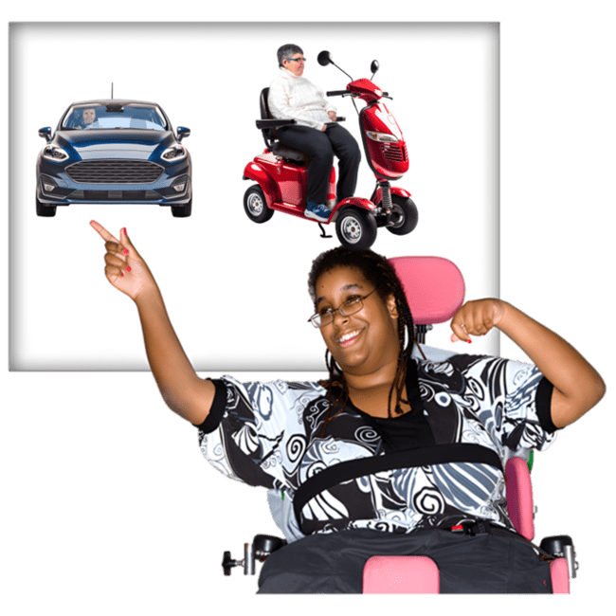 | The AVE scheme means that:  - applicants can choose an accredited provider who meets their mobility needs  - no credit checks are needed
   | More information on AVE is online at: gov.scot
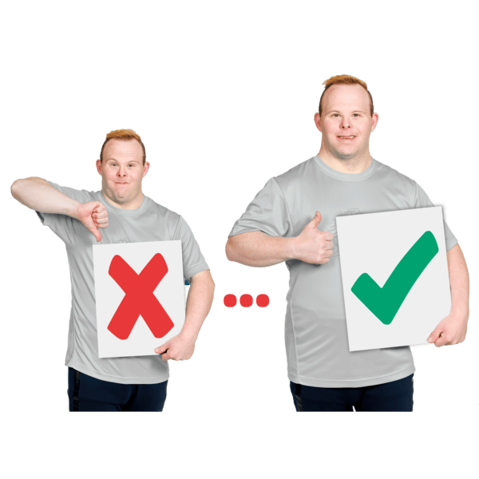 | We want to find out if these changes have affected you or might affect you in the future, in a good or a bad way.  By sharing your experience we can:  - better understand if you are getting what you need from AVES  - see what is working well and what could be made better
 | Thank you for taking part.  Your voice matters.

How to fill in this survey
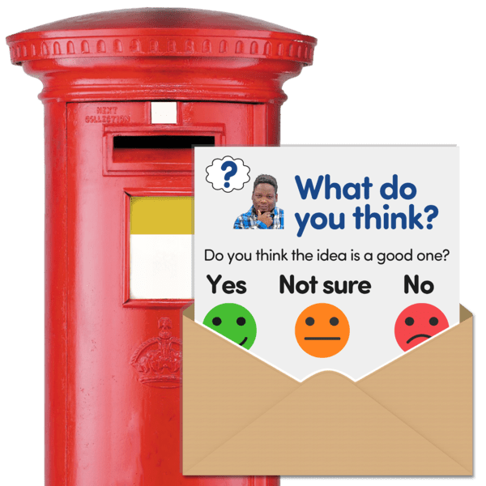 | You can type or write your answers on this form and send it to us.
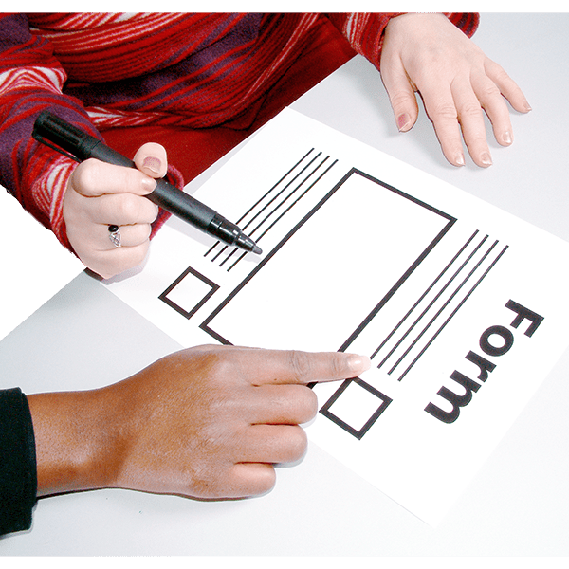 | If you want to write your answers in the boxes then you can use the enter button to make the boxes bigger first.  Then print out the answer pages ready to write on.
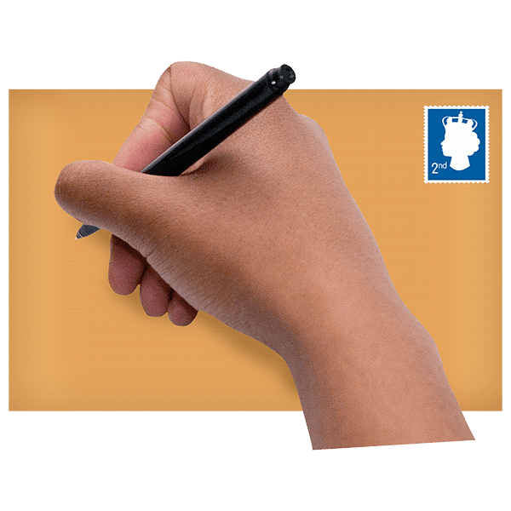 | Put your answers in an envelope and write the address on the front.
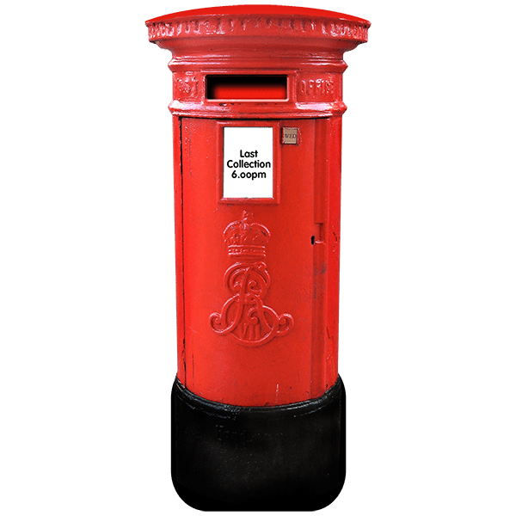 | The address is:  Inclusion Scotland  Robertson House  152 Bath St  Glasgow  G2 4TB
By email
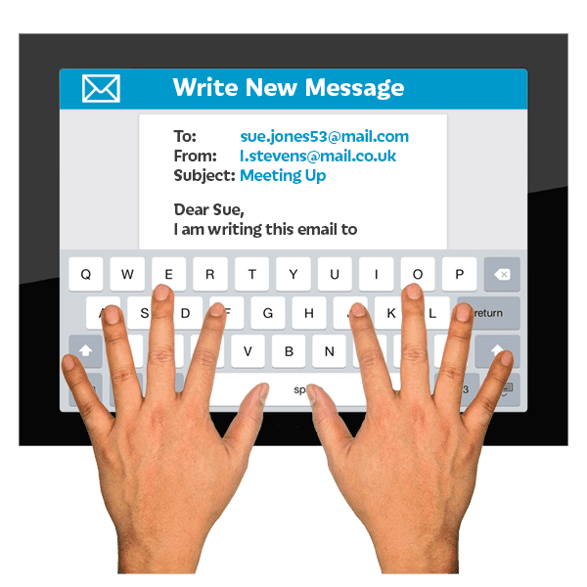 | You can send us your answers by email.
 | If you are answering by using this document, click on the box of the answer you agree with and a tick will appear. ☐
 | If you change your mind you can click on it again to untick it.
 | If you are typing, the spaces will get bigger as you type.
 | When you have finished, save a copy and email it to: info@inclusionscotland.org
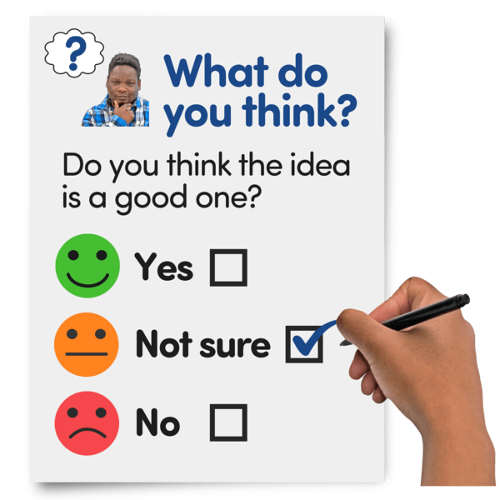 | Each question is in bold black writing.

Consent - this means agreeing
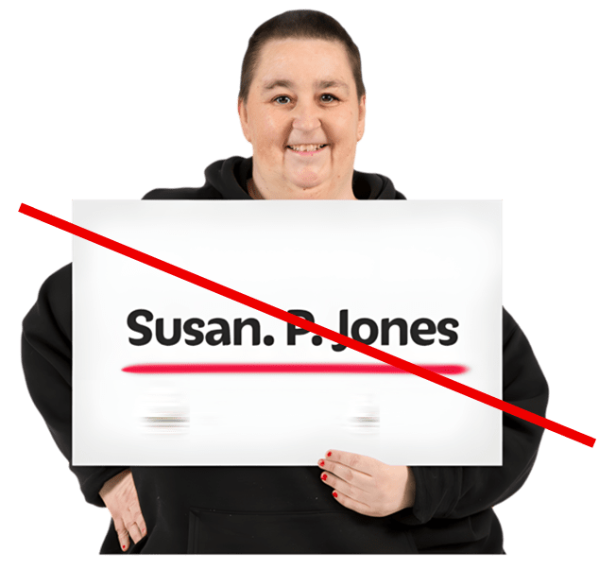 | The survey is anonymous – this means you do not have to give your name.  You should not give us any information that could identify you or anyone else.
 | We might use the words you write in your answers when we report the results of this survey.  But we will not share any information that could identify you.
- Do you consent to your information being used in this way?

If you tick ‘no’ your answers cannot be used.
 |   Yes | ☐
 |   No | ☐

Information about who answers our questions
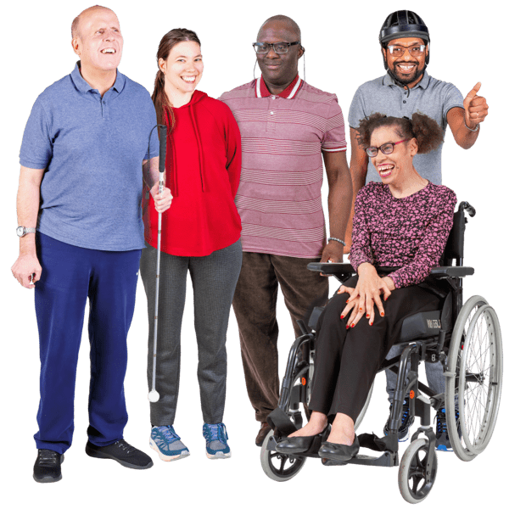 | 2. Do you have a disability, or long-term health condition that affects your day-to-day activities?  Please tick one:
 | Yes |  | ☐
 | No |  | ☐
 | I do not want to say |  | ☐
3. If yes, please tell us about the barriers that disabled you.
Write or type your answer here:

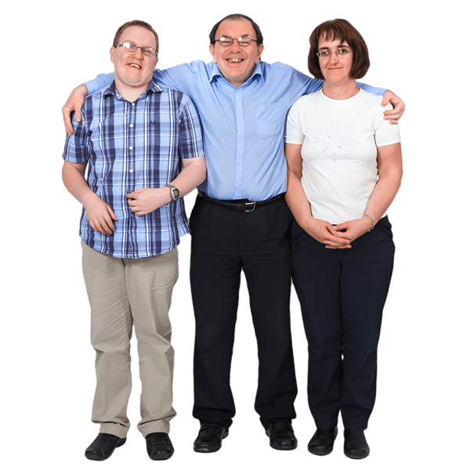 | 4. What is your gender? This means if someone sees themselves as male or female or in a different way.
 | Male |  | ☐
 | Female |  | ☐
 | Non-binary – I do not see myself as male or female |  | ☐
 | I do not want to say |  | ☐
 | I prefer to self-describe - please tell us how:
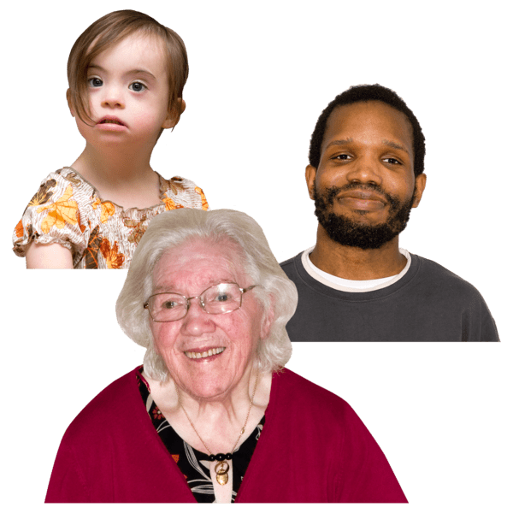 | 5. What age group are you in?
 | 19 or under |  | ☐
 | 20 to 29 |  | ☐
 | 30 to 39 |  | ☐
 | 40 to 49 |  | ☐
 | 50 to 59 |  | ☐
 | 60 to 69 |  | ☐
 | 70 or older |  | ☐
 | Prefer not to say |  | ☐
  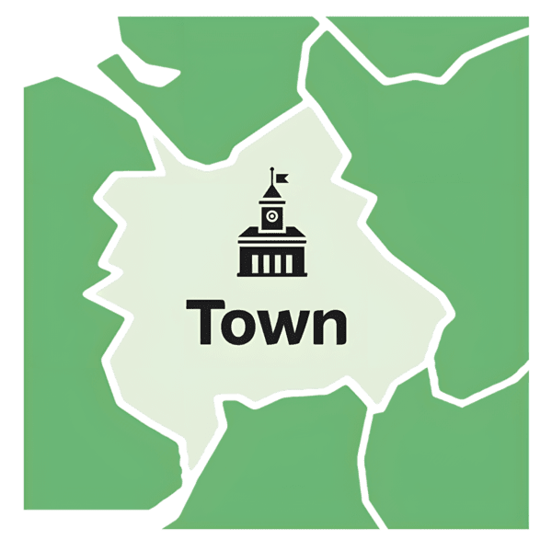  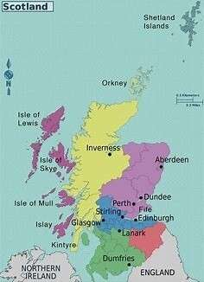 | 6. What best describes the area you live? Please tick one.
 | A large city like Glasgow or Edinburgh | ☐
 | A smaller city like Perth, Inverness, or Dundee | ☐
 | small town | ☐
 | rural area | ☐
 | on an island | ☐
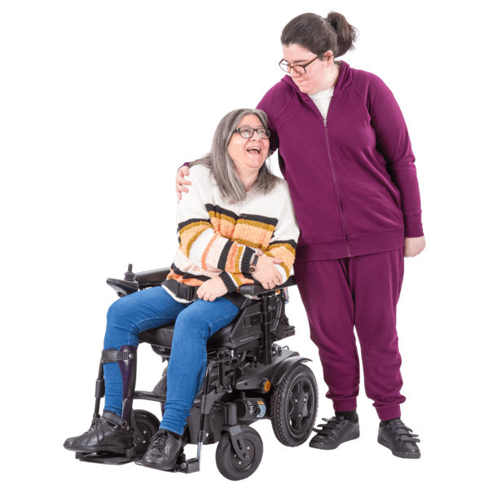 | 7. Are you the main carer for someone who needs support because of their age, disability, or health condition?
 | Yes |  | ☐
 | No |  | ☐
 | 8. What is your ethnic background?
 | White - Scottish |  | ☐
 | White – Other British |  | ☐
 | White - Irish |  | ☐
 | White - Polish |  | ☐
 | White – Gyspsy/Traveller |  | ☐
 | Mixed or multiple ethnic groups |  | ☐
 | Asian - Indian |  | ☐
 | Asian - Pakistani |  | ☐
 | Asian – Bangladeshi |  | ☐
 | Asian - Chinese |  | ☐
 | Asian – Other Asian background |  | ☐
 | African – African, Scottish African, British African |  | ☐
 | Prefer not to say |  | ☐
 | Other |  | ☐
 | 9. What is your sexual orientation?
 | Heterosexual/straight |  | ☐
 | Bisexual |  | ☐
 | Gay or lesbian |  | ☐
 | Pansexual |  | ☐
 | Prefer to self-describe |  | ☐
 | Prefer not to say |  | ☐

Questions about Motability changes
 | 10. Have you ever applied for Motability? Did you get it?
 | Yes – applied and got Motability | ☐
 | Yes- applied but didn’t get accepted | ☐
 | No – Never applied | ☐
11. If you applied for Motability but didn’t get accepted, why was this?
How has this affected you?

Write or type your answer here:

 | 12. Do you have a car or other vehicle from Motability?
 | Yes | ☐
 | No | ☐
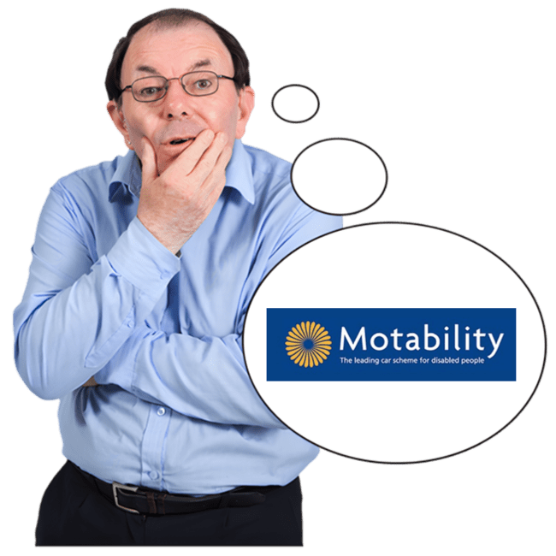 | 13. Did you know about the changes to the Motability Scheme before taking this survey?
 | Yes | ☐
 | No | ☐
 | I am not sure | ☐
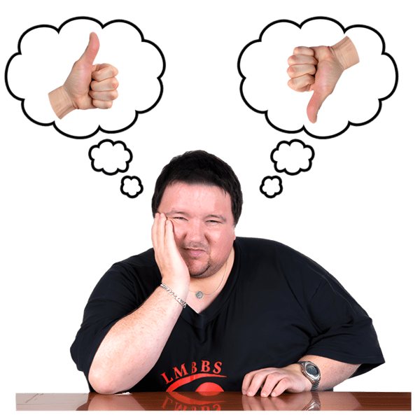 | 14. Have the changes to the Motability Scheme affected:  - the vehicle you have now  - or the lease agreement you have now
 | Yes | ☐
 | No | ☐
 | I am not sure | ☐
 | This does not affect me | ☐
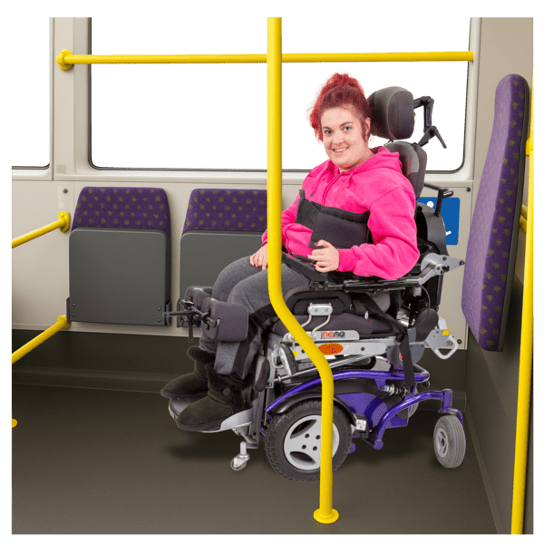  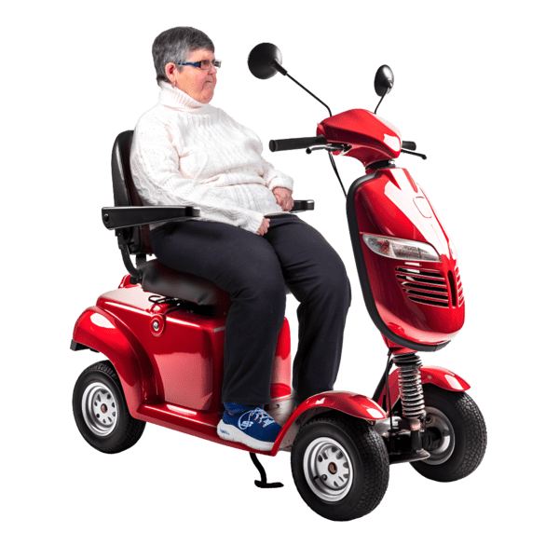 | 15. If you answered yes to Question 14, please tell us how the changes have affected your ability to travel independently.
 |   Yes it has changed my ability to travel independently | ☐
 | Tell us how it has changed. Write or type your answer here:
 | No it has not changed my ability to travel independently | ☐
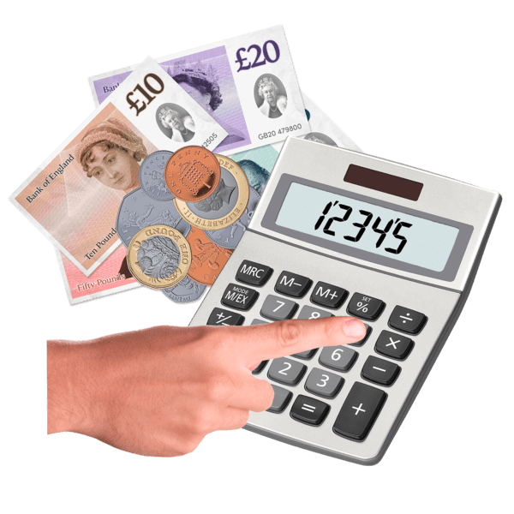 | 16. Do you think the changes to the scheme will affect your finances? This means how much money you have.
Write or type your answer here:

 | 17. How easy or difficult was it to find out information or get support with the changes to Motability?
   | Very easy | ☐
 | Easy | ☐
 | Difficult | ☐
 | Very difficult | ☐
 | This did not affect me | ☐
 | 18. Do you have any worries about the changes to Motability?
Write or type your answer here:

The good things about Motability
 | 19. What has it been easier to do since getting a vehicle through Motability?  Please tick all that apply.
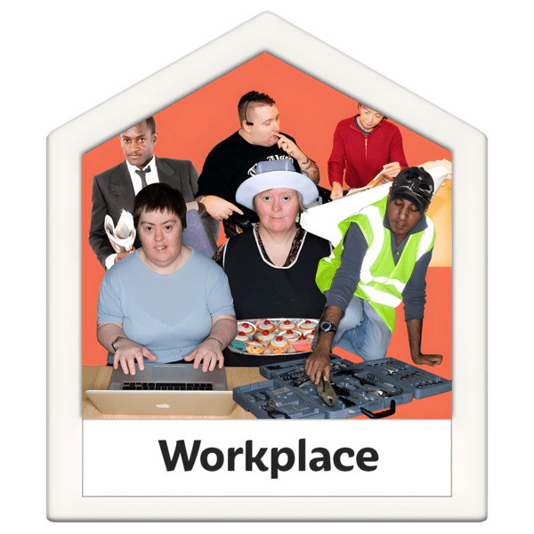  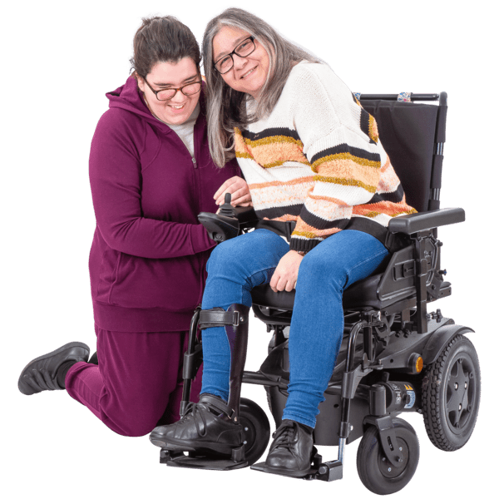 | Getting to and from work | ☐
 | Getting to and from a volunteering role | ☐
 | Caring responsibilities like getting a child to school, or getting someone you look after to appointments | ☐
 | Going to your own appointments | ☐
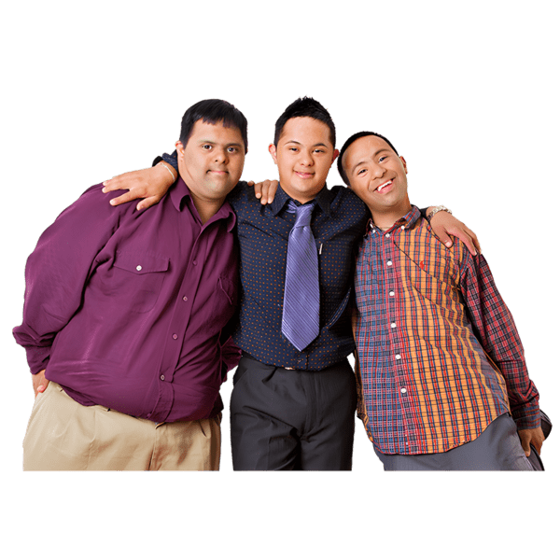  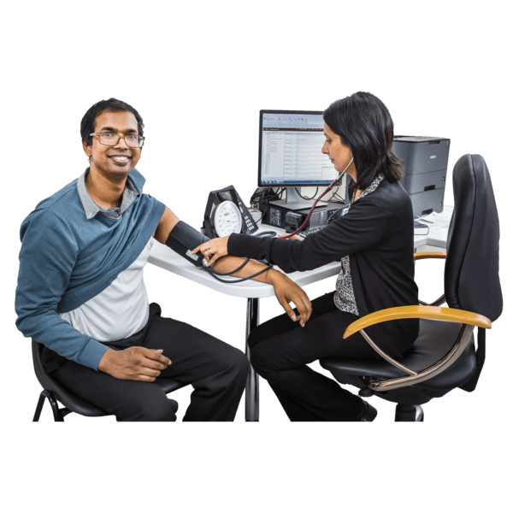 | General independence like doing shopping, meeting friends, planning out what you want to do when | ☐
 | Taking part in art or sport activities | ☐
 | Other - please tell us what: | ☐
 | 20. What difference has the Motability scheme made to you or people you care for?
Write or type your answer here:

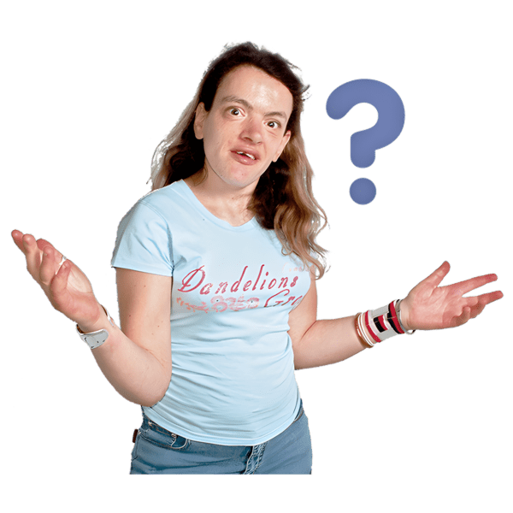 | 21. Is there anything else you want to tell us about the Motability scheme or other things about mobility and independent living?
Write or type your answer here:

