

Tell us how cuts to self-directed support have affected disabled people
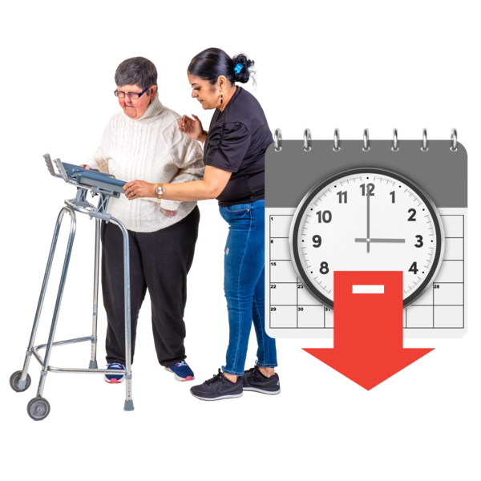

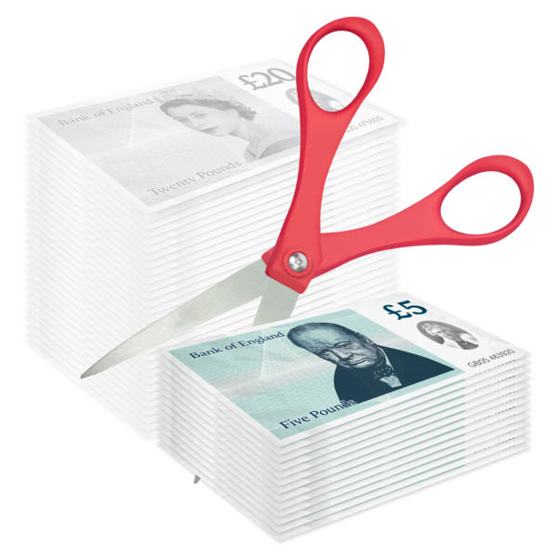

Easy Read
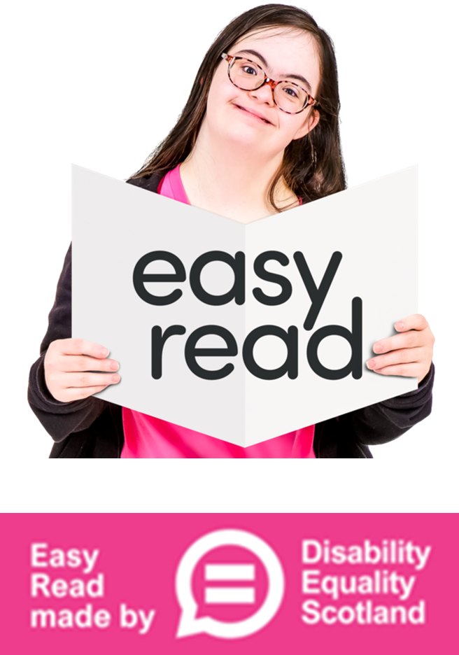

About this survey
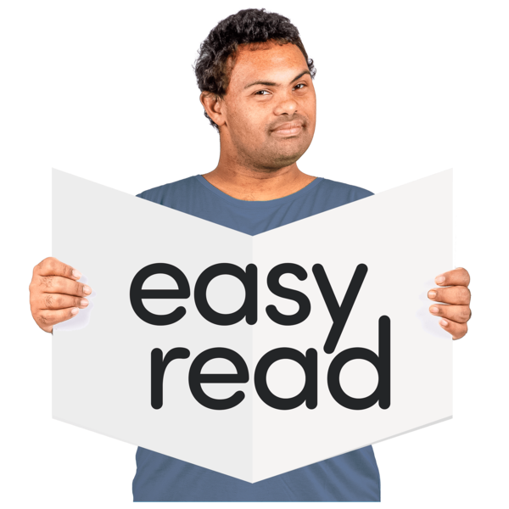 | This is an Easy Read survey.  A survey is a set of questions.  Answer our questions to tell us what you think.
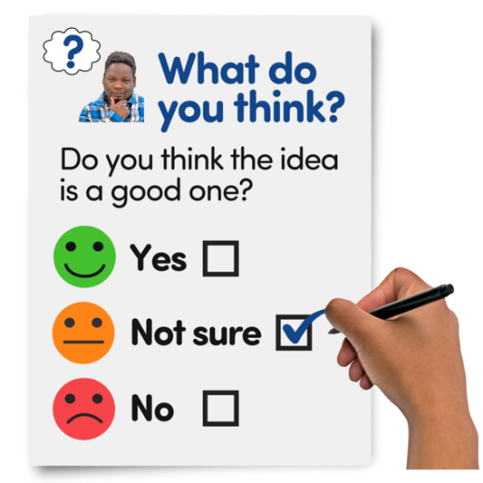  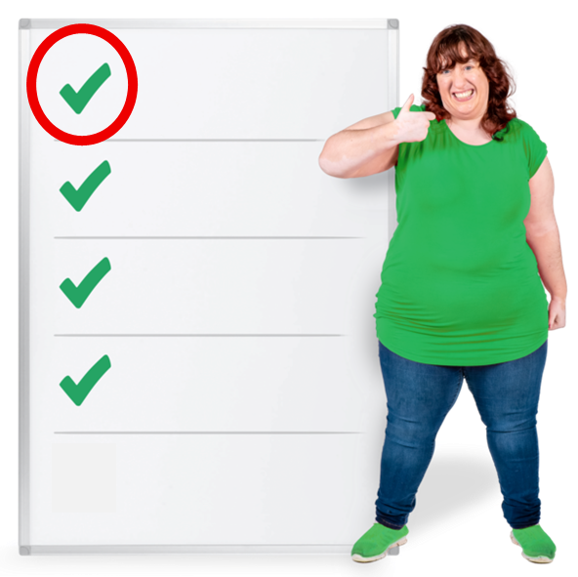   | The questions ask you about cuts to self-directed support or SDS for short.  Self-directed support gives people more choice and control of their care and support services.  There are 4 types or options of SDS.  This survey is for people on option 1 of SDS.  Option 1 gives people direct payments – this means people can choose and buy the services they need instead of getting them from their council.
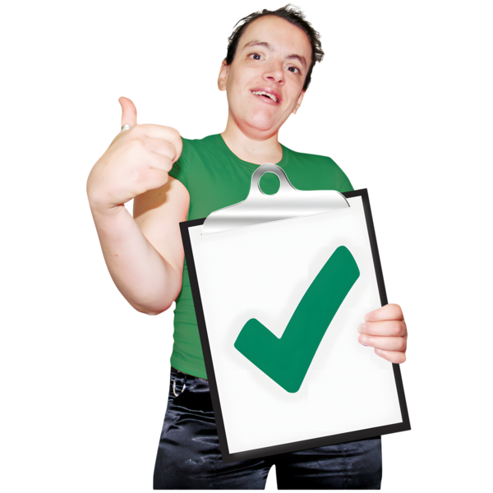  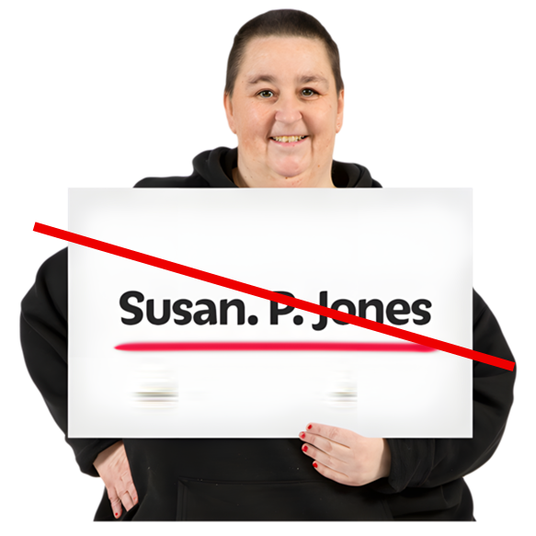  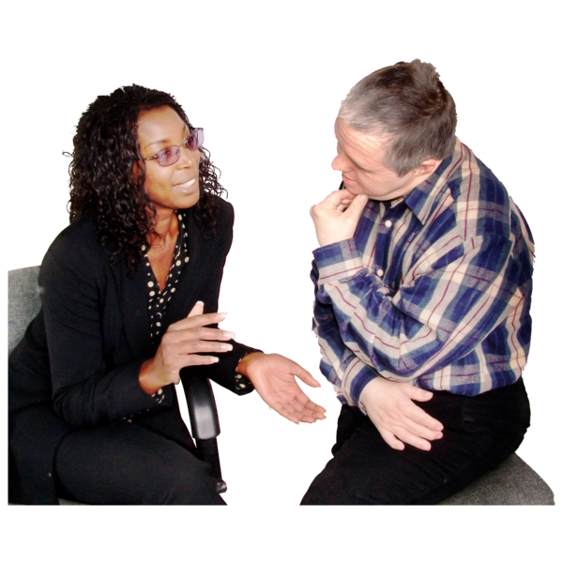 | All of the survey responses are anonymous.  This means we do not know who has sent the information.  By completing this survey you agree to let Inclusion Scotland use your answers to highlight the affect of these cuts on disabled people.  The information you give us will be help us when we talk to the Scottish and UK Governments and other organisations.
 | If you have any questions or comments please email: info@inclusionscotland.org
How to answer the questions in the survey
 | If you are answering on a screen, you can click the little box next to your answer.  A tick will appear.  If you change your mind you can click it again.
 | If you are typing your answers the space will grow as you type.
 | If you are writing your answers on a paper copy use the Enter button to grow the spaces before you print the pages.  Please only answer the questions that apply to you.
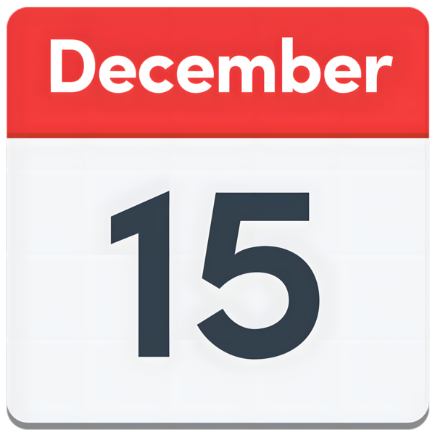  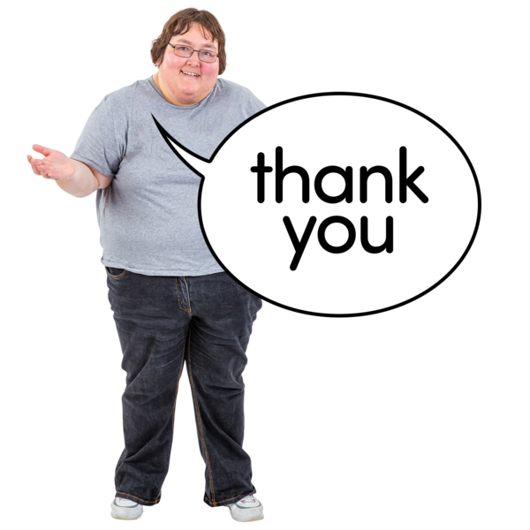 | Send us your answers before 19 December 2025  Thank you for taking the time to answer the questions below.

Question 1
 | 1. Are you a disabled person getting SDS?
 |   Yes | ☐
 |   No | ☐
 |   I am not sure | ☐

Question 2
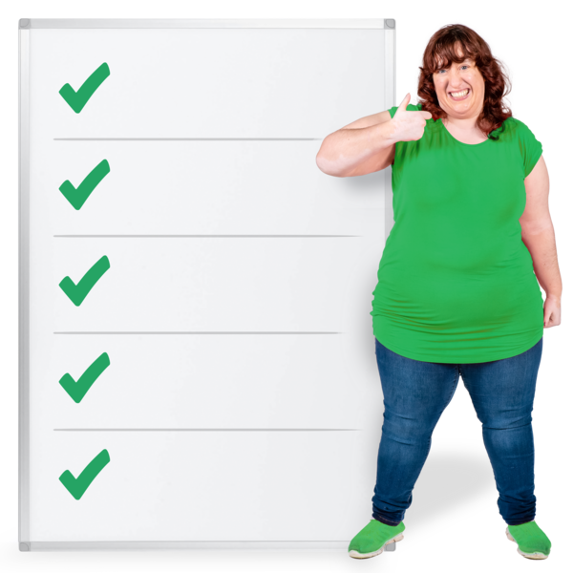 | - Do you get a direct payment under Option 1 of SDS?
 | Yes | ☐
 | No | ☐
 | I do not know | ☐

Questions 3 and 4

- If you get SDS through direct payments, have there been any changes to:

- how it is provided

- or how much you get - has it been reduced, increased or stopped?

If yes, please tell us how you were told about the changes and what has changed.

Write or type your answer here:

 | 4. How have these changes affected your daily life, independence or your wellbeing – feeling comfortable, healthy and happy?  Please give some examples.
Write or type your answer here:

Question 5
- Have you been told that your Personal Assistant hours or support need to change because of budget cuts?

If yes, how has this affected you?

Write or type your answer here:

Question 6
- What do you most want local and national leaders to understand about the affect of the cuts to SDS?
Write or type your answer here:

Question 7
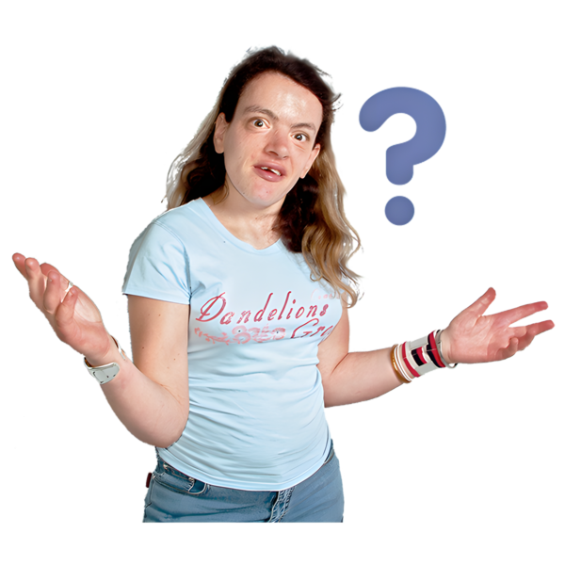 | - Is there anything else that you want to tell us about SDS or direct payments?
Write or type your answer here:



