

Poverty and Social Security Lived Experience: Privacy Notice Easy Read
 | Thank you for your interest in working with us.
   | By answering this survey you have the option to provide us with personal information. This is called “Personal Data”.  The Personal Data is looked after by the Data Controller.  Personal Data is things like;  - Your Name  - Your Address
 | Who is the data controller?  The data controller is the organisation or person who holds your personal data. The data controller is Inclusion Scotland.
   | Why are we collecting your data?  We are collecting your data to find out how we can develop the Poverty and Social Security Lived Experience Group.  This reason we need this information is called legitimate interest. Legitimate interest means we need to have a good reason for keeping information about you.
 | Some of the information we ask for is called “special category data”. This means it is more private information about you.  This includes things like:  • Age  • Disability  • Race  • Gender  • If you are married  • If you are pregnant or have a young baby
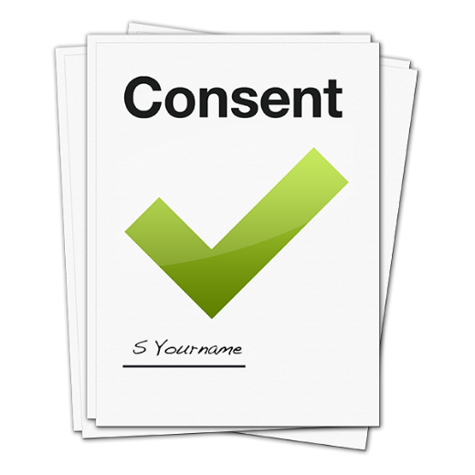 | We need your permission to keep this information.  We need a written statement to confirm that we have your permission to hold this information. This is called consent.  We will use this information to make a decision and contact you about your survey response, if you accept.
How will we use your data?
We will only use your data:
- To contact you about the group with your consent.
- To make sure people interested are from diverse backgrounds.

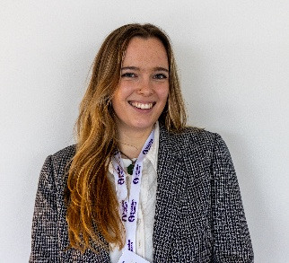   | Who will have access to my data?  People in charge of developing the group These are currently Caitlin Fowler and Pauline Nolan.
  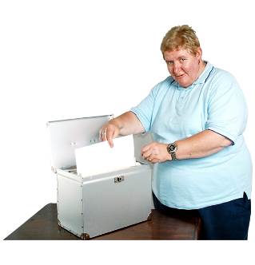   | How will your personal data be stored?  Paper documents will be held in a lockable cabinet. Electronic files will be stored on our computers and password protected.
     | How long do we keep your information? We will keep the documents for up 6 months after the end of the project.  We look again at how we store data every two years.  We will look again at this privacy notice to see if we need to change anything in June 2027
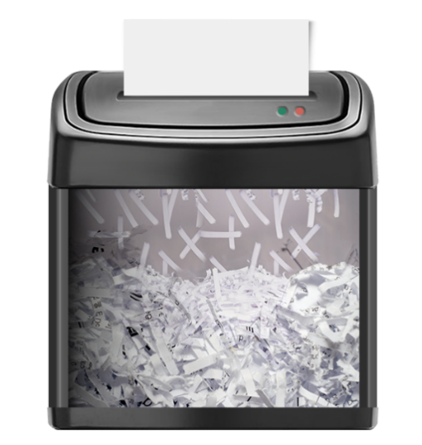 | How will your data be destroyed?  Paper documents will be destroyed by confidential shredding. Electronic files will be securely deleted.
   | What are my rights?  You have a number of rights about your personal data.  You have the right to see the information that we keep about you.  You have the right to correct the information that we have about you.  You have the right to ask that we delete the information we keep about you.
     | You can contact us by telephone on 0131 370 6700 or by e-mail info@inclusionscotland.org  You can write to us at:  Inclusion Scotland,  Robertson House, 152 Bath Street, Glasgow, G2 4TB
     | If you are unhappy about how we used your data, you can contact the Information Commissioner Office. by phoning 0303 123 111 or e-mailing Scotland@ico.org.uk  Or Write to:  The Information Commissioner's Office - Scotland  45 Melville Street  Edinburgh, EH3 7HL



