

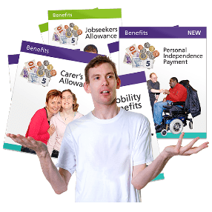
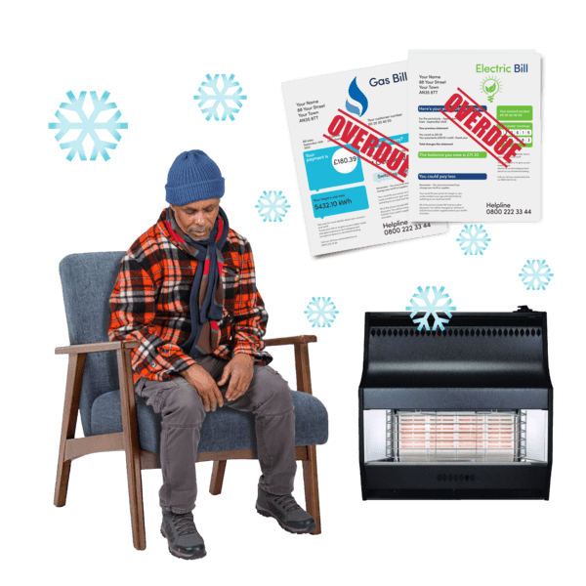
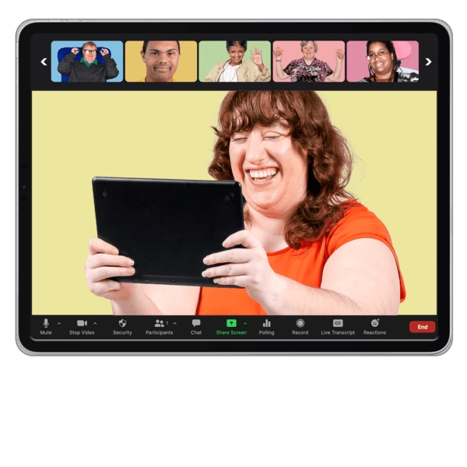
Help shape a lived experience group on poverty and social security

Easy Read




What this survey is about
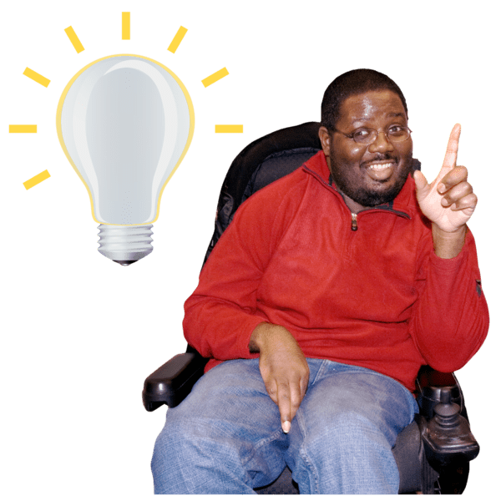 | Lived experience means what people know based on the things they have experienced.  Poverty means not having enough money to pay for basic things like food, heating or housing.  Social Security or benefits is the money some people get from the government to live on.
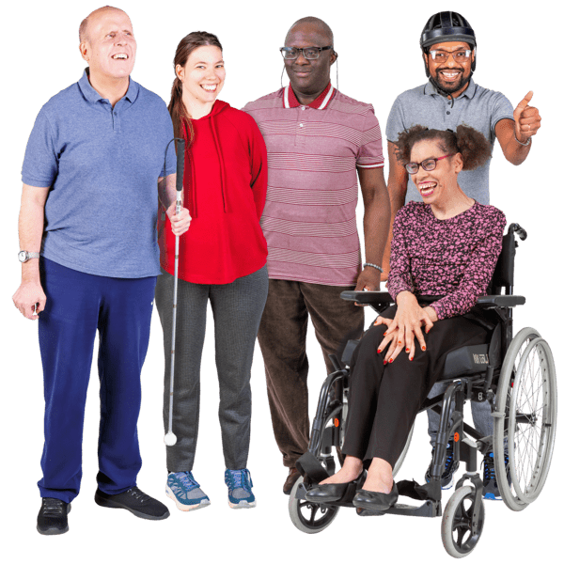 | Inclusion Scotland is changing our Poverty Lived Experience Group.  We want to include more disabled people from across Scotland and to offer ways to share your experiences, learn and be leaders.
   | We need your help to decide how the group will run.  If you have any questions please email us at info@inclusionscotland.org  The survey closes on 18 December.
 | Answer our questions to tell us what you think.  If you are answering on a screen, you can click the little box next to your answer.  A tick will appear.  If you change your mind you can click it again.
 | If you are typing your answers the space will grow as you type.
 | If you are writing your answers on a paper copy use the Enter button to grow the spaces before you print the pages.

About you – you do not have to answer these questions if you do not want to
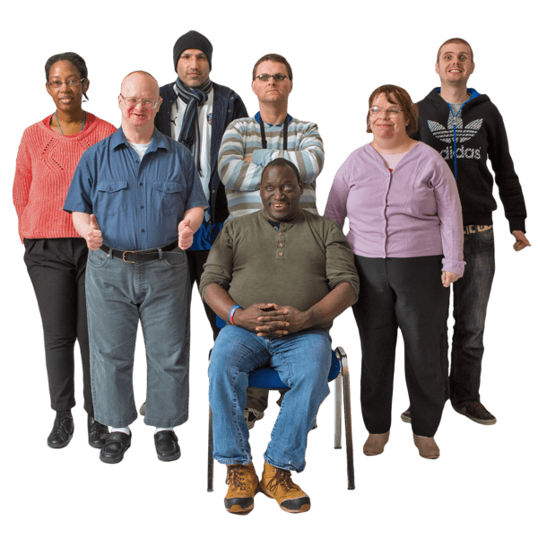 | These questions will make sure the group:  - has people from different backgrounds and regions  - has people with different experiences
 | 1. Are you a disabled person?
 |   Yes | ☐
 |   No | ☐
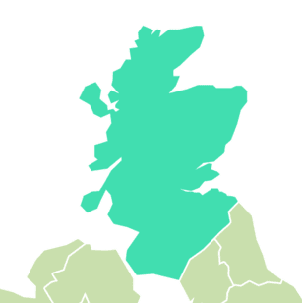  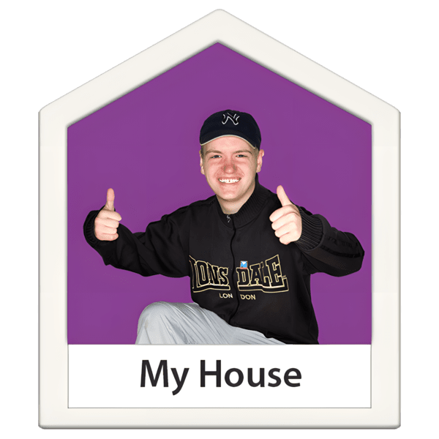 | - Which region of Scotland do you live in?
 | Aberdeen City | ☐
 | Aberdeenshire | ☐
 | Angus | ☐
 | Argyll & Bute | ☐
 | Clackmannanshire | ☐
 | Dumfries & Galloway | ☐
 | Dundee City | ☐
 | East Ayrshire | ☐
 | East Dunbartonshire | ☐
 | East Lothian | ☐
 | East Renfrewshire | ☐
 | Edinburgh (City of) | ☐
 | Falkirk | ☐
 | Fife | ☐
 | Glasgow City | ☐
 | Highland | ☐
 | Inverclyde | ☐
 | Midlothian | ☐
 | Moray | ☐
 | Na h-Eileanan Siar (Western Isles) | ☐
 | North Ayrshire | ☐
 | North Lanarkshire | ☐
 | Orkney Islands | ☐
 | Perth & Kinross | ☐
 | Renfrewshire | ☐
 | Scottish Borders | ☐
 | Shetland Islands | ☐
 | South Ayrshire | ☐
 | South Lanarkshire | ☐
 | Stirling | ☐
 | West Dumbartonshire | ☐
 | West Lothian | ☐
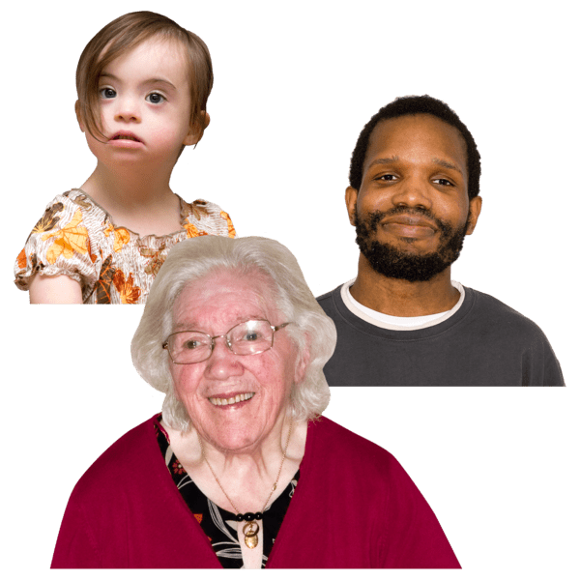 | 3. What age group are you in?
 | 16 to 24 | ☐
 | 25 to 35 | ☐
 | 35 to 44 | ☐
 | 45 to 54 | ☐
 | 55 to 64 | ☐
 | 65 and over | ☐
 | I do not want to say | ☐
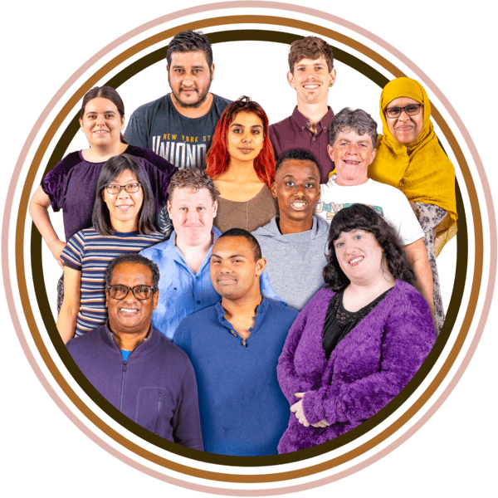 | 4. What is your ethnic background?
 | White - Scottish | ☐
 | White - Other British | ☐
 | White - Irish | ☐
 | White - Polish | ☐
 | White - Gypsy/Traveller | ☐
 | Mixed or multiple ethnic groups | ☐
 | Asian - Indian | ☐
 | Asian - Pakistani | ☐
 | Asian - Bangladeshi | ☐
 | Asian - Chinese | ☐
 | Asian - Other Asian background | ☐
 | African - African, Scottish African, or British African | ☐
 | Caribbean or Black - Scottish Caribbean, British Caribbean, or other Black background | ☐
 | I do not want to say | ☐

Designing the group

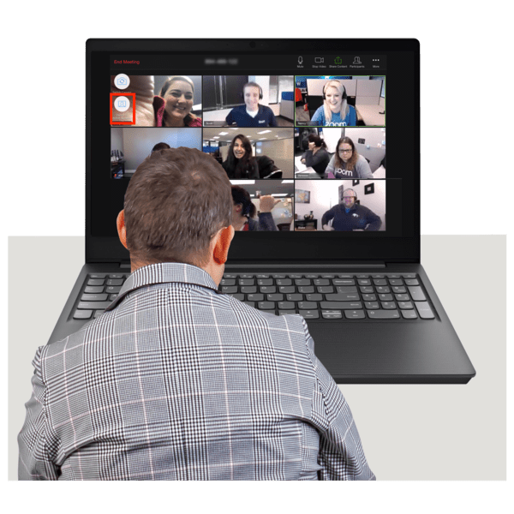 | This will help us to design the group based on what you need and what you have experienced.  - What would you most like this new space to be? Tick up to 3 answers.
 | A discussion group to share lived experience and ideas | ☐
 | A network for connecting and sharing information | ☐
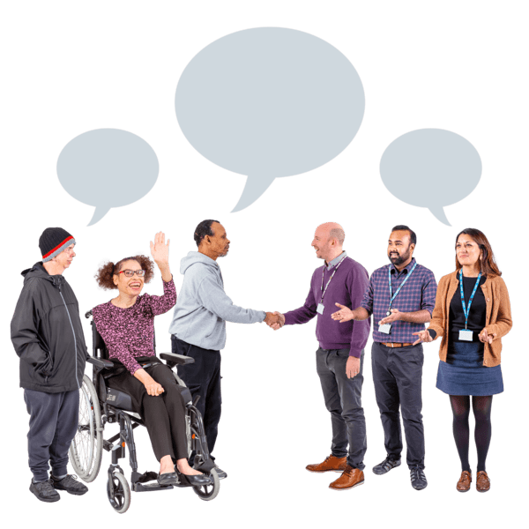 | A group that helps shape Inclusion Scotland's policy work | ☐
 | A space to work with Scottish Government or other organisations that make decisions | ☐
Something else – please tell us what. Write or type it here:

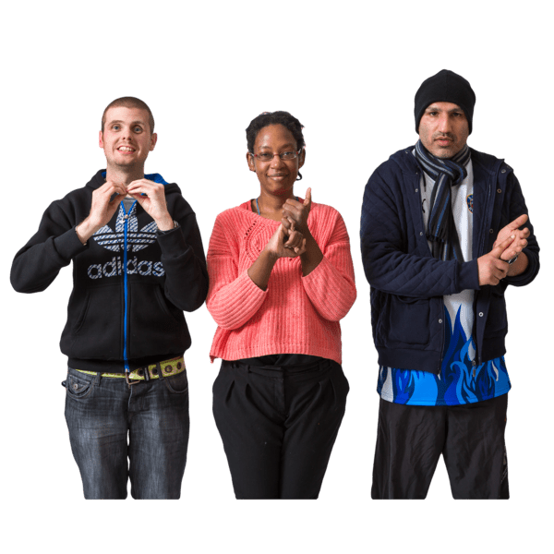   | 6. What do you need to make sure that the meetings are accessible to you? Tick as many answers as you need.
 | BSL |  | ☐
 | A captioner or captions |  | ☐
 | Easy Read Information |  | ☐
 | Large Print |  | ☐
 | Accessible meeting rooms |  | ☐
 | Quiet spaces |  | ☐
Something else – please tell us what. Write or type it here:

 | 7. What would you like the group to focus on? Tick up to 3 answers.
 | Poverty and cost of living |  | ☐
 | Social security (benefits system) |  | ☐
 | Employment |  | ☐
 | How poverty affects people, for example on health, independent living or housing |  | ☐
Another thing – write or type it here:

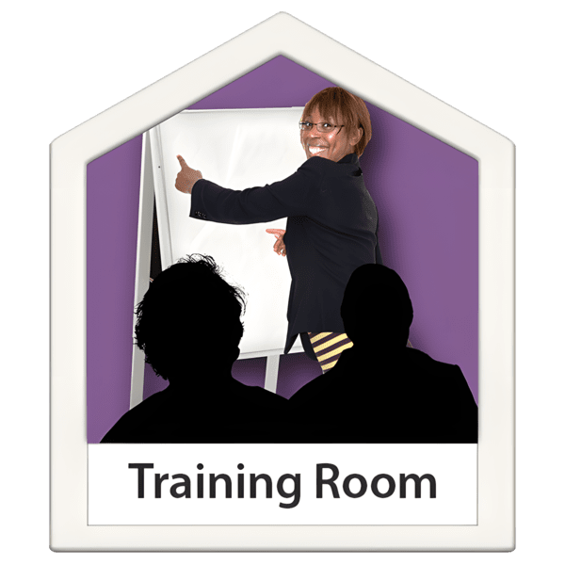 | 8. If Inclusion Scotland could provide small training or development sessions for members what topics would interest you most? Tick up to 3 answers.
 | Training on policy influencing or campaigning | ☐
 | Learning about the social security systems and current reforms | ☐
 | Confidence building or public speaking workshops | ☐
 | Writing or storytelling skills for sharing lived experience | ☐
 | Learning and networking with other disabled people | ☐
 | Ways to present to or meet with decision-makers | ☐
Something else – write or type your answer here:

 | 9. If this group could change one thing about how poverty and social security affect disabled people in Scotland what would it be?  Tick only 1 answer.
 | Making benefits easier to access or understand |  | ☐
 | Making sure people get enough income to live with dignity |  | ☐
 | Improving Access to Work or support for employment |  | ☐
 | Stopping cuts to essential services |  | ☐
 | Reducing stigma and discrimination |  | ☐
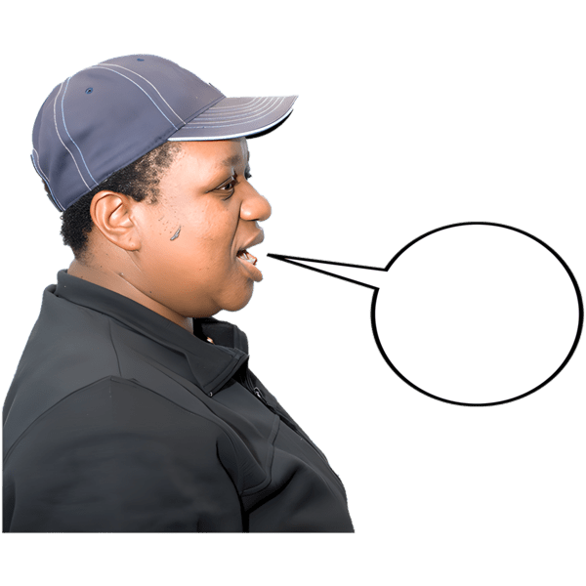 | Making sure disabled people’s voices are heard by people and organisations that make decisions |  | ☐
Another thing – please write or type your answer here:

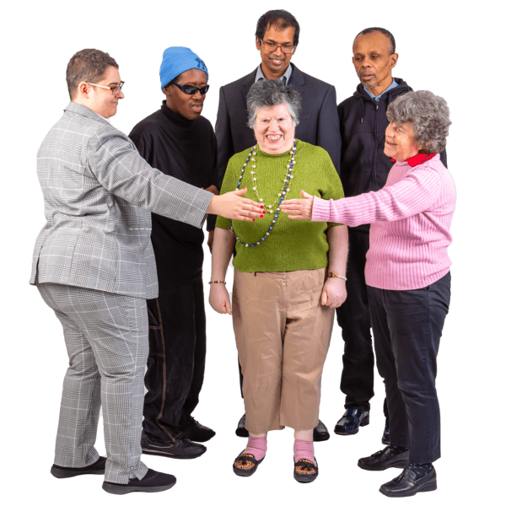 | 10. What would help you feel comfortable and supported in this group?  This could be things like:  - ways to get to know other members  - shorter sessions with breaks  - ways to send in answers to questions
Write or type your answer here:

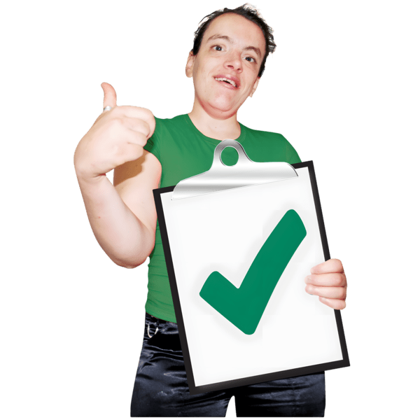 | 11. What would make being part of this group valuable or worthwhile for you?  This could be things like:  - having your experiences influence policy  - connecting with others who share similar experiences  - learning new skills  - having your voice heard
Write or type your answer here:

 | 12. Is there anything else you would like to tell us about that would:  - make this group work well for you  - inspire you to become a part of it?
Write or type your answer here:

Taking part and communicating
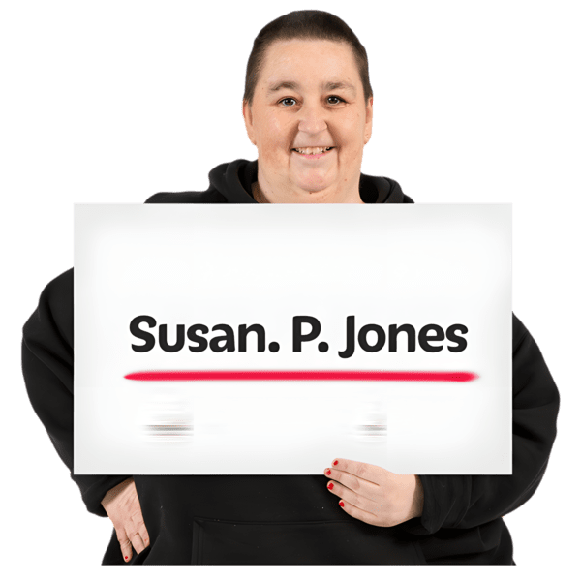  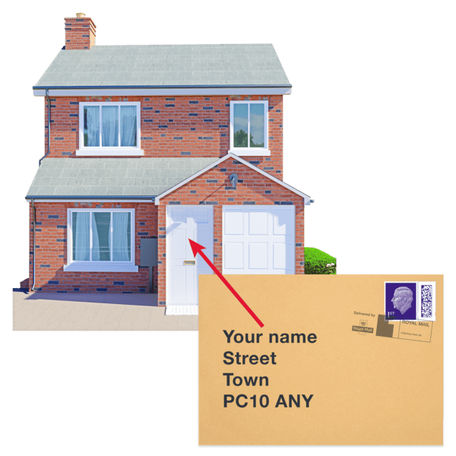 | 13. Would you like to be involved in this group?  We will only use your contact details to get in touch about this group, future meetings, and opportunities in Inclusion Scotland.  Your information will be kept private.  Please tell us your name and email address if you want to be in the group.
Your name:

Your email address:

 | 14. How would you like group meetings to take place?
 | In person |  | ☐
 | Online |  | ☐
 | A mix of in person and online |  | ☐
 | Other. Please tell us. Write or type your answer here: |  | ☐
 | 15. How often would you like this group to meet or connect?
 | Every 2 months | ☐
 | Every 3 months | ☐
 | A few times a year on specific projects | ☐
 | Less often than this | ☐
Other – please write or type your answer here:

 | 16. What time of day suits you?
 | Morning | ☐
 | Afternoon | ☐
 | Evening | ☐
 | I do not mind what time | ☐
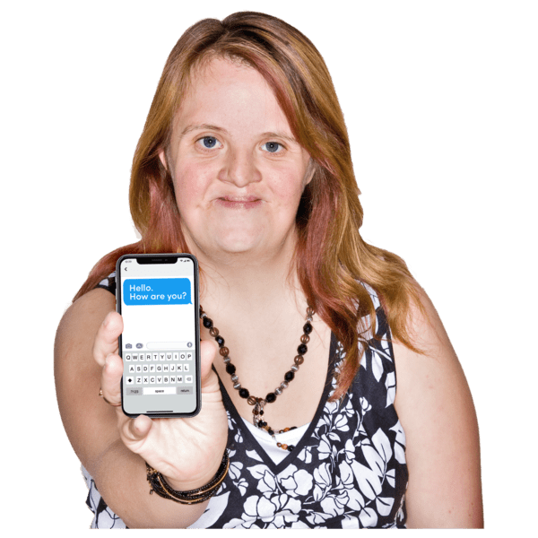 | 17. How do you want us to contact you about meetings or updates?
 | Email |  | ☐
 | Whatsapp group |  | ☐
In another way. Write or type your answer here:

Help us name the group
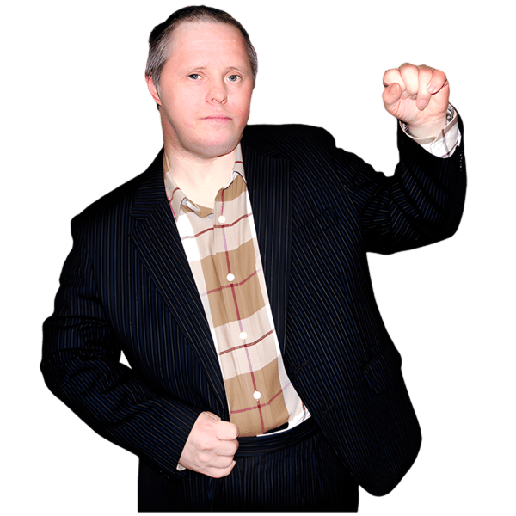 | We want this group to have a name that feels inclusive, empowering, and reflects the experiences of disabled people in Scotland who are affected by poverty and social security.
 | 18. Which name do you like the best?
 | Voices for Fairness |  | ☐
 | Inclusive Voices Forum |  | ☐
 | People Led Policy Panel (Poverty & Social Security) |  | ☐
 |  | Poverty Lived Experience Group (this is what it was called before) | ☐
Other – please tell us what:

