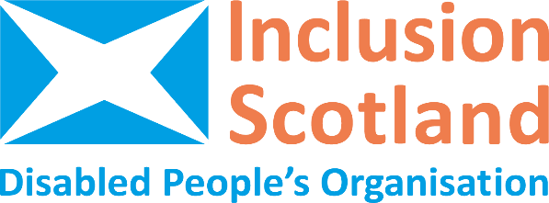

Summary of recommendations of the Independent Review of Adult Disability Payment
The key recommendations from the review are:
Mobility
- Remove the 20-metre rule and adopt a more realistic, holistic assessment.
- Extend the threshold to 50 metres or more to better reflect real mobility needs.
- Replace the points-based system with an outcomes-focused model.
- Account for fluctuating and invisible conditions like fatigue and pain.
Application
- Simplify forms using plain language.
- Improve access to early support and advocacy.
Decision-Making
- Enhance transparency, consistency, and fairness.
- Prioritise lived experience in policy and practice.
- Train decision-makers to apply outcomes-based decisions.
Lived Experience & Co-Production
- Ensure meaningful input from disabled people, not tokenism.
Conditionality
- Remove new barriers to employment.
- Reduce unnecessary eligibility checks.
- Shift from compliance to person-centred, supportive policies.
Eligibility Criteria
- Move beyond the points system to reflect real-life impact and lived experience.
- Recognise invisible and fluctuating conditions, including mental health.
- Focus on societal barriers, not just functional ability.
- Train staff to apply criteria holistically and flexibly.
- Include dignity, autonomy, and participation in criteria.
- Co-produce criteria changes with Disabled People’s Organisations.
Support & Access
- Increase awareness of available support.
- Strengthen outreach to marginalised groups.
Financial
- Safeguard eligibility and uphold Adult Disability Payment as a rights-based entitlement.
- Avoid budget-driven restrictions that reduce access.

If you need more information or information in another format, please contact us on info@inclusionscotland.org or by calling 0131 370 6700.

