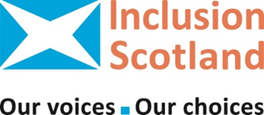
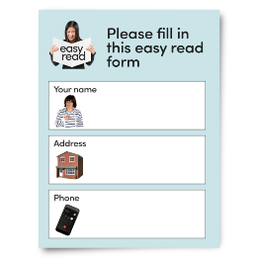  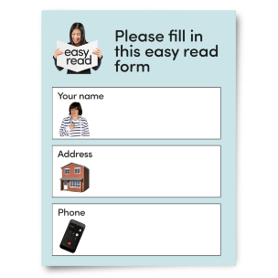  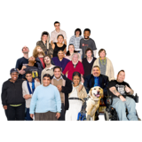   | People-led Policy Panel Member Application Form
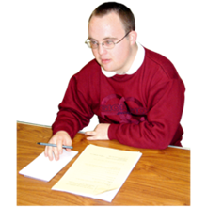 | This form is for volunteering with the People-led Policy Panel.
 | We are recruiting 15 people who need to use adult social care support.
 | There will be regular on-line meetings to meet the Scottish Government.
 | You can find more information on what we are looking for on our Role Description form.
 | More information can also be found on our webpage. People-Led Policy Panel (Adult Social Care Support) - Inclusion Scotland
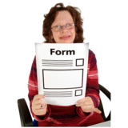 | This application form will ask you questions about how you need to use adult social care support.
 | Please leave blank any questions that you cannot or do not want to answer.
 | Please let us know if you need help filling in the form.
 | Keeping your information private is important to us.
 | The information you give us on this form will be held securely and will not be shared unless you say we can.  Please read the Privacy Notice we have sent with this application form for more information.
 | Please see the Inclusion Scotland Privacy Policy for more information https://inclusionscotland.org/about-inclusion-scotland/privacy-policy
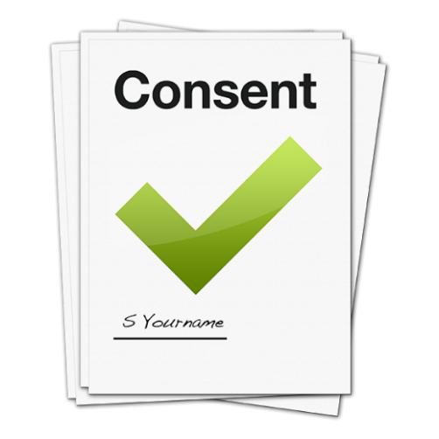 | Data Protection  Your Name:  Today’s date:  ☐ I give my permission for Inclusion Scotland to hold my sensitive personal information for the reasons outlined in the privacy notice.
Application Form | Information about you  Contact details
 | Name
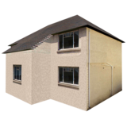 | Address
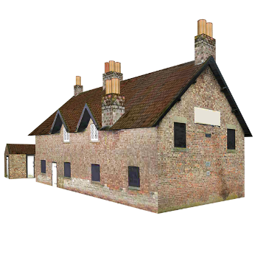 | Do you live in a remote or rural area?  Yes ☐  No ☐
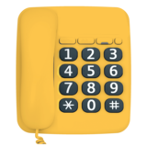 | Telephone Number
 | Email
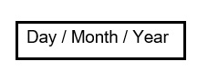 | Today’s date
 | Where did you hear about the People-led Policy Panel?
 | What are your hopes for being involved in the Policy Panel?
Gender
Please tell us your gender:
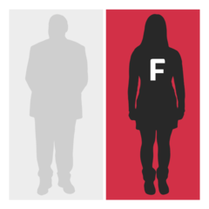 | Woman ☐
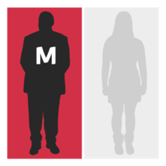 | Man ☐
 | Write here if you want to describe your gender in your own words.
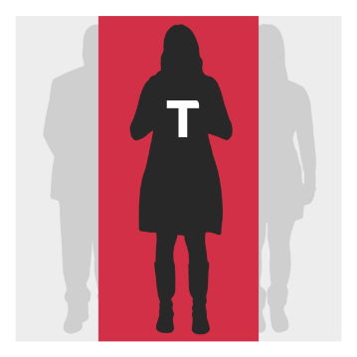 | Have you ever identified as transgender?  Yes ☐  No ☐
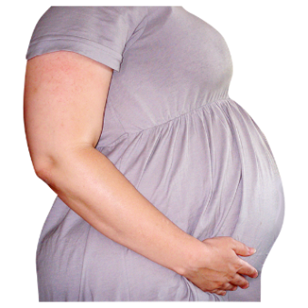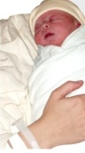 | Maternity status  Please tick if you are pregnant or the mother of a child less than six months old.  Yes ☐ No ☐
 | Age  What is your date of birth?
 | Disability  Please tick or indicate any statements which apply to you.
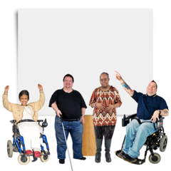 | I consider myself a disabled person ☐
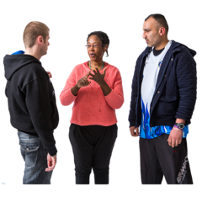 | I am a member of the Deaf community ☐
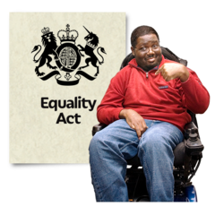 | I have a physical or mental impairment which “substantially affects my ability to carry out normal day to day activities” and has or is expected to last at least 12 months ☐
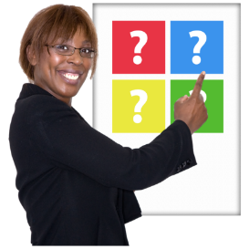   | Please tick below any barriers which prevent you from making the same choices as other people:
 | I experience communication difficulties (e.g. lack of sign language, subtitling, etc.)☐
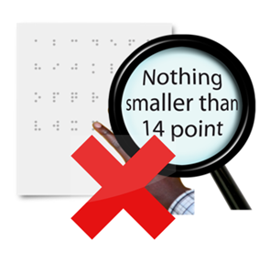 | I experience inaccessible materials for visual impairments ☐
 | I experience inaccessible materials for learning difficulties/disability ☐
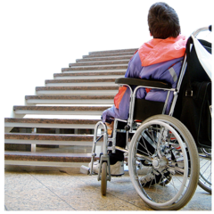 | I experience access issues with buildings (e.g. lack of level access/lifts) ☐
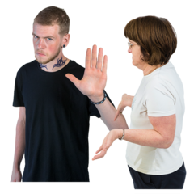 | I experience bad attitudes or negative assumptions (e.g. by staff, etc.) ☐
 | I experience a lack of awareness or understanding of my requirements ☐
 | I experience different barriers. ☐  Please say what they are:
 | I have previously experienced disability and/or have a changeable condition which could affect me in the future and/or has a long term impact on my choices ☐
 | If you have ticked any of the boxes above please tell us about the nature of any physical, sensory or mental impairments, conditions or “differences” (for example learning difficulties, dyslexia, Autistic Spectrum, etc.) that you have:
 | None of the above ☐  (please say why below)
 | Sexuality  Please tell us what option you feel most accurately describes your sexuality:
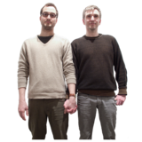 | Heterosexual/straight ☐  Gay man ☐  Gay woman/lesbian ☐  Bi-sexual ☐
 | Write here if you would prefer to describe your sexuality differently:
 | Marital Status  Please tell us what your current marital status is:
  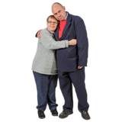 | Single ☐  Married ☐  Civil Partnership ☐  Separated ☐  Divorced ☐  Widowed ☐  Living Together/Common Law Partner ☐
 | Religion  Do you consider yourself to be religious (hold active belief in a god or gods and/or hold to specific views or positions due to having religion)?  Yes ☐  No ☐  Don’t know ☐
    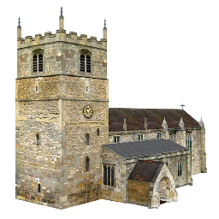        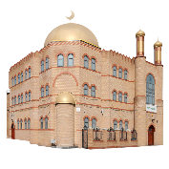   | If you ticked “Yes” please indicate which religion or body do you identify with:  Church of Scotland ☐  Roman Catholic ☐  Other Christian (please specify):  Buddhist ☐  Hindu ☐  Jewish ☐  Muslim ☐  Sikh ☐  Another religious body (please specify):  Don’t know ☐  I don’t belong to any organised religion ☐
   | If you ticked “No” would you describe yourself as any of the following:  Atheist – I don’t believe in any gods ☐  Agnostic – I am not sure if any gods exist ☐  Humanist ☐  Not sure ☐  Other (please specify):
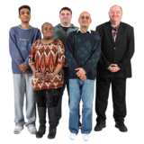 | Ethnicity  Please tell us about your ethnicity.
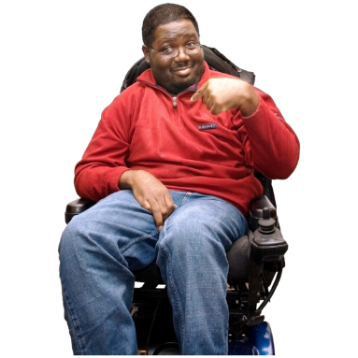 | - African, Caribbean or Black  African, African Scottish or African British ☐  Black, Black Scottish or Black British ☐  Caribbean, Caribbean Scottish or Caribbean British ☐  Other (please specify):
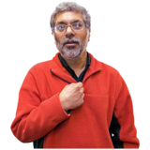 | - Asian, Asian Scottish of Asian British  Bangladeshi, Bangladeshi Scottish or Bangladeshi British ☐  Chinese, Chinese Scottish or Chinese British ☐  Indian, Indian Scottish or Indian British ☐ Pakistani, Pakistani Scottish or Pakistani British ☐  Other (please specify):
 | - White  Scottish ☐  English ☐  Irish ☐  Northern Irish ☐  Welsh ☐  British ☐  Gypsy/Traveller ☐  Polish ☐  Any other white ethnic group ☐  (please specify):
 | D. Mixed or multiple ethnic groups  Any mixed or multiple ethnic groups ☐ (please specify):  - Other ethnic group  Arab, Arab Scottish or Arab British ☐  Other (please specify):
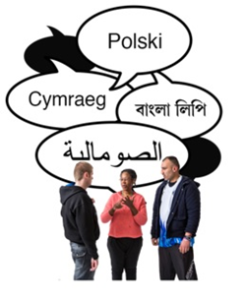 | Language  Is English your first language?  Yes ☐ No ☐  If you ticked “No” what is your first language?
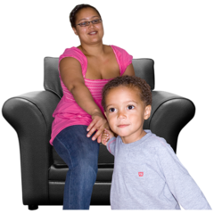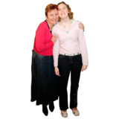 | People you care for  Do you have dependents e.g. children or adults that you provide support to?  Yes ☐ No ☐
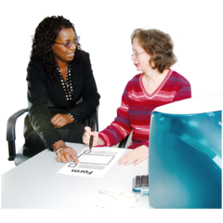 | How have you used, or tried to use adult social care support?  I receive adult social care support and get the support I need. ☐  I receive adult social care support but I don’t get enough support. ☐  I have applied for adult social care support for myself but did not receive it. ☐  I am a paid carer of someone using adult social care support. ☐  I am an unpaid carer of someone using adult social care support. ☐  I am an unpaid carer of someone unable to use adult social care support ☐  I am a carer but I need adult social care support myself. ☐  I have never been asked about adult social care support, but I think I need it. ☐
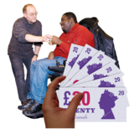  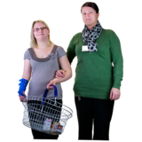  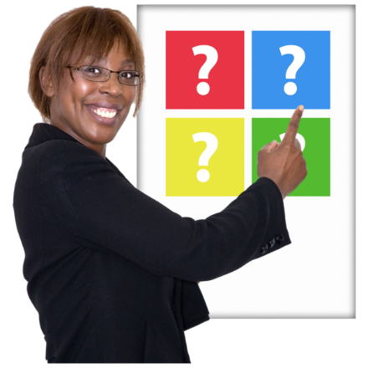 | If you have used adult social care support, how was it paid for?  Self-directed Support (SDS):  Yes ☐ No ☐  If you ticked “Yes” which type:  Option 1: Paid to you as a Direct Payment for you to employ your own staff ☐  Option 2: You have chosen which agency / organisation you wish to support you, and the money is given to them ☐  Option 3: You have chosen to allow the Council to arrange your care services ☐  Option 4: You have chosen a mix of these options for different types of care ☐
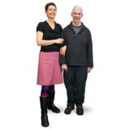 | If you ticked “No” which type of social care support funding  Independent Living Fund ☐  Private Funding ☐  I fund my social care support another way ☐  (please give details):
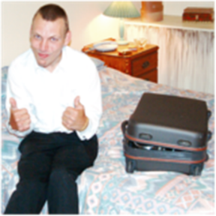  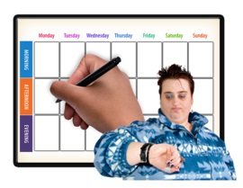  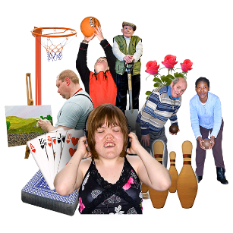 | How much adult social care support do you, or someone you care for, receive?  Occasional respite care / short breaks ☐  Regular overnight care ☐  Less than 10 hours a week ☐  Between 10 and 30 hours a week ☐  More than 30 hours a week ☐  Can you tell us what kind of adult social care you receive? E.g. personal care, meals, Telecare, activities.
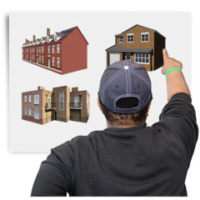 | Where does, or did, the adult social care support take place?  In sheltered housing ☐  In a residential or nursing home ☐  In a day care centre ☐  In a prison or offenders’ unit ☐  Living independently alone ☐  Living independently with others (shared accommodation) ☐  Somewhere else ☐(please tell us where):
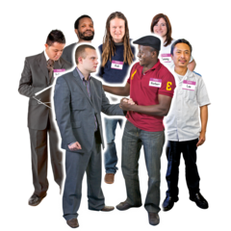 | Who provides the adult social care support?  The local Council ☐  A charity, social enterprise, or voluntary organisation ☐  A private company ☐  I employ staff directly ☐
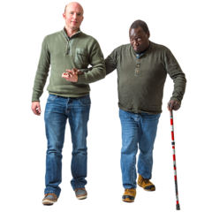 | Do you, or have you, received other adult social care services not covered by any of the options above?  Yes ☐ No ☐  If you ticked “Yes” what kind of support?
 | Do you also receive support from your local NHS on a regular basis?  Yes☐ No ☐  If you ticked “Yes” what kind of support?
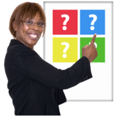 | Other Options:  If you are not selected for the Policy Panel would you like us to contact you to make you aware of other opportunities with Inclusion Scotland? Yes ☐ No ☐
 | Would you like to join Inclusion Scotland as a member for free?  Yes ☐ No ☐
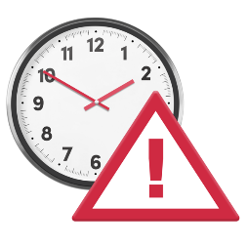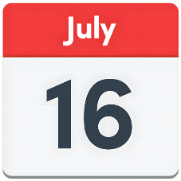 | Please return your Application Form to Inclusion Scotland by Wednesday 16 July.
 | Postal address:  Inclusion Scotland  Robertson House  152 Bath St  Glasgow  G2 4TB
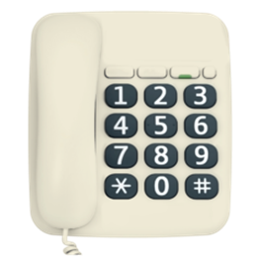 | Telephone: 0131 370 6718
 | Email: info@inclusionscotland.org
 | Made by Inclusion Scotland using Photosymbols.

