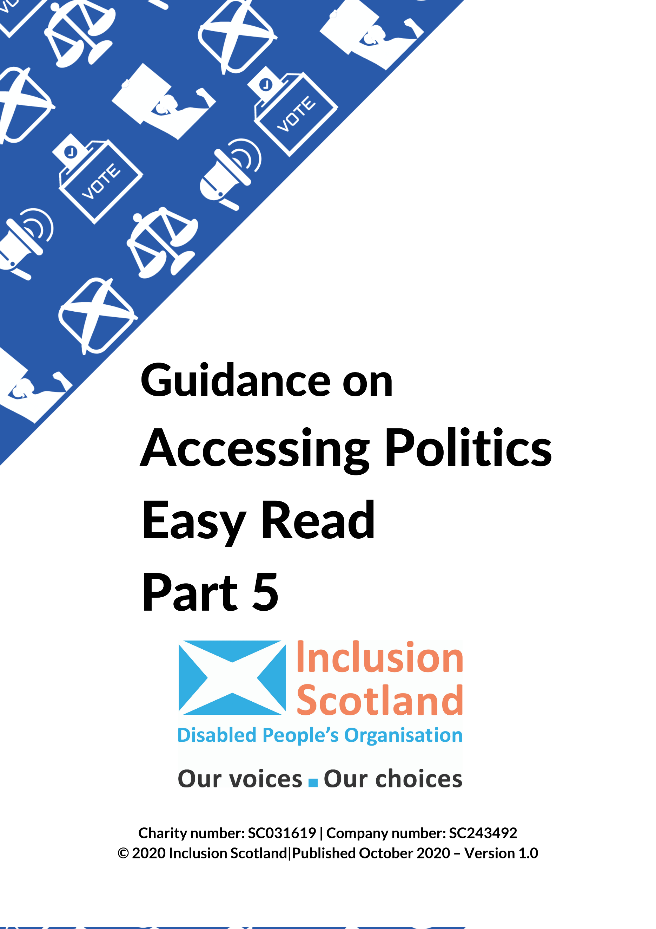
Access to Politics
Part 5
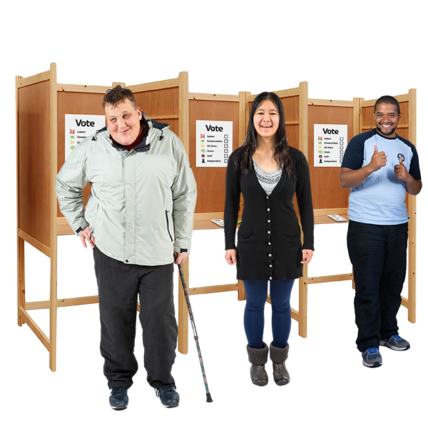

How to take part (2)
Standing as a party candidate.
Running an election campaign.
Your message – what you want to tell people.

Copyright images © Photosymbols. Prepared by Disability Equality Scotland
Inclusion Scotland made this guide:

- to show disabled people how to get involved in politics.

- to show how to make politics accessible for disabled people.

It is in 8 parts:
- What are my rights? What can change to make it easier for me?
- Who represents me?
- Petitions.
- How to take part (1).
- How to take part (2).
- Tips for campaigning.
- Election day.
- Accessibility checklist.
We hope this guide is useful to you.
Get in touch with us at: civicparticipation@inclusionscotland.org
to tell us what you think of the guide or if you need advice and support.

Standing as a party candidate
 | If you want to be elected and you agree with most or all of the views of a political party, you might decide to represent that party and be their candidate.
To stand for a political party, you must be a member of that party.
Some political parties want you to have been a party member for a certain length of time before you can be a candidate.
How do political parties choose candidates?
If you want to be a candidate for a political party look at their website to see how they choose candidates.
A list of all registered UK political parties is available from the Electoral Commission.
 | There is usually an interview as part of the selection process.
You will be asked questions about:

- What you know about the area you want to represent.
- Any jobs or experience you have had in the party.
- What you know about Scottish politics and local politics.
- What you know about Scotland’s political system – things like number of seats, how the council or Parliament is run.

There could also be:
- Roleplay

The interviewer may act like a journalist and ask you difficult questions.

For example: ‘The First Minister only cares about the Union – what do you think?’
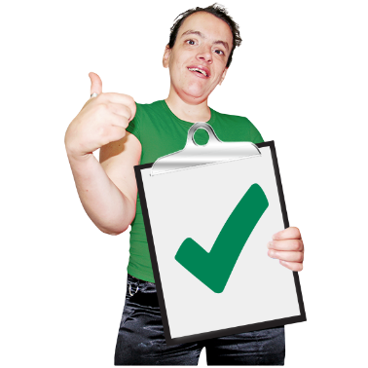 | Try to move your answer away from the difficult question and make the points you want to make (for example what your party has done well.)
- Teamwork/Team Activity

You may be asked, with other applicants, to come up with a campaign activity.

This is to see what you know about having a good campaign, but also shows if you are good at working with other people.
- Hustings

You may be asked some questions in a hustings format to see how well you answer.

A hustings is a meeting where candidates in an election answer questions from voters.

 | Try to make 3 points or have 3 examples in each answer – this works both in interviews, and as a candidate or elected official.
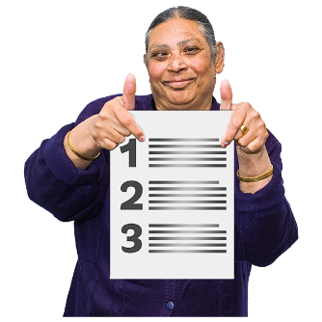 | Disabled candidates can ask for questions before the interview as a reasonable adjustment.
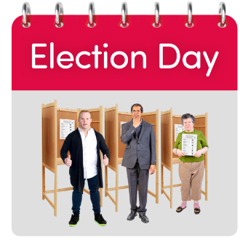 | Remember being chosen as a candidate is only one part of a long journey.  It does not mean you will win an election.

Running as an independent candidate
You can stand as independent candidate if your views do not match with a political party.
If you get elected as an Independent, you can vote on issues in the way you want.
You do not have to follow what a political party thinks about an issue.
 | You do not have to follow the selection process to become a political party candidate.
 | You will not have the help or advice that a political party can give or have volunteers to help you.

Running an election campaign
Election Agents
You need an election agent unless you are standing in a Community Council election.
An election agent looks after the money for your campaign.

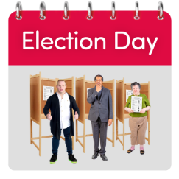 | You can do this yourself if you want.  You must tell the relevant Returning Officer who your election agent is.  The Returning Officer is the person who runs the election and says who has been elected.
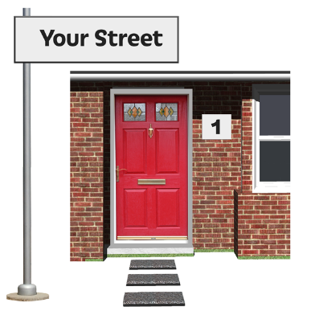 | Office Address  Your Election Agent must have an office address in the area where you are running for election, or in a nearby area.  The Returning Officer will send any information to this address.
Expenses and Spending Limits
There are rules about how much you and your agent can spend at elections.
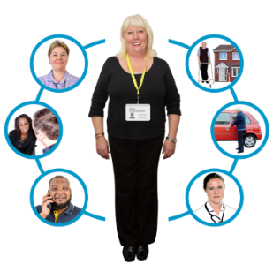 | This includes money for:  - advertising  - transport  - meetings  - and staff.
 | The limit on how much you can spend depends on the type of election you are standing in.
If you belong to a political party or group, they might be able to help you with money for your campaign.
Most candidates ask people to give money to their campaign.
If not you must pay for the campaign yourself.
In Scotland any money spent on your campaign because of your disability is not counted in campaign spending limits.
You must say how you have spent the money on a form called the campaign spending return.
This includes money from the Access to Elected Office Fund (Scotland).
 | Information on spending limits and the submission of campaign spending returns is available from the Electoral Commission.
Donations
A donation is money, goods or services given to a candidate for free.
A donation could be:
- A gift of money or other property.
- Sponsorship of an event or publication.
- Membership fees for an organisation.
- Covering the cost of using a service, for example a service that checks your social media.
- Free or cheaper use of an office.

You may only accept a donation over a certain amount from a permissible donor.

Check the rules on the Electoral Commission website to find out who is a permissible donor.
If it is against the rules you must give the money back.

Your message – what you want to tell people.
If you want to be elected you will spend a lot of time telling the public about your campaign.
You will be:
- canvassing – this means talking to people and trying to get them to vote for you
- and going to public meetings.
To tell people what you think, you need to use communication skills like:
- listening
- talking to the public
- dealing with people who think differently from you
- trying to make disagreements better.
Find things you have in common.
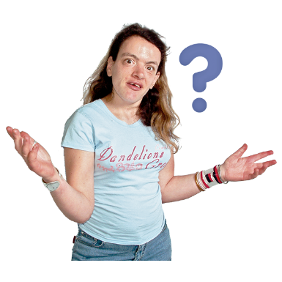 | Try to find out more about someone’s point of view.  Try to agree why it is a problem and then tell them how you can help.
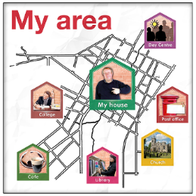 | If elected, you would represent everyone in your area.  Not everyone will have voted for you.  You need to have a good relationship with the public and understanding what different groups in your community will need.
Answering questions
Questions are a good way to talk about what you think about things and what your policies are.
It is important to find out what is important to voters.
You need to show you are interested in their thoughts.
 | You can show how your policies will work well and this will hopefully get them to vote for you.
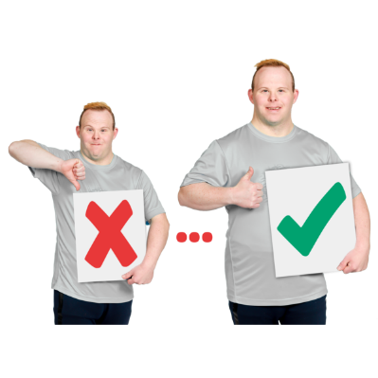 | You should also think about how you can change your policies to fit what voters want.
Saying things that are helpful to people.
When talking to voters in a particular area, find out what are the problems that worry people in that area.
This will help you talk about things that will help people in that area.
You should have good, clear advice ready to help.
This will help to show voters that you are interested in things that are important to them.
They will think you will be good at representing them.

Be Clear
Do not explain things in too much detail.
Talk about the most important things.

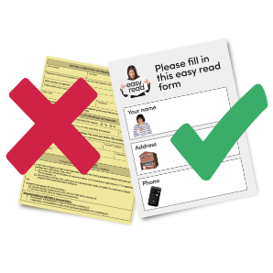 | Make sure your message is clear and simple and easy to understand.
Be Direct
Do not worry about giving difficult messages or bad news.
Explain any difficult messages simply at the start of the conversation.
You might not be able to say anything that is positive.
You need to show you understand it is a difficult message for the people you are talking to.
Avoiding arguments.
Try to stop any conversation turning into an argument.
Say what your points are in a calm way.
If the person is not responding well, think about ending the conversation by wishing them a good day or thank them for their time and move on.
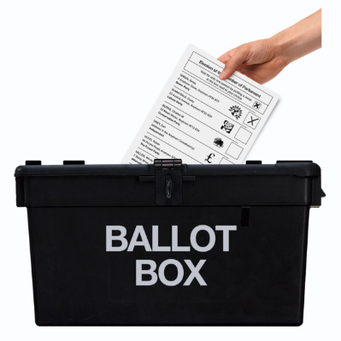 | Some people might not want to talk to you.  This could be because:  - it is not a good time  - they do not want to hear your views  - they are not interested in the election.
Other people might argue with what you are saying.
They might say something you do not agree with.
Let them say what they want and then reply calmly and sensibly.
Show that you are listening to what they have to say and keep a calm tone of voice.
Preparation
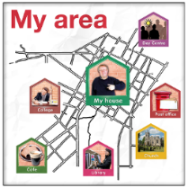  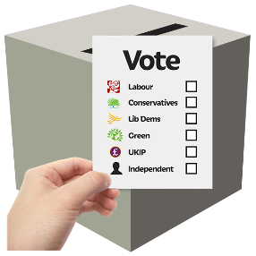 | Here are some things to remember when you are speaking in public:  - Benefits  Why should voters vote for you?  Think about the good work you would be able to do if they vote for you.  For example, are you campaigning for improvements to the local area or trying to provide a new service for the community?
- Interests
Think about what you are interested in and work you are doing in the area, council, constituency, or region.

- Things you have done well.
Can you give a few examples of your work to show that you can make a difference?

- Reasons
Think about why someone might not want to elect you.

Think about what you would say if people talk about these things.

Hustings
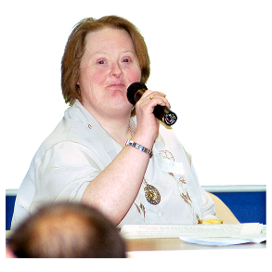 | Hustings are meetings for candidates standing in Scottish and UK Parliamentary elections.  They are like the television programme Question Time.
A chairperson will be in charge of the meeting.
They will not be linked to a political party.
The chairperson will let each candidate speak for a certain time, and no one can interrupt them.
They will ask the candidates questions.
The audience can ask questions.
 | More information on election hustings is available here.

Copyright images © Photosymbols. Prepared by Disability Equality Scotland

