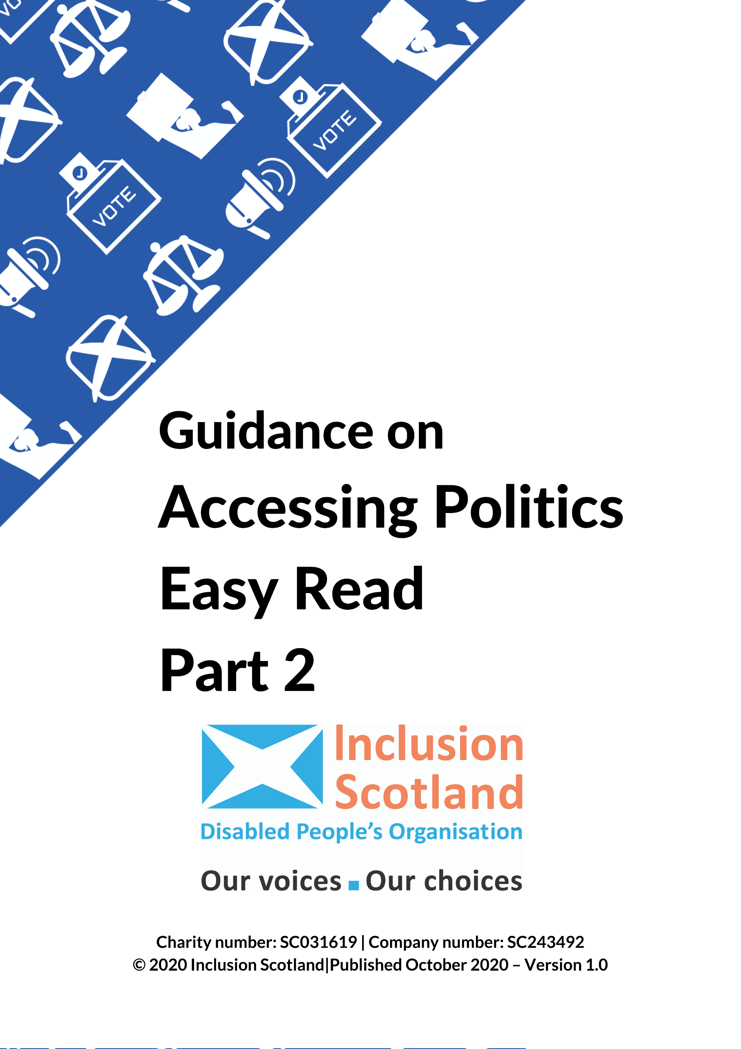

**Access to Politics**

**Part 2**

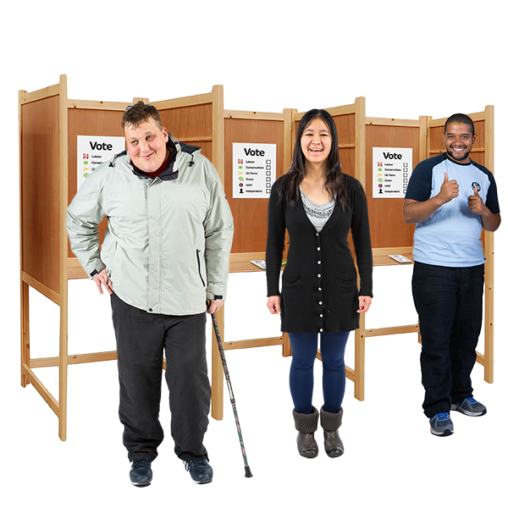

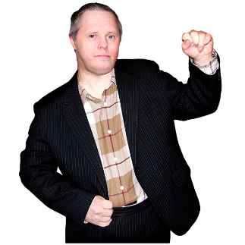

**Who represents me?**

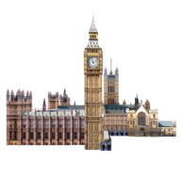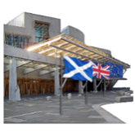

**Who has the power?**

Copyright images © Photosymbols. Prepared by Disability Equality Scotland

|  |  |  |  |  |  |  |  |  |  |
| --- | --- | --- | --- | --- | --- | --- | --- | --- | --- |
| |  |  | | --- | --- | | 3 people next to a voting booth. | Inclusion Scotland made this guide:   * to show disabled people how to get involved in politics. | | Reasonable Adjustments - a wheelchair user next to a ramp with a speech bubble above her head saying 'I need' and images of easy read and extra time on a stopwatch. | * to show how to make politics accessible for disabled people. | | a woman pointing at the first point on a list of 3 things. | It is in 8 parts:   1. What are my rights? What can change to make it easier for me? 2. Who represents me? 3. Petitions. 4. How to take part (1). 5. How to take part (2). 6. Tips for campaigning. 7. Election day. 8. Accessibility checklist. | | Email on a computer screen. | We hope this guide is useful to you.  Get in touch with us at: [civicparticipation@inclusionscotland.org](mailto:civicparticipation@inclusionscotland.org)  to tell us what you think of the guide or if you need advice and support. |   **Who represents me?** | |
| Scottish Parliament buildingUK Parliament buildingCouncil building with 4 staff outside it. | Each person in Scotland is represented by:  • Several community councillors.  • Three or four local councillors.  • One constituency MSP (Member of the Scottish Parliament).  • Seven regional MSPs.  • One constituency Member of the UK Parliament (MP).  A constituency is an area. |
| **Community Councils** | |
| 5 people meeting round a table | Community Councils are set up by Local Authorities.  They are run by residents in a local area.  They are not paid. |
| a local map | Community councils are the most local level of elected representation in Scotland. |
| Scottish Saltire flagHandshake | There are around 1,200 community councils in Scotland.  Community councils are separate from local councils but get support from them. |
| a smiling woman holding a checklist with 4 things - there are green ticks against 2 of the things. | Community councils bring local people together to help make things happen.  Their work can include:   * Projects that will make their community better for everyone. |
| Questionnaire with the title 'tell us what you think' | * Community newsletters. * Surveys or questionnaires to find out what local people think about things. |
| a man holding his fist in the air.local map | * Campaigns about local issues. * Organising community events like local galas. |
| Taxi license plateBuilding work and equipment | They have to ask community councils about:   * planning applications – what is built where * and who can get licenses – for taxis, or for places that sell things like alcohol.   More information on Community Councils is available [here](http://www.communitycouncils.scot/). |
| **Local Councils** | |
| a theatreClassroom with a white board and chairsRoad and a car | Local Councils are in charge of many important public services like:   * theatres and libraries * sports centres and swimming pools * schools, nurseries, colleges and community education * housing * roads and public transport * social work and community care * getting rid of waste.   There are 32 [councils](https://www.cosla.gov.uk/councils) in Scotland. |
| a town on a map | Each local council area is divided into a number of ‘wards’ or smaller areas.  Each ward has 3 or 4 councillors.  More information on Local Authorities is available [here](https://www.gov.scot/publications/local-authorities-factsheet/). |
| **Scottish Parliament (Holyrood)** | |
| Scottish Parliament buildinga local map | The Scottish Parliament is at Holyrood in Edinburgh.  It has 129 MSPs (Member of the Scottish Parliament).  They each have a region or ‘constituency’. This is the area they represent. |
| Manifestos and party rosettes. | They are elected every five years in Scottish Parliament elections.  Every person in Scotland is represented by an MSP. |
| a police officer next to an image of a law document.Scottish Parliament building | The Scottish Parliament passes laws and looks at the work of the Scottish Government.  Most work is done by Scottish Parliament committees, made up of MSPs from different parties. |
| two people discussing - there is a 'Yes' speech bubble from one person and a 'No' speech bubble from the other. | Final decisions are taken by a vote of the whole Scottish Parliament. |
| a smiling man holding a checklist with 4 things on it.  He is pointing to the item with a green tick against it.a police officer next to an image of a law document. | Changing laws or making new laws can be suggested by:   * the Scottish Government * MSPs * Scottish Parliament committees * or by people or groups using the Scottish Parliament’s petition system. |
| Website Link on a computer screen | More information on the Scottish Parliament is available [here](https://www.parliament.scot/about-the-parliament.aspx). |
| **UK Parliament (Westminster)** | |
| UK Parliament building | The UK Parliament is at Westminster, in London. There are two Houses of Parliament. |
| General Election UK - a map of the UK showing people holding their election ballots.  There is an image of a voting booth and a voting box. | 1. **The House of Commons**.   There are 650 MPs.  They are elected in UK General Elections which usually happen every five years.  There are 59 Scottish MPs.  Each MP represents a ‘constituency’ – an area of Scotland. |
| UK Parliament building | 1. **The House of Lords**.   Lords are called peers. They are not elected.  They are chosen by the Government. They do not represent an area. |
| a police officer next to an image of a law document. | The UK Parliament passes laws and looks at the work of the UK Government.  Most of the work is done by committees, made up of MPs and peers from different parties. |
| two people discussing - there is a 'Yes' speech bubble from one person and a 'No' speech bubble from the other. | Final decisions are made by voting in the House of Commons and then the House of Lords.  More information on the UK Parliament can be found [here](https://www.parliament.uk/about/). |
| **Holyrood or Westminster – who has powers?** | |
| Scottish Parliament buildinga UK map highlighting Scotland | The Scottish Parliament passes laws on things that affect many parts of everyday life in Scotland.  These are called **devolved** matters. |
|  | This means the UK Parliament has given the Scottish Parliament the right to make decisions in these areas. |
| a man looking confused with images of benefits behind him.a police officer next to an image of a law document.Classroom with a white board and chairs | Devolved matters include:   * agriculture, forestry and fisheries * education and training * health and social services * housing * law and order * local government * sport and the arts * tourism * and some parts of the benefits system. |
| money - coins and notes, and a finger pushing numbers on a calculator. | The Scottish Government decides what taxes we pay in Scotland.  Most of the money that Scotland uses comes from the UK Government.  The Scottish Government decides how to use this money. |
| a police officer next to an image of a law document.Parliament | The UK Parliament passes laws on things that affect the whole of the UK. These are called **reserved** matters. |
| Universal Credit with different images of staff, money and buildings.a workplace with different types of workers.an image of the Data Protection Act with a phone and computer, and a woman holding her fingers to her lips. | Reserved matters include:   * TV and radio stations * data protection * defence and energy * employment * immigration * trade and industry * transport * and some parts of the benefits system including Universal Credit. |
| Website Link on a computer screen. | You can find out more about the powers of the Scottish Parliament in the Scotland Acts of 1998, 2012 and 2016.  These documents are available on the [Scottish Parliament website](https://www.parliament.scot/visitandlearn/60191.aspx). |
|  | The [Legislative Consent Memorandums](https://www.parliament.scot/parliamentarybusiness/Bills/31308.aspx) have information about the powers the UK Government has and what powers it has given the Scottish Parliament. |
| **How to find who represents you.** | |
| Website Link on a computer screen. | You can find your community councillors and local councils on their council websites.  You can find your local MSPs [here](http://www.parliament.scot/msps.aspx) and your local MP [here](https://members.parliament.uk/members/Commons).  Search for their name, party, or the area they represent. |
| a smiling man holding a checklist with 4 things on it.  There are green ticks against 2 of the items. | You should be able to find information on the things they are interested in and what work they do.  This will help you to find who will be the best people to help you. |
| **Get in touch with your representative** | |
| Mobile PhoneEmail on a computer screen. | You can get in touch with your representative by:   * Phone * E-mail * Social media |
| Reasonable Adjustments - a woman who is a wheelchair user next to a ramp.  She has a speech bubble over her head which says 'I need' and there are images of easy read and extra time on a stopwatch. | When you get in touch with your representative or arrange a meeting ask for reasonable adjustments if you need them.  A reasonable adjustment is something that would make it easier for you to take part. |
| Skype call on a computer screen. | If you can’t go to a meeting ask your representative to visit you at home, or have a meeting online using Skype/Zoom. |
| a woman signing 'support' in BSL | Ask for communications support like a British Sign Language interpreter or palantypist if you need one. |
| **Talking to your representative about what is important to you.** | |
| a man talking to a woman who is writing things down. | Remember your representative will not know about everything.  They will be able to help you better if you can give them as much information as possible. |
| a question mark surrounded by 6 grey silhouettes of heads. | Think about these points before you get in touch with your representative:   * **WHAT** do you want to talk about?   Be clear and keep it simple.   * **WHO** will it make a difference to?   This will show how important your problem is. |
| a confused woman shrugging her shoulders with a question mark beside her. | * **WHY** does something need to be done?   What will happen if nothing is done?   * **WHO** needs to make the changes you want? * **HOW** can the problem be sorted? What needs to happen? |
| a wheelchair user in front of a step and a door. | For example:   * **WHAT:** I can’t put my household rubbish in the outside bins because they are not accessible. |
| a question mark surrounded by 6 grey silhouettes of heads. | * **WHO:** 6 other people on my street have the same problem. |
| Litter bin | * **WHY:** It is not healthy. It stops me living independently. If rubbish is not cleared we get rats. * **WHO:** This is a local council problem. |
| a man pointing his finger in the air with a lightbulb idea above his head. | * **HOW:** I have a design for accessible bins.   Is this something the council would be willing to change? |

Copyright images © Photosymbols. Prepared by Disability Equality Scotland