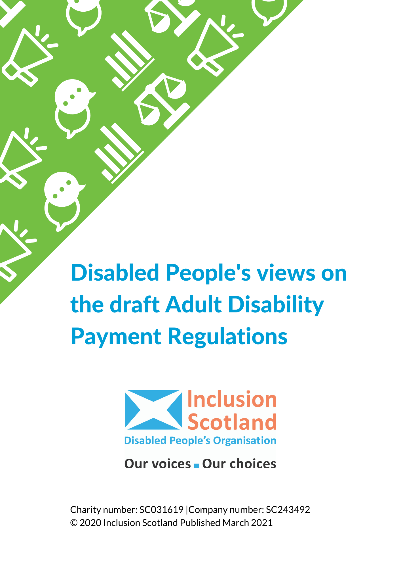

In February 2021 Inclusion Scotland ran a survey to ask disabled people their views on key aspects of the Adult Disability Payment draft regulations. Adult Disability Payment is a new Scottish benefit which will replace Personal Independence Payment for eligible disabled people aged 16 to 64. It will be delivered by Social Security Scotland from spring 2022.

Over 300 people responded to the survey and we used the findings to write a response to the Scottish Government’s consultation on the regulations which closed on Monday 15 March 2021.

We also ran a webinar for Inclusion Scotland members on Monday 1 March where we had an in-depth discussion about some of the issues in the consultation. These also informed our consultation response.

This report sets out what disabled people told us and our response to the Scottish Government’s consultation.

Thank you to everyone who took part in the survey and came along to the webinar.

## Award Periods

**The issue:** Scottish Government says that awards of Adult Disability Payment for conditions or impairments that are unlikely to improve will be for either 5 or 10 years. However, these award lengths are not mentioned in the draft regulations. This means that they could be easily reduced in the future.

**We asked:** Do you think that the 5 and 10 year award periods should be set out in the regulations?

Most respondents (76%) said the 5 and 10 year award periods **should** be set out in the regulations.

### Disabled people told us:

1. Having the award periods set out in the regulations will mean disabled people will be guaranteed some stability and will not have to go through stressful assessment processes.

“It definitely needs set out in the regulations and should not be reduced. Many disabled people with long-term conditions go through needless stress when they are regularly reassessed, despite no change in their condition.”

1. Under the current system people have been reassessed within the period of their award – there should not be any reassessment within the award period.

“Yes. Fed up of dreading the time for another assessment. The old system calls you A YEAR before your final date.”

1. There should be no reassessments for conditions that are lifelong and unlikely to change.

“If people have a condition that cannot get better, it not only stresses them to be continually assessed, it is a waste of resources.”

1. The award periods should go in the regulations to ensure subsequent governments can’t easily make changes and to ensure it is not open to interpretation:

“I worry that a future, less compassionate government could use this lack of clarity to hurt disabled people.”

### We told the Scottish Government:

1. Although the accompanying policy paper states that 5 or 10 year awards will be made (for long term conditions that are unlikely to improve) we can find no such provision in the draft regulations. We can only assume that the issue of the length of awards is going to be addressed in guidance rather than regulations.
2. This is very disappointing as Inclusion Scotland, and other stakeholders, have previously called for the award periods to be set out in regulations so that disabled people have some security and know they will not face ongoing reassessments.
3. Issues surrounding the length of awards cannot be resolved in guidance. Guidance provides no certainty for disabled people that they will not be subjected to frequent stressful assessments at some point in the future even though they have permanent conditions/impairments.

## 20 Metre Walking Test

**The issue:** Under the Adult Disability Payment regulations, the 20 metre walking test inherited from the UK PIP system is set to continue. This states that if you can walk more than 20 metres, aided or unaided, then you do not get the points you need for Enhanced Mobility component.

This means you would not qualify for a Motability vehicle either. The previous test under Disability Living Allowance was being unable to walk 50 metres.

**We asked:** What walking test distance do you think should be used to decide whether someone should get the Enhanced Mobility Component?

Most respondents (81%) said that the 20 metre walking test **should not** be used, opting for either 50 metres (32%) or other (49%).

### Disabled people told us:

1. A walking test distance should not be used. Instead, other factors that impact on an individual’s ability to walk should be taken into account, including pain and tiredness that result from walking.

“Neither 20 or 50 meters is nuanced enough. Mobility is not just whether you can walk but the impact that is has on you with pain and fatigue.”

1. The 20 metre test is ‘arbitrary’ and assessments should be based on what the individual can access and participate in, for example moving around the house, getting to and around shops.

“It seems very arbitrary, surely it would be better to test where they can walk to e.g. bathroom, kitchen, local shops”

1. People with mental health conditions, autism and variable conditions could be disadvantaged by the 20 metre walking test.

“How impact of mental health can be factored into this test? As often it's not something that is visible. When most people will prep themselves for the assessment so will present better than they are normally are; or can only manage it because of the support they have with them.”

### We told the Scottish Government:

1. Most people we engaged with disagreed with the application of the 20 metre walking test.
2. At present someone who - "Cannot undertake any journeys at all because it would cause overwhelming psychological distress.." might only score 10 points using the descriptors meaning that they would not qualify for the Enhanced Mobility rate. That seems both unfair and unjust to particular impairment groups.
3. Disabled people believe that this rule unfairly penalises disabled people and deprives them of benefits to which they should be entitled.
4. Disabled people are also concerned that some of the reasons provided for retaining the status quo would apply equally at the time of any independent review thus constraining the opportunity for a radical change in approach.

## 50% Rule

**The issue:** Under the Adult Disability Payment regulations, the 50% rule is to continue. This rule says that to qualify for the benefit you must be impacted by your condition, to the extent set out in the descriptors (for example be unable to prepare and cook a meal or to get dressed) on at least half the days (50%) in every month.

**We asked:** Do you agree or disagree with the 50% rule?

Most respondents **disagreed** with the 50% Rule (59%).

### Disabled people told us:

1. The 50% rule is inflexible and is unfair for people with fluctuating and progressive conditions which are often unpredictable.

“I disagree with the 50% rule as this is an arbitrary measure of ability/disability and does not allow for a nuanced and inclusive understanding of the ways in which disabilities and long-term health conditions impact individuals.”

1. Impairments/conditions can have a significant impact even if they fall under the 50% threshold.

“Being impaired on a variable basis does not mean there are no support needs. Being unable to do anything whatsoever on two days a week is a significant impairment, even if on the other days functionality is reasonable.”

1. Impairments/conditions that do not meet the 50% threshold can still have a considerable impact on people’s ability to remain in employment and perform basic tasks like eating and dressing.

“You cannot measure someone’s disability in this way. A person who struggles even several days in a month still requires help and this can be costly or mean the difference between employment or having to be trapped at home.”

1. Although people may be able to undertake certain tasks, the impact of doing so can be debilitating.

“Some people, myself included, struggle to get dressed or cook a meal but are left exhausted by the process.”

1. The focus should be on the impact of the impairment/condition, rather than percentages.

“Individuals should be consulted on their condition and disability holistically and in a person-centred manner. Every person is different, and everyone’s disability affects them in different ways which are unique to them. It shouldn’t be based on a percentage, but rather the impact the disability has on their lives.”

1. Having support or finding alternative ways of doing things can keep them above 50% but could ironically result in them not being eligible for support.

“It seems it will punish people during recovery, giving them less and less as they get better. Making it harder to keep up with the cost of healthy living. 1 step forward and 2 back springs to mind.”

### We told the Scottish Government:

1. Most disabled people we engaged with disagreed with the application of the 50% rule.
2. The 50% rule does not deal well or fairly with people who have variable conditions.
3. The great majority of webinar participants favoured a social model approach to assessing the impact of variable conditions on daily living rather than the medical/functional approach which was adopted under PIP and is being continued with the Adult Disability Payment.

## Terminal Conditions

**The issue:** The draft regulations say that before a condition can be treated as terminal the medical practitioner must refer to the guidance on terminal illness issued by the Chief Medical Officer. Unlike regulations, guidance can be easily changed meaning that fewer, or more, people could be awarded entitlement under terminal illness rules without any debate in Parliament.

**We asked:** Do you think the guidance should be put in regulations?

Most respondents (52%) said that the guidance on terminal condition **should** be put in regulations.

### Disabled people told us:

1. The guidance must be put in regulations to make sure they cannot be changed without proper oversight and transparency. Having the guidance in regulations also ensures there is more certainty.

“I think all guidance should be regulated so its clear for everyone interacting with this system. its then not down to mere interpretation and means its easy to understand”

1. People with terminal illness must be treated compassionately and have quick access to the support they need.

“People dealing with a terminal illness deserve not to have any grey areas in benefit award. It is part of human dignity and nobody who is so ill should have to fight for benefits, which , lets face it are short awards .”

### We told the Scottish Government:

1. Most disabled people said that the guidance on terminal conditions should be put in regulations
2. If the guidance is not put into regulations it will not be subject to Parliamentary scrutiny and there is nothing in the regulations that would prevent a definition of terminal illness being adopted which would reduce the number and proportion of disabled people achieving entitlement through this route.
3. The Scottish Government and officials should not be placing stakeholders in a position of accepting promises to "please trust us". Such promises are useless in the event of a change of Government, or even of policy, at some point in the future as they cannot be relied on in tribunal or court.

## Assessors

**The issue:** The draft regulations say that anyone who has two years’ experience of health or social care work is “qualified” to carry out an assessment for Adult Disability Payments.

**We asked:** Do you think that someone with 2 years’ experience of social care or health related work should be able to make a decision about whether someone gets Adult Disability Payment?

Most respondents (73%) said they **did not** think someone with 2 years’ experience of social care or health related work should be able to make a decision about whether someone gets Adult Disability Payment.

## Disabled people told us:

1. 2 years’ experience is insufficient and assessors need to have a combination of experience and qualifications.

“This is totally inappropriate, someone's way of life is at stake. I have been in this position where people make judgements not having a clue how chronic schizophrenia impacts of every aspect of life and yet they have such power to make these decisions. People doing these assessments need experience of life as well as qualifications.”

1. Assessors should be medically qualified and must have specialist knowledge about the person’s condition.

“Assessments should be done by fully qualified practitioners with experience relevant to the condition they are assessing e.g. a physiotherapist should not be able to assess someone with complex mental health conditions”

1. Assessors should be people with lived experience of the condition that the person being assessed has:

“I think people who have disabilities should assess other with similar disabilities so they can understand what the applicant has to deal with in their life. Able bodied and able minded people have no idea what it’s like living with disabilities”

1. Specific types of qualifications/training/experiences should be required for assessors.

“I think that there should be a national qualification introduced specifically for this role. Disability is such a broad spectrum that 2 years experience is just not enough.”

1. Assessors must have an understanding of disability, including the social model.

“Such a person may be appropriate however, if that is to be the criteria it must be complemented in regulations by specific training requirements and these must include training on the social model of disability and the human rights of disabled people.”

## We told the Scottish Government:

1. Inclusion Scotland welcomes the draft regulations which provide extra assurance to those disabled people with mental health issues and/or learning difficulties that the impact of their impairments will be assessed by health and social care practitioners with **relevant** experience.
2. Virtually all health professionals will have undergone rigorous training. The same does not apply to all of the social care workforce. Many social care workers are unqualified. For example the Workforce Skills report (2016/17) estimated that only a third of 30,000 support workers in adult care homes held the qualifications required for registration.
3. Our engagement with disabled people shows that that 2 years social care experience does not given the reassurance to disabled people that those carrying out assessments will be "suitably qualified".

# Overpayments

**The issue:** The draft regulations say that overpayments of Adult Disability Payment can be recovered even if they are due to an official making a mistake (error) in awarding the benefit.

**We asked:** Do you think that Social Security Scotland should be able to take back money that they wrongly paid to someone due to their own mistake?

Most respondents (63%) said that Social Security Scotland **should not** be able to take back money that they wrongly paid to someone due to their own mistake.

## Disabled people told us:

1. Disabled people who are overpaid and have spent the money in good faith should not be punished because of mistakes made by the Agency.

“Because it’s not the claimant’s fault; they’ll then be penalised in their daily life going forward from that point because they’ll have spent that money in good faith.”

1. Taking money back from someone could cause financial hardship as well as having negative impacts on mental and physical health.

“This would seriously impact our mental health and my even push some to suicide. Life is so very difficult enough for us without the added worry/stress of finding ourself in such a position.

## We told the Scottish Government:

1. Most disabled people we engaged with disagreed with the Agency being given the power to recover overpayments due to official error.

1. The DWP's latest guidance on recovery of overpayments (Benefit Overpayment Recovery Guide, Version 2.50, August 2020) states that - overpayments “classified as Official Error …. are not recoverable under social security legislation".
2. Despite this the Scottish Government seem intent on recovering overpayments of Adult Disability Payment which occur due to official error thus providing less rights to Scottish claimants than those of claimants elsewhere in the UK.

If you require this report in an alternative format please contact [research@inclusionscotland.org](mailto:research@inclusionscotland.org)

**Contact Us**

|  |
| --- |
| Inclusion Scotland  22 – 24 Earl Grey Street,  Edinburgh,  EH3 9BN |
| info@inclusionscotland.org |
| Office number: 0131 370 6700 |
| Visit our website: inclusionscotland.org |
| Follow us on Social Media:  @inclusionscot |
| @InclusionScotland |
| @inclusionscotland |







