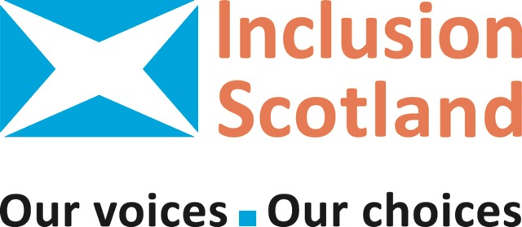

Application Form for Individuals to become a member of Inclusion Scotland as an Associate or Supporter

Inclusion Scotland is a network of Disabled People’s Organisations. We work to achieve positive changes to policy and practice, so that we disabled people are fully included throughout all Scottish society as equal citizens

As an individual you can be a member of Inclusion Scotland as either an Associate or a Supporter as follows. It is free to join us.

Associate If you are a disabled person you can join Inclusion Scotland as an Associate. This includes if you are a person with physical or sensory impairments, have a mental health condition, have learning difficulties, have a cognitive impairment, have an autism spectrum disorder, are from the Deaf community or have problems with addiction.

Supporter If you are a non-disabled person you can join Inclusion Scotland as a Supporter. Any individual who agrees with our values and supports our work is welcome to become a Supporter.

If you would like more information or you have any questions about what it means to join Inclusion Scotland please email Janice at,
members@inclusionscotland.org or call 0131 370 6725

How did you hear about us? Website/ Social Media/Telephone enquiry/ Partner referral/ Other:

Please tick as appropriate:

I am applying to be an Associate as a disabled person

I am applying to be a Supporter as a non-disabled person

Contact Details

Please provide us with the following information.

Name:

Address:

Post Code:

Council Area:

Telephone Number:

E-mail:

Data Protection

☐ I confirm that I have read and understood the privacy notice that forms part of this application. I confirm that I agree to the terms in that privacy notice.

I support Inclusion Scotland’s aims and values.

Signed:

Name

Date:

Thank you for your support.

Please return your Application Form by e-mail to members@inclusionscotland.org or post it to:-

Janice Sheridan-Harrison
Inclusion Scotland
22-24 Earl Grey Street
Edinburgh
EH3 9BN

On completion of this form you will be sent a Joining Pack.

The Information Partnership Privacy Notice
Inclusion Scotland is what is called the ‘Controller’ of the personal information you give to us. ‘Personal information’ means things like your name, your email address or your phone number.

What personal information do we collect from our partners?
When you become a partner, we collect your contact details; your name, address, email address and or phone number. When you sign up to get emails or post (marketing) from Inclusion Scotland we collect your personal information in order to provide you with you have asked us for.
We use your postal address to send you out postal marketing if you do not have an email address or for access reasons. We require your email address to send to out electronic mailings. Inclusion Scotland uses an online service called MailChimp to send out emails to you. By giving us your personal information, you agree it will be transferred to MailChimp for processing in accordance with their Privacy Policy and Terms.
Inclusion Scotland uses an online service called SalesForce to store your personal information. By giving us your personal information, you agree it will be transferred to SalesForce for processing in accordance with their Privacy Policy.

Why we need your personal information?
We need to know your personal data in order to provide you with information of interest to disabled people in Scotland, Inclusion Scotland activities and opportunities for you to get involved in our work. We will also occasionally send you information about how we are processing your personal data. We will not collect any personal data from you we do not need in order to provide the information outlined to you.
We need to know your personal information in order to provide you with the marketing you want us to send you. This marketing will be one of the following:
- Bi- Weekly Inclusion Scotland e-bulletin
- Inclusion Matters monthly newsletter

We will not collect any personal information from you we do not need in order to provide the newsletter or e-bulletin.

What we do with your personal information?
All the personal information Inclusion Scotland processes is processed by our staff in the UK. By ‘processing’ we mean things like securely keeping your personal information on SalesForce, sorting your personal information, for example into membership type, and using your personal information to send you electronic or posting mailings. For the purposes of IT hosting and maintenance your personal information is held on servers within Europe. No one else (‘third parties’) can have access to your personal information unless the law says they can.
We have put Data Protection arrangements in place to make sure the processing of your personal information is effective and secure. More information on how we do this can be found in our Privacy Notice. Or, you can contact us if you would like us to send you information about this in a different way.

How long we keep your personal information?
The personal information you have given us will be kept with us until you tell us that you no longer want to get marketing from us.
You can change your mind about getting marketing at any time via phone by calling 0131 370 6700, by emailing info@inclusionscotland.org or via the unsubscribe button at the bottom of all our emails. You can also write to us at:
Inclusion Scotland,
22-24 Earl Grey Street
Edinburgh, EH3 9BN

What are your rights?
If at any point you believe the information we process on you is incorrect you can request to see this information and have it corrected or deleted. If you wish to raise a complaint on how we have handled your personal data, you can contact us to have the matter investigated. info@inclusionscotland.org

If you are not satisfied with our response or believe we are processing your personal data not in accordance with the law you can complain to the Information Commissioner’s Office by phoning 0303 123 1115, textphone on 01625 545 860, email Scotland@ico.org.uk or write to:
The Information Commissioner's Office - Scotland
45 Melville Street
Edinburgh, EH3 7HL

