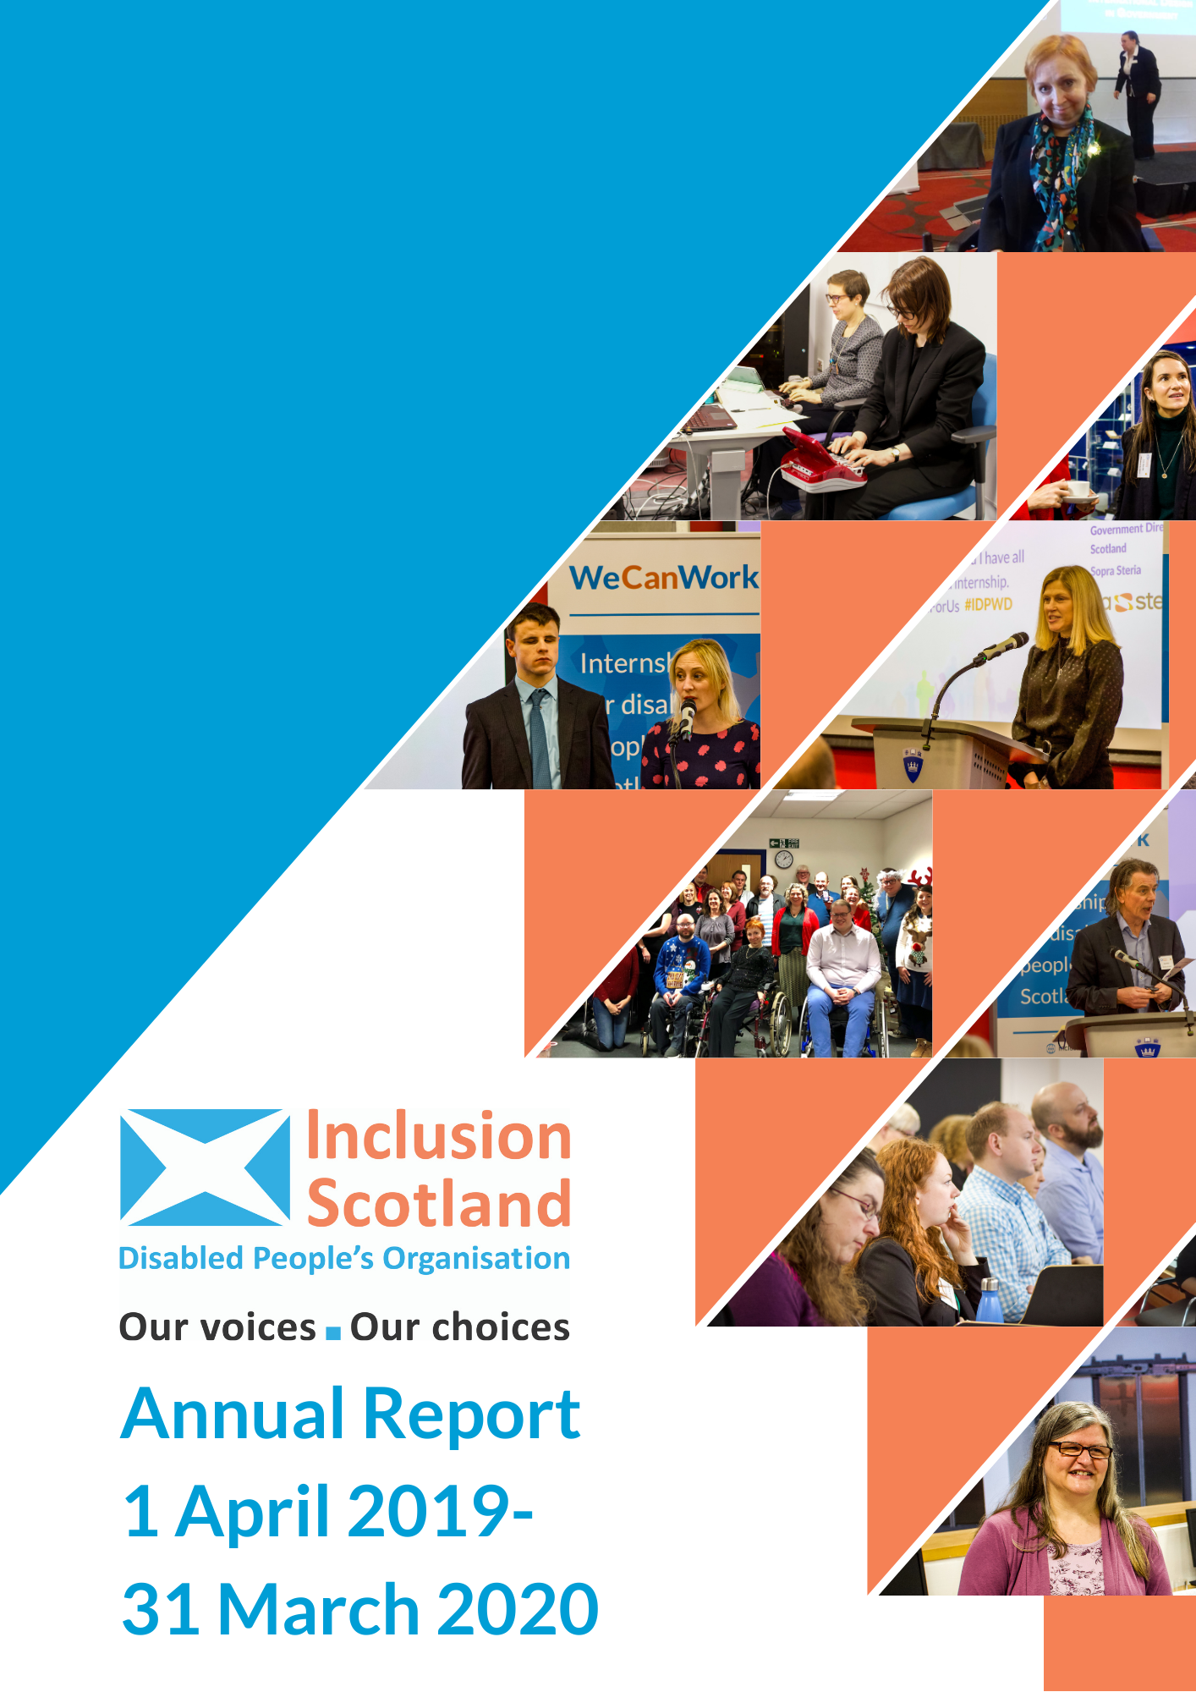

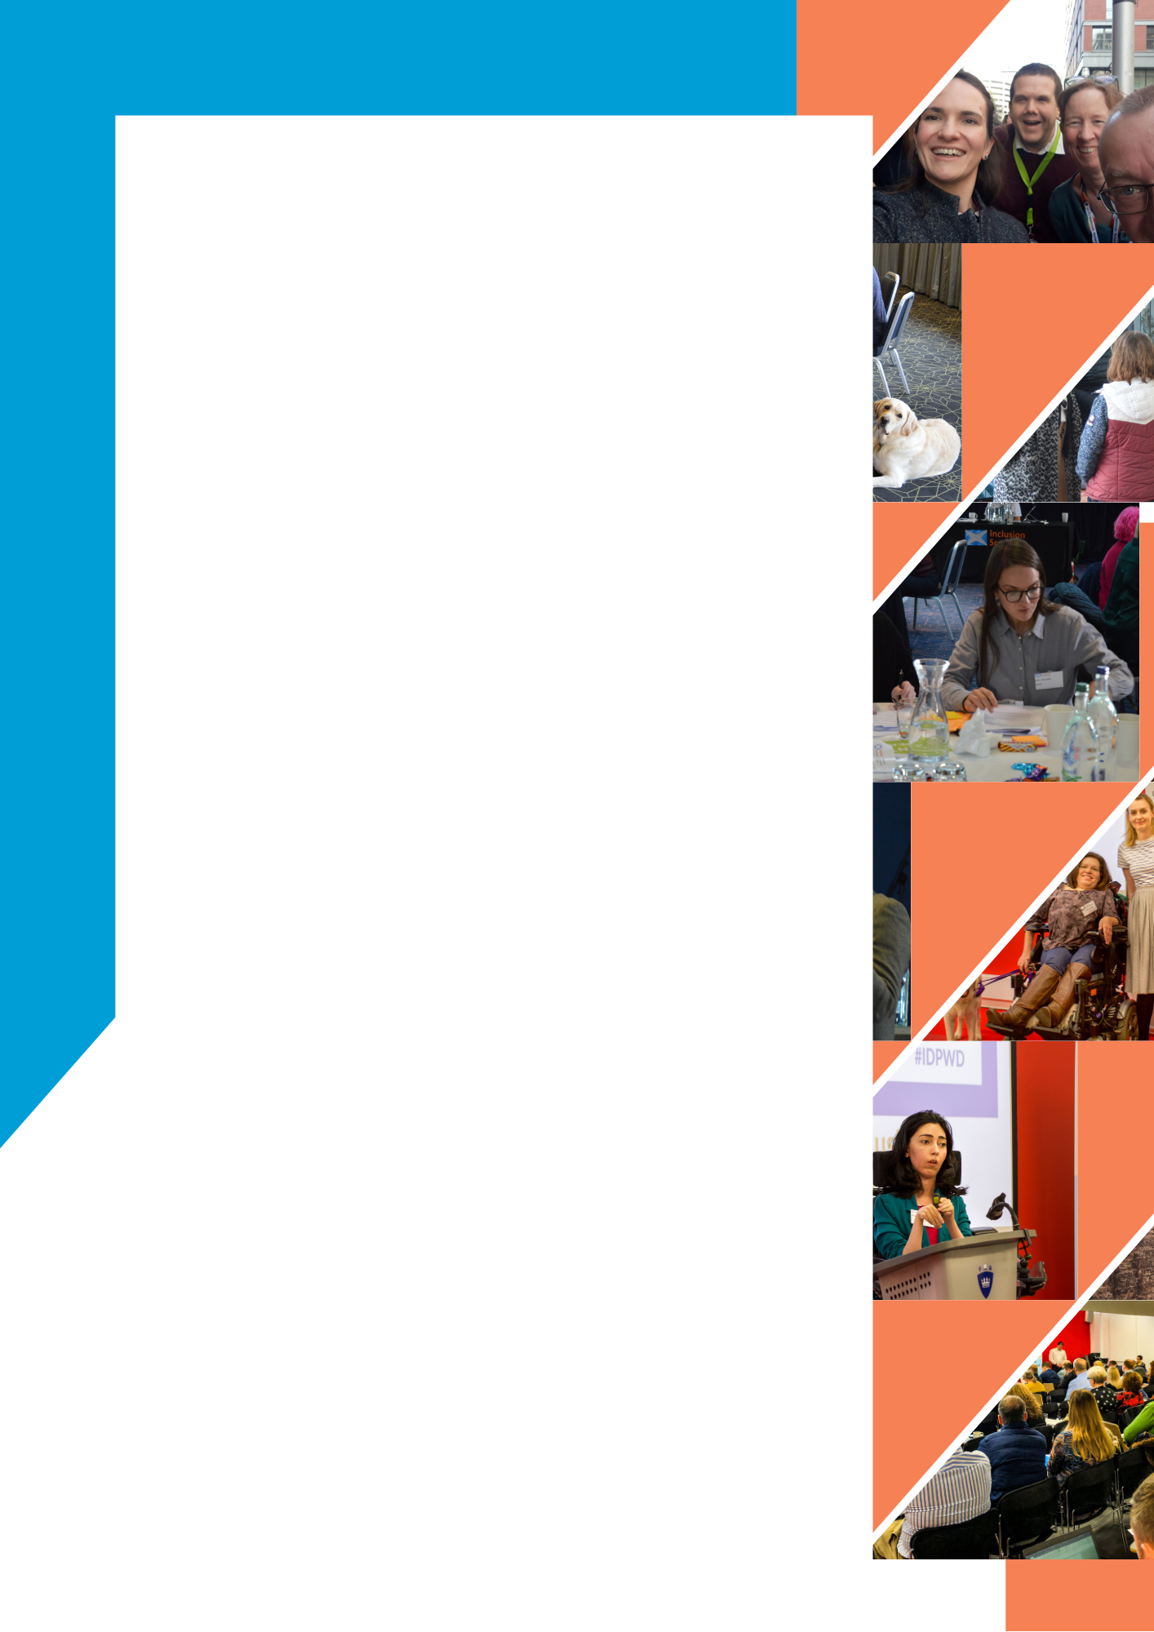
Contents Page
Convenor's Foreword 1
Chief Executive Officer’s Report 3
Mission Statement 4
Funders 4
Influencing Policy 5
Research 12
Promoting Participation 13
Events 25
Finance 27
Board 30
Thank You 31

Convenor's Foreword

Once again, I’m proud to introduce Inclusion Scotland’s annual report, which describes yet more successes over the past year.
Real progress has been made towards establishing the Scottish Just Law Centre, led by JustRight Scotland with us as a partner. This should soon offer a real opportunity to take legal cases and set legal precedents. It means we will be able to seek changes to laws and practices and avoid some of the continuous battles we’ve had to fight to have our basic rights recognised.
Our efforts to gain employment for disabled people continue to flourish through our ‘We Can Work’ Internship Programme and direct work with private sector employers. Social security has continued to be a major area of concern but with success to report in gaining Winter Fuel and additional carer payments.
I’m a passionate believer in Inclusive Design and co-production. The Disability Research on Independent Living and Learning (DRILL) programme, which will soon be drawing to a close, has been an outstanding example of co-production with disabled people and researchers which must surely lead to some more examples of this in the near future.
Our People Led Policy Panel continued to support disabled people to take an active part in developing Scottish Government policy and reforms to the way adult social care support is delivered. Meanwhile, our Lived Experience Leadership project made progress on exploring ways to promote and support disabled people’s leadership more generally.
On a personal note, I’ve been proud to serve Inclusion Scotland as Convenor for almost four years. I will be handing over to a successor in the course of the next year and wish them all the best for the future in what continues to be a thriving organisation.
Terry Robinson

Chief Executive Officer’s Report
Reading this annual report on what Inclusion Scotland did in the year ending March 2020 is a reminder of how it was before the Covid-19 virus arrived and the world changed. We continued our work on promoting participation, social security, employment, access to services and rights and justice, as we pushed towards our goal of inclusion and equal citizenship for all disabled people in Scotland.
We began exploring how to incorporate the UN Convention on the Rights of Persons with Disabilities into Scottish law. Of course, rights aren’t rights if they can’t be enforced. Action to set up a ‘Scottish Just Law Centre’ to take cases was therefore an important accompaniment.
Our new projects on Lived Experience Leadership and public appointments really progressed, as did our work with employers. We supported disabled people in the Highlands to get closer to establishing a new Disabled People’s Organisation. The innovative People-Led Policy Panel co-produced a programme of adult social care reform with the Scottish Government and others. There were clear wins on devolved social security, with our lobbying helping to drive forward the introduction of a Winter Fuel Allowance and a Carers Additional Payment. Meanwhile, the Disability Research on Independent Living and Learning programme was nearing the end of it five years and we turned our attention to promoting its findings and securing its legacy.
Just three weeks before the end of the financial year everything unexpectedly skidded to a halt with the arrival of Covid-19. We took rapid action to review our work, but like everyone else we couldn’t foresee what was to come. That’s for next year’s annual report!

Mission Statement
Inclusion Scotland works to achieve positive changes to policy and practice, so that we disabled people are fully included throughout all Scottish society as equal citizens.
We do this by:
- Influencing decision-makers, ensuring that disabled people are involved in developing effective solutions for policy and practice that reflect our expertise by experience and meet our needs and aspirations.
- Supporting disabled people to be decision-makers themselves, promoting the equal representation of disabled people as policy-makers and our right to make decisions about our own lives.
- Developing capacity, awareness and engagement, of disabled people, disabled people’s organisations, and the organisations and institutions that affect our lives.

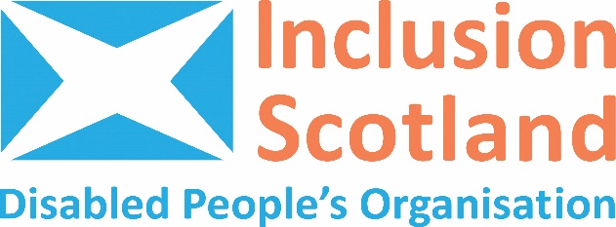

Funders

With thanks to our funders The Scottish Government and The Big Lottery for their financial support during the year.
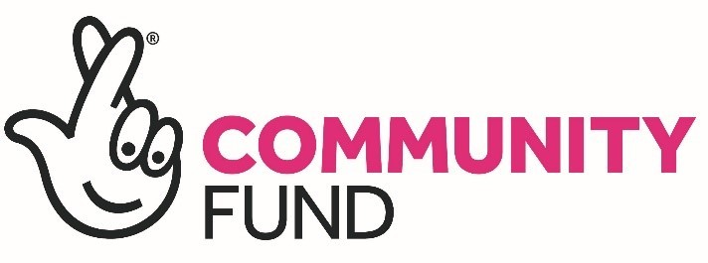

Influencing Policy
Influencing access to justice and human rights
We continued to champion disabled people’s human rights in all our policy and parliamentary work, and use human rights approaches in all our projects. Throughout the year, we gathered evidence on whether disabled people’s human rights are being met in Scotland. We collated evidence from our disabled people’s organisation members, disabled people, research and press to include in a report to the United Nations. We told them about the things that are working in Scotland and where more action is needed to meet our human rights. We are working towards the full incorporation of the United Nations Convention on the Rights of Persons with Disabilities into Scots’ law. This would make the rights in the Convention enforceable for all those areas that are devolved to Scotland. We have been working hard to ensure that disabled people’s rights are included in the recommendations by the Human Rights Taskforce to the First Minister. The Human Rights Taskforce is a group of Ministers, public bodies and individuals with relevant expertise, working to develop new laws in Scotland that will protect our human rights. If economic, social and cultural rights are to be made into law in Scotland, we want that process to benefit disabled people.
This year we formed a partnership with human rights law firm, JustRight Scotland and the Scottish Trans Alliance to work towards setting up a ‘Scottish Just Law Centre’. When it launches in Autumn 2020 the Centre will use action called 'public interest litigation' to help us win cases around disability discrimination. Public interest litigation means that cases can be brought by individuals or organisations and will help to change laws and policies so that a large number of people, rather than just the one person who was discriminated against.



JustRight Scotland are delighted to partner with Inclusion Scotland to extend access to justice to disabled people across Scotland, through the development of our Scottish Just Law Centre. This project, launching in Autumn 2020, aims to provide more accessible information on the legal rights of disabled people as well as capacity for some first tier organisations, like disabled people’s organisations and the Citizens Advice Bureau, to refer legal casework in specific areas to us for legal advice and representation. Our commitment – together with our partners – is to help more disabled people and disabled peoples organisations in Scotland use the law to defend and promote rights, and to help achieve just outcomes on legal issues that matter to them.

Jen Ang, Partner/Director, JustRight Scotland

Influencing access to social security
We continued to contribute to the development of the devolved social security system. We secured improvements to new Fraud Regulations which will protect disabled people’s rights. We participated in Scottish Government advisory groups and lobbied to bring forward the Scottish Child Payment. Our lobbying helped secure a £250 Winter Fuel Allowance for those in receipt of the higher rate of the Disability Living Allowance benefit and a Carers Additional Payment for families with 2 or more disabled children (worth £520 a year).


…Inclusion Scotland has noted that ‘There is obviously a real concern amongst disabled Scots about potential delays in the transfer to the new system’. It also said that ‘There is ... an issue with raised expectations of receiving a better system of support from those who are losing support under the current system.’ It is important to manage those expectations, and to ensure that there are no delays and that expectations of a better and fairer system are met.

Pauline McNeill, Scottish Labour MSP for Glasgow on Social Security Disability Assistance

Influencing Brexit
The UK’s withdrawal from Europe is still happening. We worked with the Health and Social Care Alliance and the Human Rights Consortium Scotland to highlight concerns about the implications of Brexit for social care services in Scotland. This particularly concerned the impact that changes to immigration policies may have on recruitment of Personal Assistants from other European countries.

Manifesto
To identify disabled people’s priorities for Inclusion Scotland’s Manifesto for the Scottish Parliament Elections in May 2021, we had an online survey in Summer 2019, held engagement events in Dumfries in partnership with one of our member Disabled People’s Organisation DGVoice, and ran workshops at last year’s Annual Conference in Dundee. We planned to launch the Manifesto in March 2020 but this was postponed due to the Covid-19 crisis. We will be working in the coming year with disabled people to find out if other issues need to be added to the Manifesto in light of Covid-19.

…the approach does not work if it is used just to pay lip service to community involvement or if certain groups are excluded. The briefing from Inclusion Scotland for the debate was particularly powerful in expressing the view that disabled people are often left out.

Graham Simpson, Scottish Conservative MSP for Central Scotland on Adopting the Place Principle

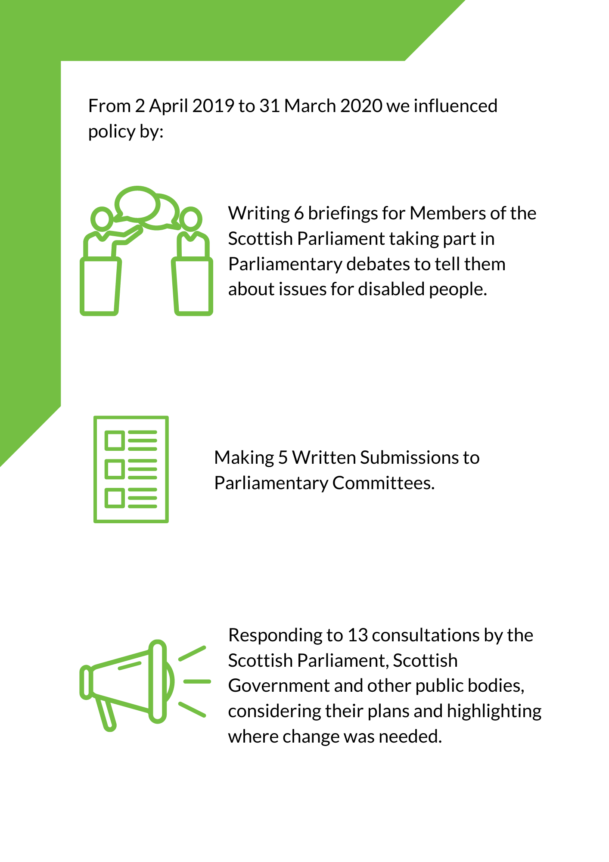

Clauses 15 and 16 of the bill as introduced are intended to increase flexibility for social care decision making during the period in which the provision is in force by allowing local authorities not to comply with particular assessment duties where complying would not be practical. The briefing from Inclusion Scotland, which represents [disabled people], warns that, in reality, the removal of those duties may result in many disabled people receiving social care support that is inadequate to meet their needs; receiving care that is inappropriate or in inappropriate settings; or maybe even receiving no social care at all. We are already hearing anecdotal evidence about the knock-on effects of the current crisis on social care packages.

Joan McAlpine, Scottish National Party MSP for South Scotland on the Coronavirus Bill

Research
The Disability Research on Independent Living and Learning (DRILL) is an innovative 5 year UK wide Programme led by disabled people, for disabled people, funded by the Big Lottery Community Fund. We led the Programme in Scotland. DRILL funds coproduced research projects which bring together disabled people and their organisations, academia and policy makers to research barriers faced by disabled people and propose solutions to ensure disabled people can live as full citizens and achieve independent living.
Definition of Independent Living: Independent Living means disabled people having the same freedom, control, dignity and control as other citizens at home, at work and in the community. It does not mean living by yourself or fending for yourself. It means the rights to practical assistance and support to participate in society and live an ordinary life.
Seven DRILL projects in Scotland are reporting on their findings as the programme approaches its end. The projects covered decision-making by people with learning disabilities, how people with lived experience of mental health issues engage in civic and public life, adapted social housing lettings, self-directed support, the barriers faced by autistic people and toilets in travel hubs. You can find out more at www.drilluk.org.uk.

Promoting Participation
Promoting Participation in Policy-making
The People-Led Policy Panel (PLPP) finished its pilot year on a high. The PLPP is made up of disabled people and carers with direct experience of using adult social care support. They have been co-producing the reform of adult Social Care Support in Scotland with the Scottish Government. In July the PLPP met with decision makers from agencies and organisations involved in the reform to launch the co-produced shared vision and framework for adult Social Care Support. The Panel then established 7 focus groups with Scottish Government staff to continue work on the reform.
Throughout the year, the panel took opportunities to showcase the co-production model of the PLPP. Panel members spoke at the Self Directed Support Scotland Conference alongside Jeane Freeman, Cabinet Secretary for Health and Sport; and at Convention of Scottish Local Authorities (COSLA) and Healthcare Improvement Scotland staff training events. Towards the end of the year, Covid-19 meant we had to put meetings and other engagement work on hold whilst everyone adapted to digital engagement. Once this had been done, the PLPP’s work was able to continue.
Promoting Participation in Employment
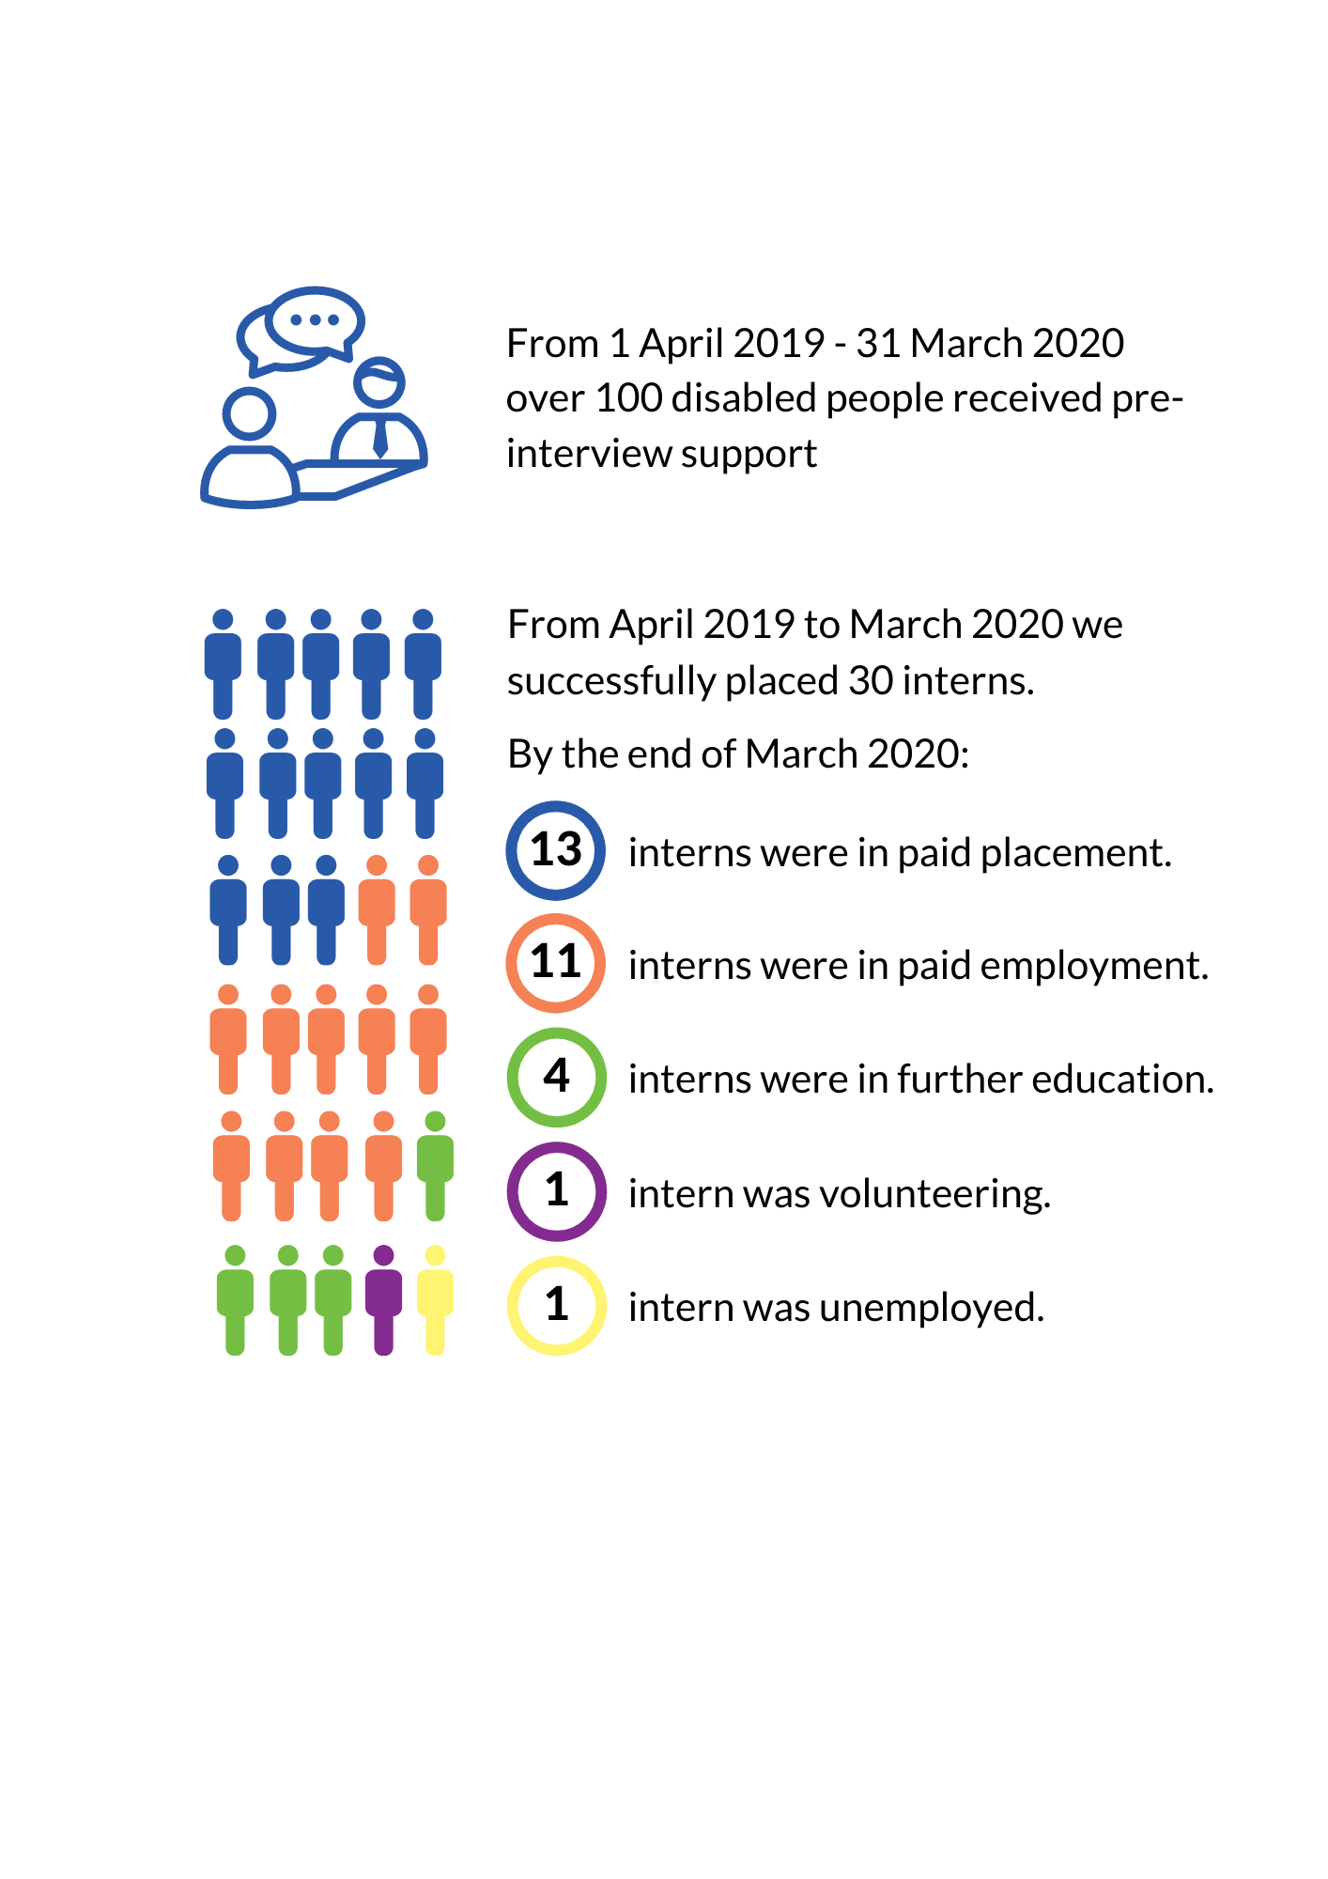
Our Internship Programme continued to succeed in supporting under or unemployed disabled people into meaningful paid employment. We have used our learning from supporting both interns and employers to develop methods and materials for wider use in improving inclusive employment practice.

The application process and particularly the interview were made relatively stress-free by Inclusion Scotland’s support and feedback before, during and after the process.

Parliamentary Internship applicant

Meeting other disabled people across the organisation has given me hope that disabled people will have a voice for positive change in Scotland.

Scottish Government Social Security Intern

Thank you for giving me my life back

Impact Funding Partners Intern

This year we expanded our network of contacts in the private and public sector, whilst championing the voice of disabled people in employment practice. We held our first conference for employers on accessible employment practices, ‘The Future is Accessible’, at Queen Margaret University in December. The event involved presentations from our interns and host employers. They promoted their experience and learning from participating in our We Can Work internship programme and encouraged employers to invest in improving their accessibility and inclusion.
We worked with employers to improve equal access to employment opportunities. For example, we presented to the Judiciary Appointments Board for Scotland (responsible for recommending individuals to become judges) on how to support disabled lawyers access opportunity and promotion.

Overall, I was very impressed by the quality of the candidates. We interviewed more individuals than we usually would in the recruitment process due to the high standard. They all had most of the key skills, knowledge, or interests we were looking for and everyone we did interview was really prepared. It was extremely difficult to choose between the final selection we interviewed. The whole process made me question the way we’ve recruited in the past, especially around the language we use in recruitment adverts and where we place adverts. I think we’ve been missing out on meeting some great potential candidates.

John McVie, Media Centre Manager at STV
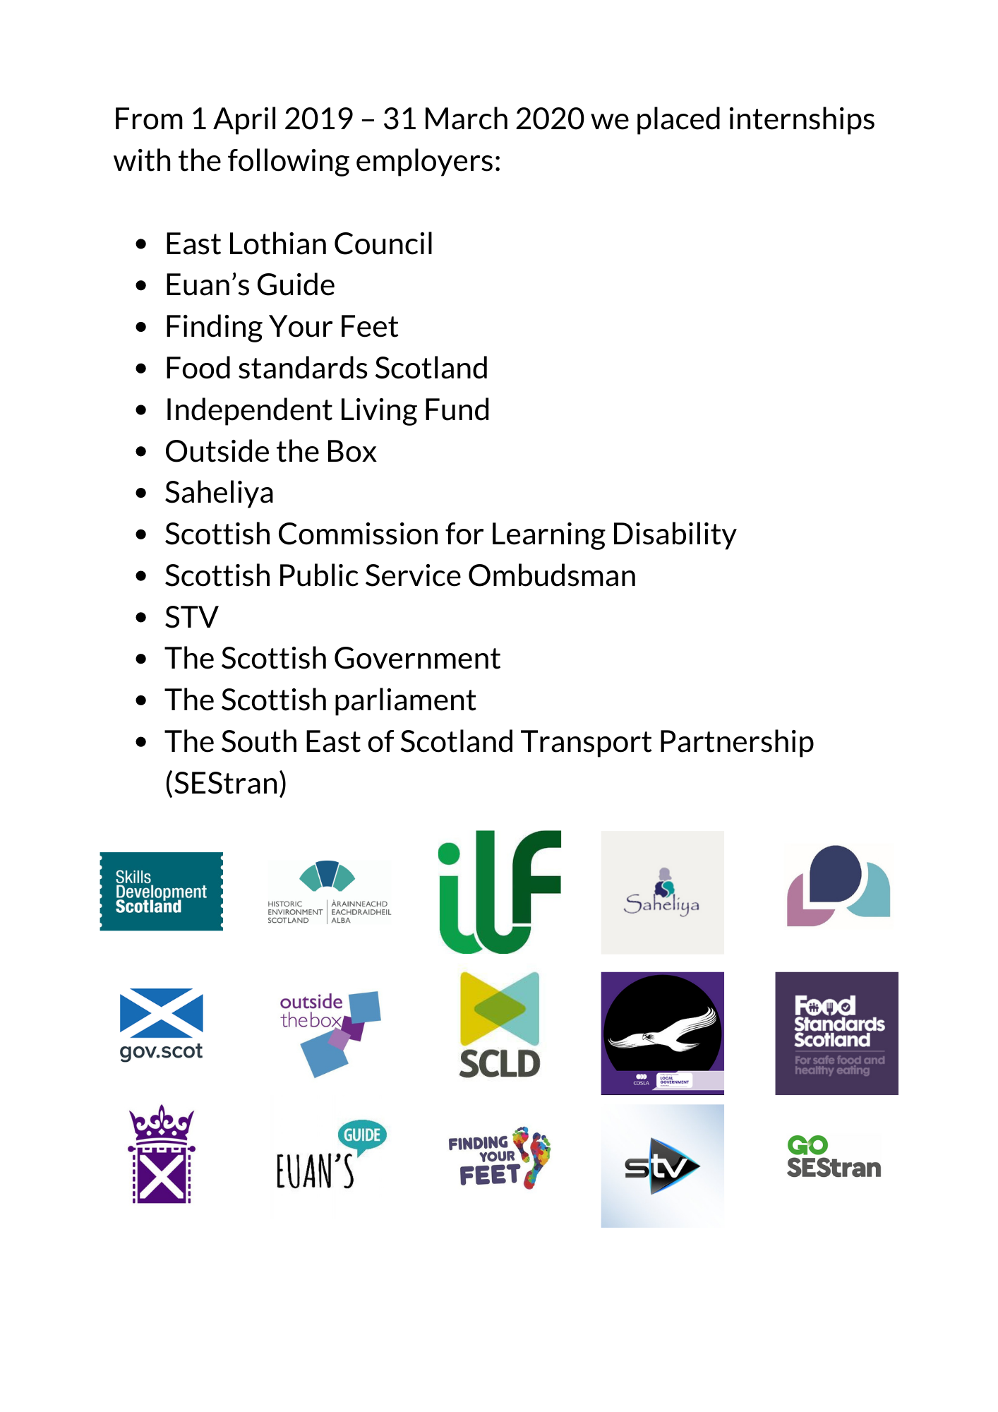
Promoting Participation in Politics
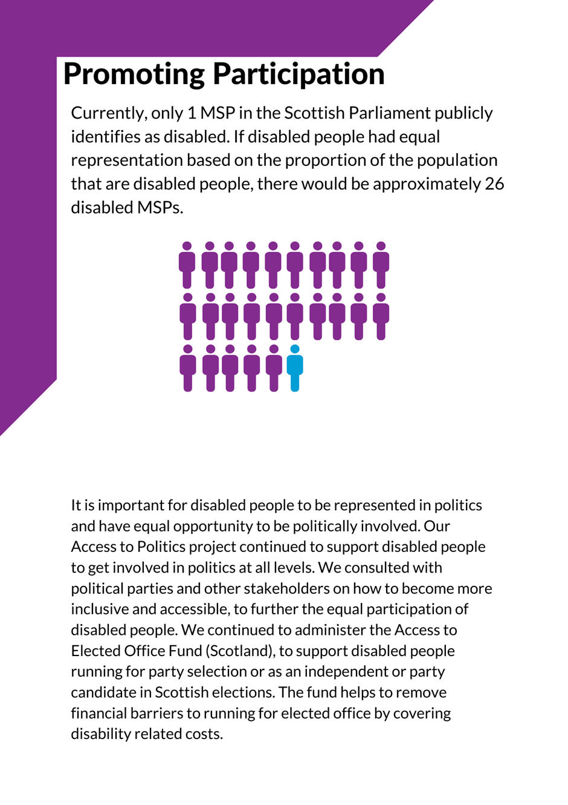
Currently, only 1 Member of the Scottish Parliament (MSP) in the Scottish Parliament publicly identifies as disabled. If disabled people had equal representation based on the proportion of the population that are disabled people, there would be approximately 26 disabled MSPs.

It is important for disabled people to be represented in politics and have equal opportunities to be politically involved. Our Access to Politics project continued to support disabled people to get involved in politics at all levels. We consulted with political parties and other stakeholders on how to become more inclusive and accessible, to further the equal participation of disabled people. We continued to administer the Access to Elected Office Fund (Scotland), to support disabled people running for party selection or as an independent or party candidate in Scottish elections. The fund helps to remove financial barriers to running for elected office by covering disability related costs.

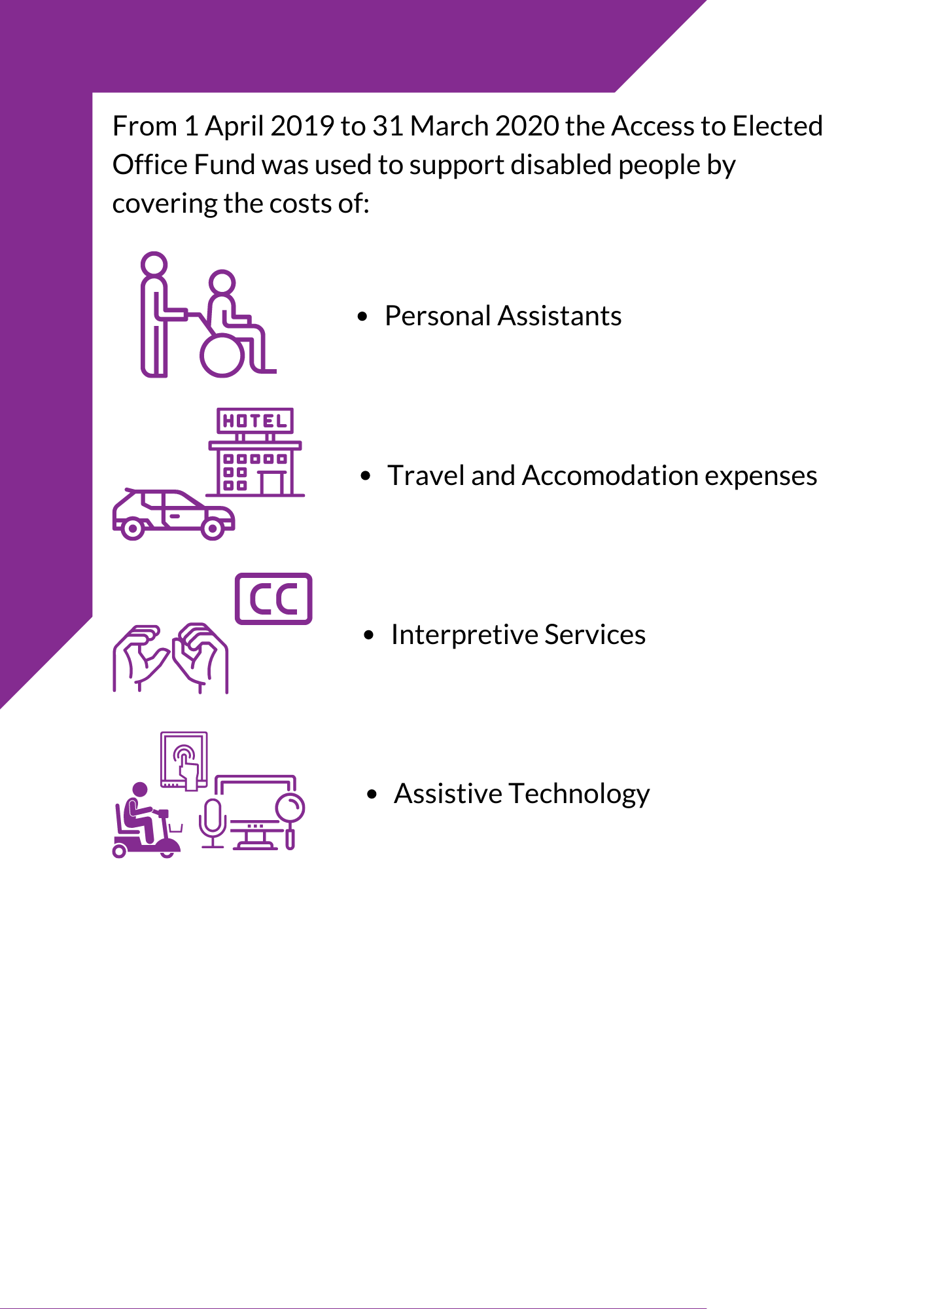

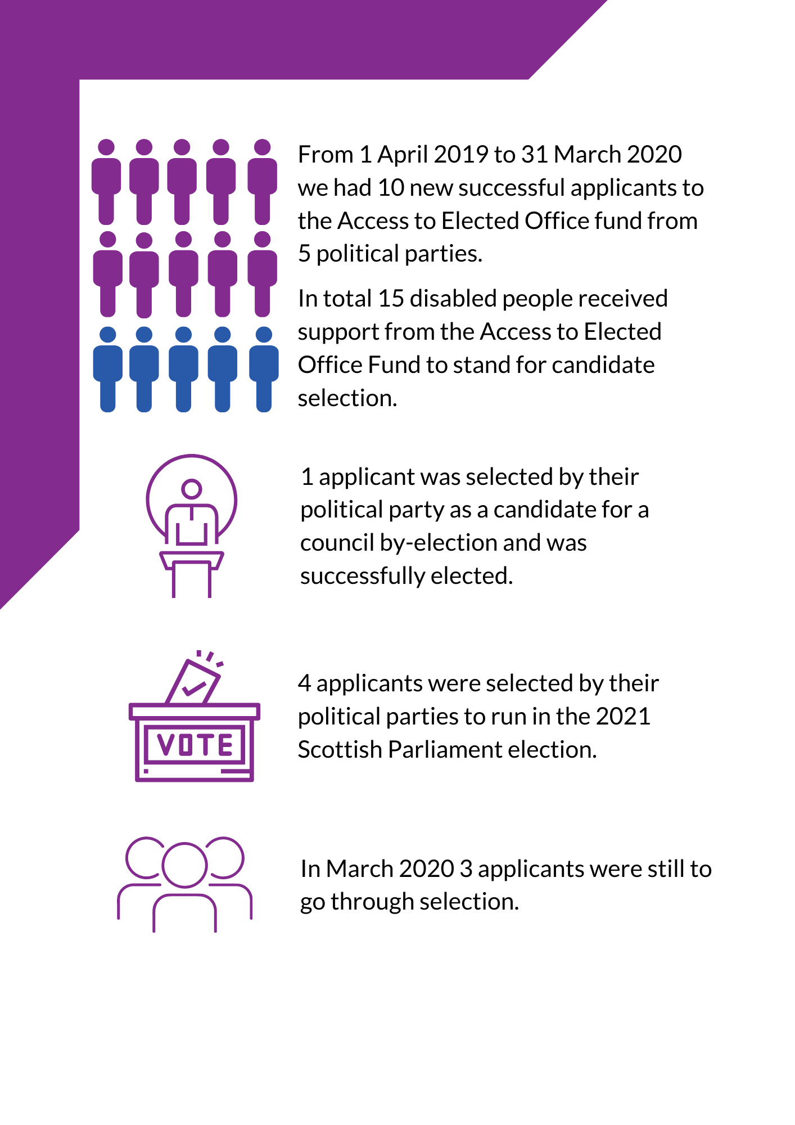

When I look back, this is all possible for me because of the Access to Elected Office Fund. It can be the first door opened for disabled candidates who require support to remove the barriers they face running for office. It doesn’t come with a magic wand – like anyone who runs for office, there’s a lot of hard work ahead for you – but it gives talent a chance where it may have otherwise been ignored. I want to thank Inclusion Scotland and the Access to Elected Office Fund for making my wish come true and helping me win my battle.
Grant Fergusson, Elected Councillor

Promoting Participation in Leadership
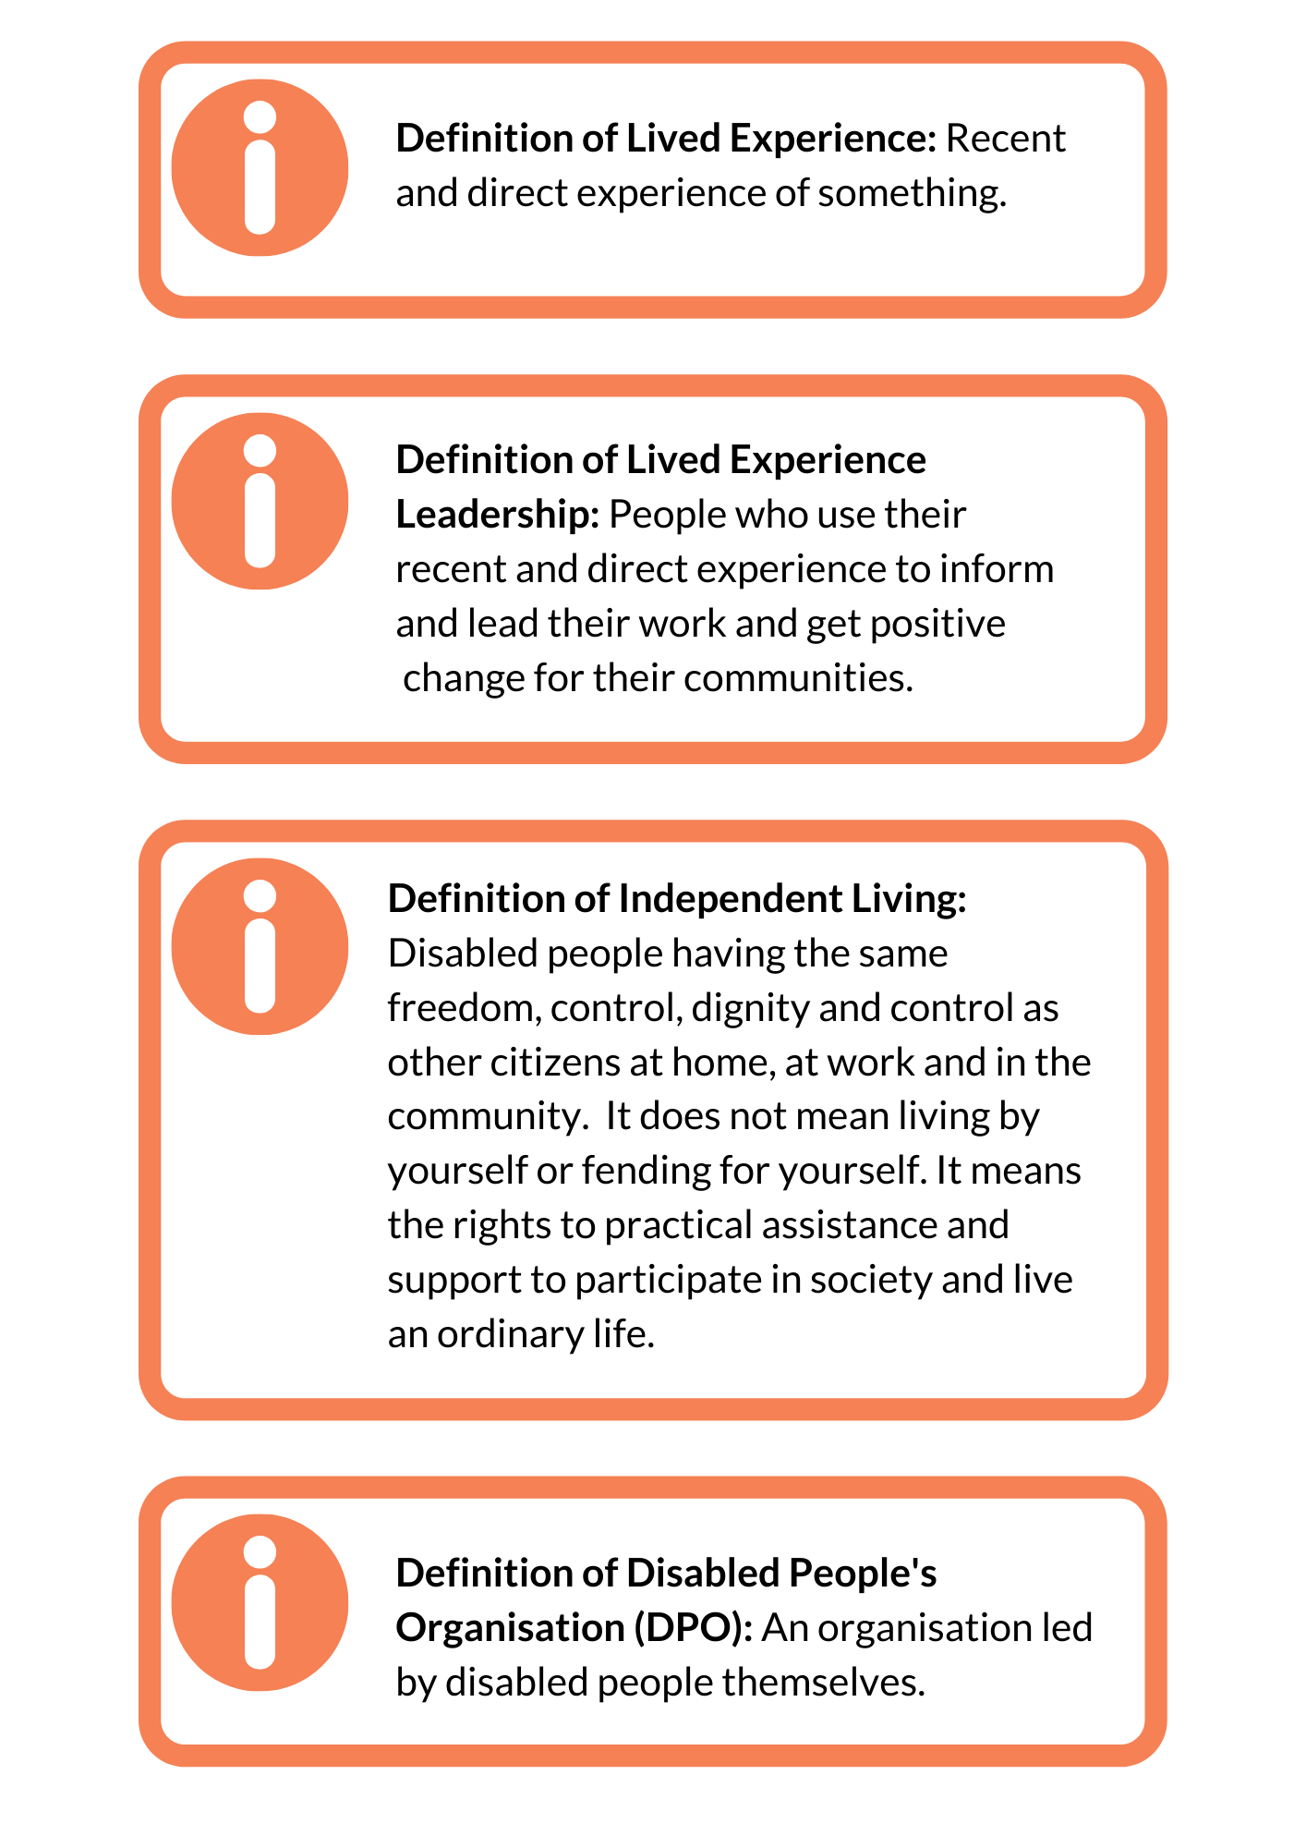
The Access to Public Appointments pilot, in partnership with the Scottish Government, granted disabled individuals the opportunity to shadow publicly appointed Boards over twelve months. Participants gained an understanding of Board members’ work, while Boards gained experience of applying reasonable adjustments to remove barriers to participation. Learning from this project will be presented in a report for the Scottish Government, to demonstrate how Board membership and Public Appointments can become more inclusive and accessible.
This year also saw us start our Lived Experience Leadership pilot project to develop training opportunities for aspiring disabled leaders. This includes supporting disabled people to recognise and use their own recent and direct experience of being disabled to create change. The project was planned in coproduction with our existing Disabled Leaders Network’s steering group. We recruited 12 participants across Scotland with a diverse range of experiences. We worked with external partners including the Centre for Voluntary Sector leadership and LEAD Scotland to set up opportunities for training and development for the participants to take part in. Unfortunately our launch event was cancelled due to Covid-19 but we are redesigning the project for digital delivery, including developing digital support for participants.

Promoting Participation in Highland
We want to engage with disabled people throughout the whole of Scotland. Our Highland Project has been bringing together as a community Highland disabled people, their allied organisations, and decision makers to work towards removing barriers to disabled people’s civic participation and supporting disabled people to take part in local and national decisions that affect them. This group is called Disability Highland Community of Practice. The group met 6 times, including an Annual Highland Summit in 2019. A key focus was work towards setting up a new Disabled People’s Organisation (DPO) in Highland, to be called HighAbility – Voices of Inclusion.
HighAbility would create leadership roles for Highland disabled people in the Scottish disability rights movement as trustees and office bearers. This new DPO would be able to work with local decision makers to ensure disabled people in the Highlands can be involved and represented in their local communities.

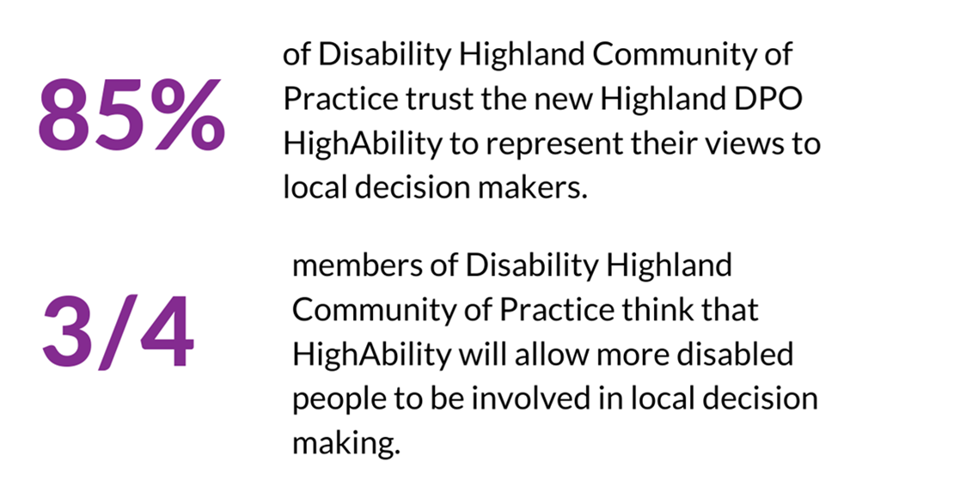
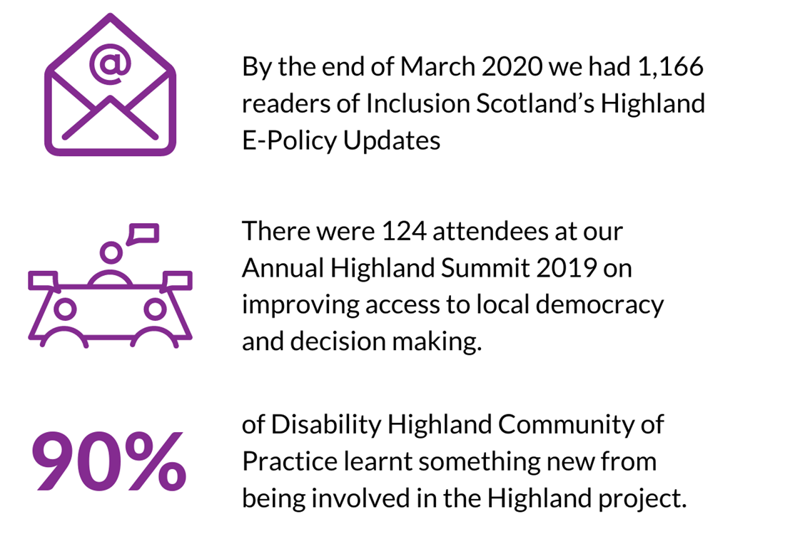

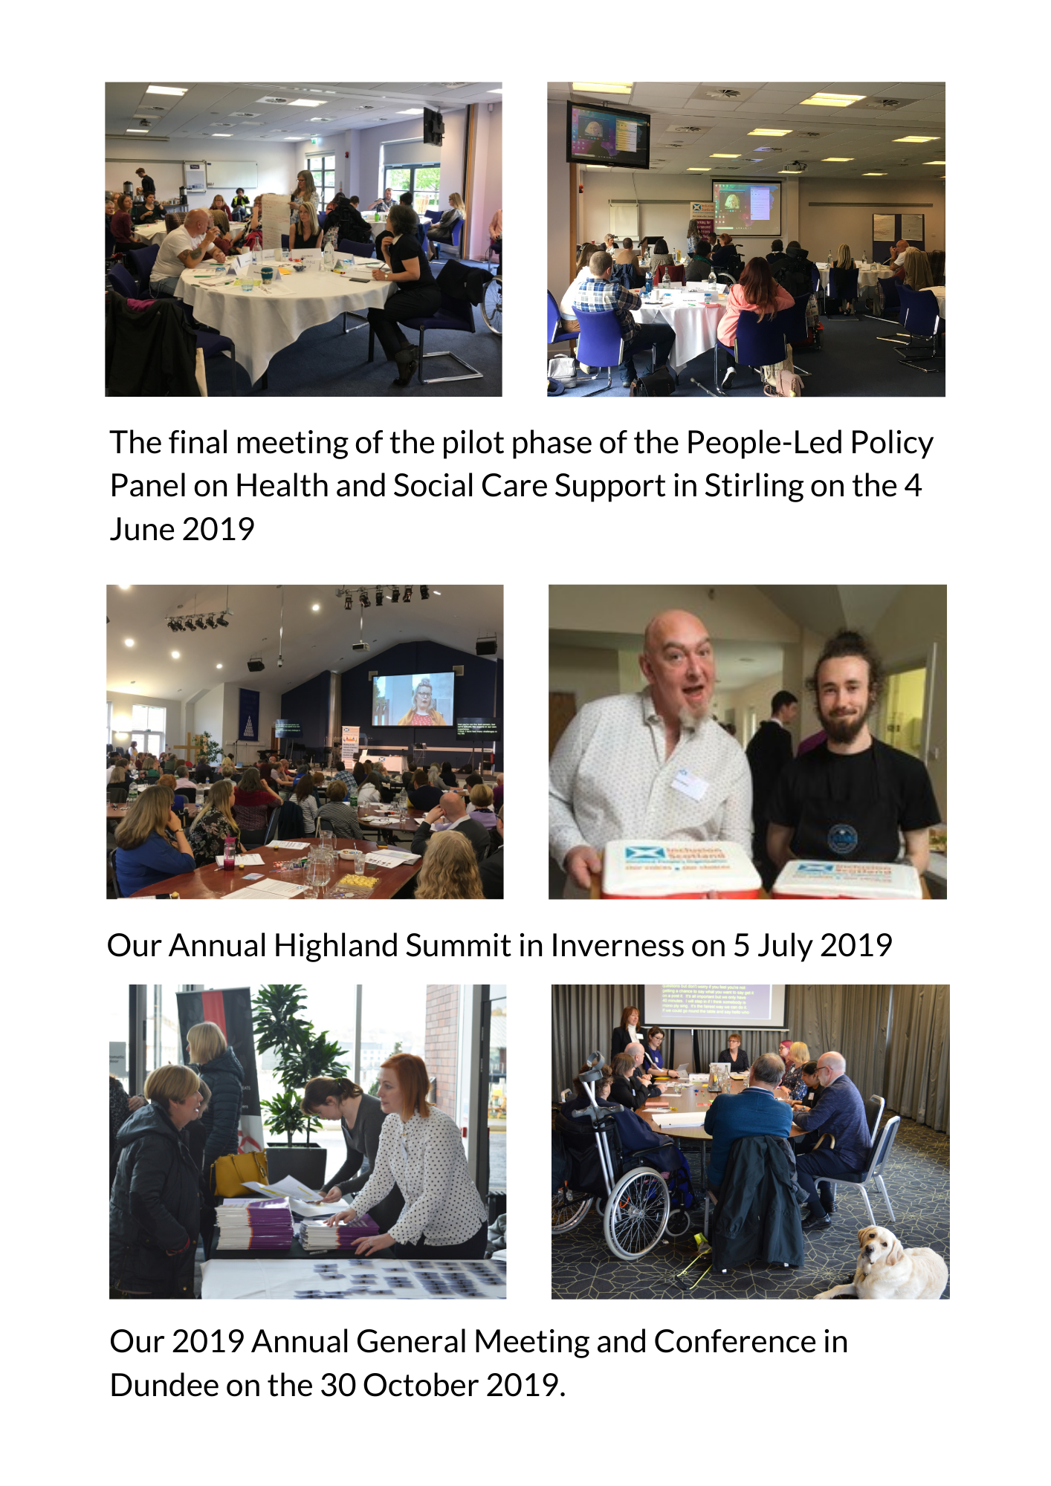
Events
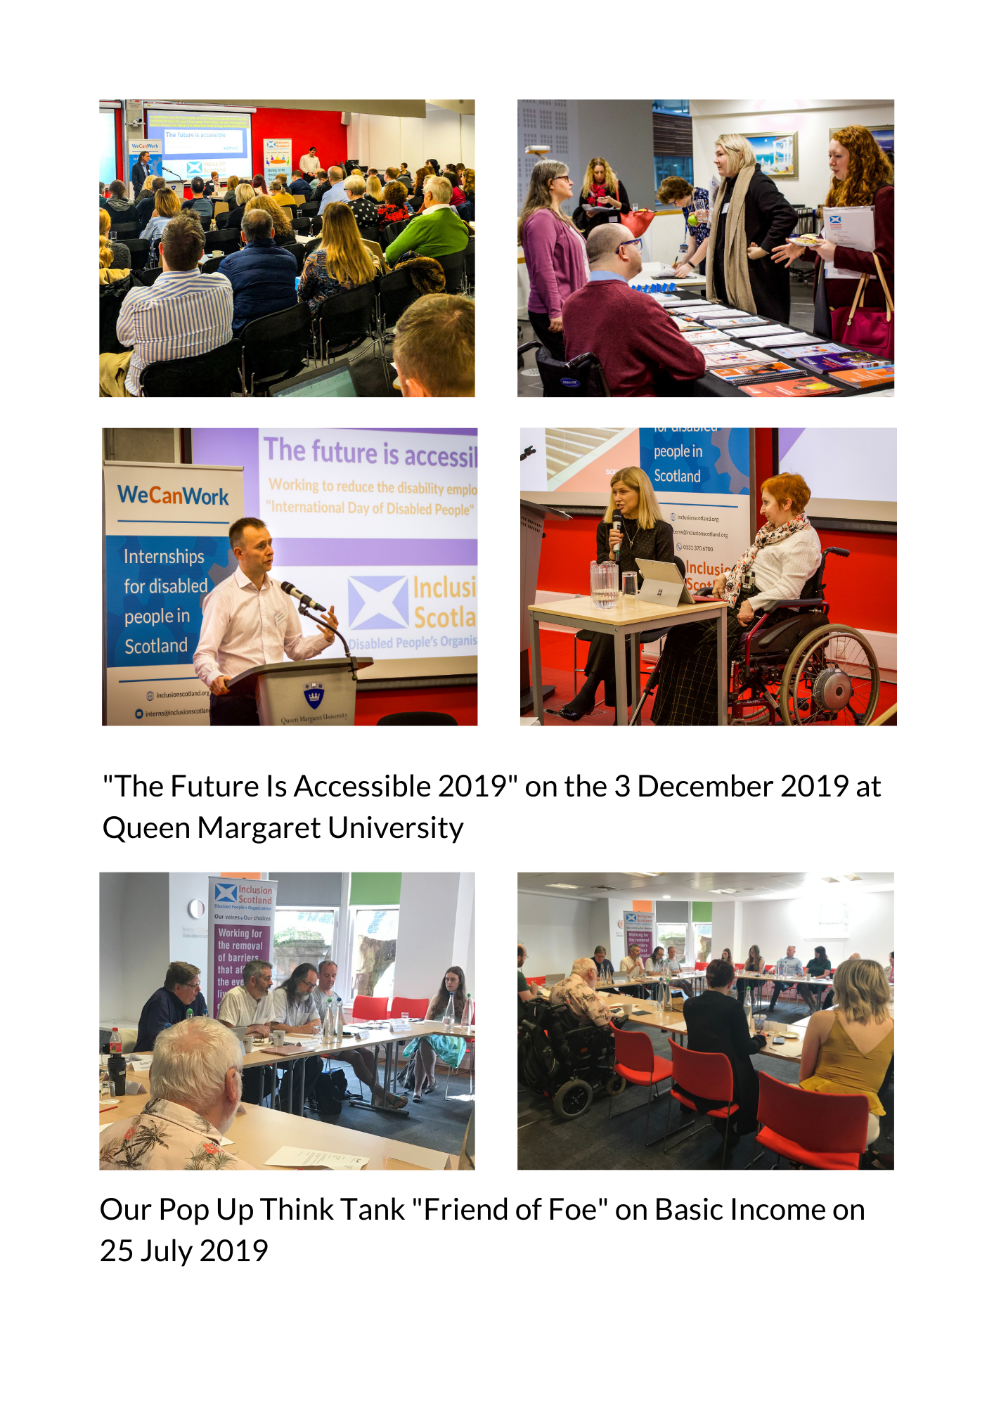

Finance
Summary of Financial activity - For the year ended 31 March 2020
Income | 2020 | 2019
 | £ | £
Donations and legacies
Donations | - | -
Scottish Government Grants | 412,274 | 414,500
Department of Work and Pensions | 23,572 | 31,339
 | -------------- | --------------
 | 435,846 | 445,839
Project activities
Grants | 459,705 | 595,946
Other income | 16,491 | 5,807
 | -------------- | --------------
Total income | 912,042 | 1,047,592
 | -------------- | --------------
Expenditure
Charitable activities
Staff salary, NI and pensions | 826,631 | 752,078
Temporary staff | 9,117 | 1,100
Training expenses | 14,358 | 5,982
Travel and subsistence | 46,008 | 37,343
Events costs | 31,701 | 34,649
Postage, stationery and publicity | 8,106 | 12,988
Rent | 73,147 | 62,584
Rates | 5,914 | -
Other operational costs | 140,838 | 69,678
 | -------------- | --------------
 | 1,155,820 | 976,402
 | -------------- | --------------
Support costs
Recruitment costs | 2,385 | 2,743
 | -------------- | --------------
Governance costs
Auditors' remuneration | 4,680 | 4,500
Auditors' remuneration for non audit work | 7,064 | 2,400
Legal and professional fees | 10,421 | 10,454
 | -------------- | -------------
 | 22,165 | 17,354
Total expenditure | 1,180,370 | 996,499
 | -------------- | -------------
Net (expenditure)/income | -268,328 | 51,093
Adjustments for:
Debts owed by us | -38633 | -20733
Credits due to us | 230551 | 42258
 | -------------- | -------------
Net with debtors and creditors: | -76,410 | 72,618
 | -------------- | -------------

Board
Terry Robinson, Convenor
Leo Starrs-Cunningham, Deputy Convenor
Gillian Lawrence, Treasurer
Andrew Mason
Derek Kelter
Fiona Kumari-Campbell
Irena Paterson
James Elder-Woodward
Kirstein Rummery
Michael Greaves Mackintosh
Ryan McMullan
Taryn Cotton

Thank You to:
- Robert McGeachy of Camphill Scotland and Kim Hartley Kean of the Royal College of Speech and Language Therapists for their partnership work on Inclusive Communications.
- Our People-Led Policy Panel for sharing their lived expertise and contributing to the Scottish Government's reform of Adult Social Care Support
- Clare Mills of Listen Think Draw, our graphic facilitator for the People-Led Policy Panel
- All members of the Lived Experience Leadership (LEL) advisory group for their support and work to help set up the Lived Experience Leadership Project.
- Kirsty Watters, Access All Areas Leadership network which became the LEL advisory group; and SCVO for setting up the internship and providing support.
- Scottish Government Public Appointments Team and the Ethical Standards Commissions for their partnership and support in the Public Appointments Shadowing Project.
- Electoral Commission for their continual support and commitment to making politics more accessible and inclusive of disabled people.
- The Political Parties in Scotland for their commitments to the Access to Politics Charter and the continuation of the Access to Elected Office Fund.
- Queen Margaret University for hosting our The Future Is Accessible event.
- Skills Development Scotland and STV for taking part in The Future Is Accessible event in December.
- Thanks to Word Up Communication for their media training.
- Thanks to Liz Kingsnorth for Non Violent Communication training.

