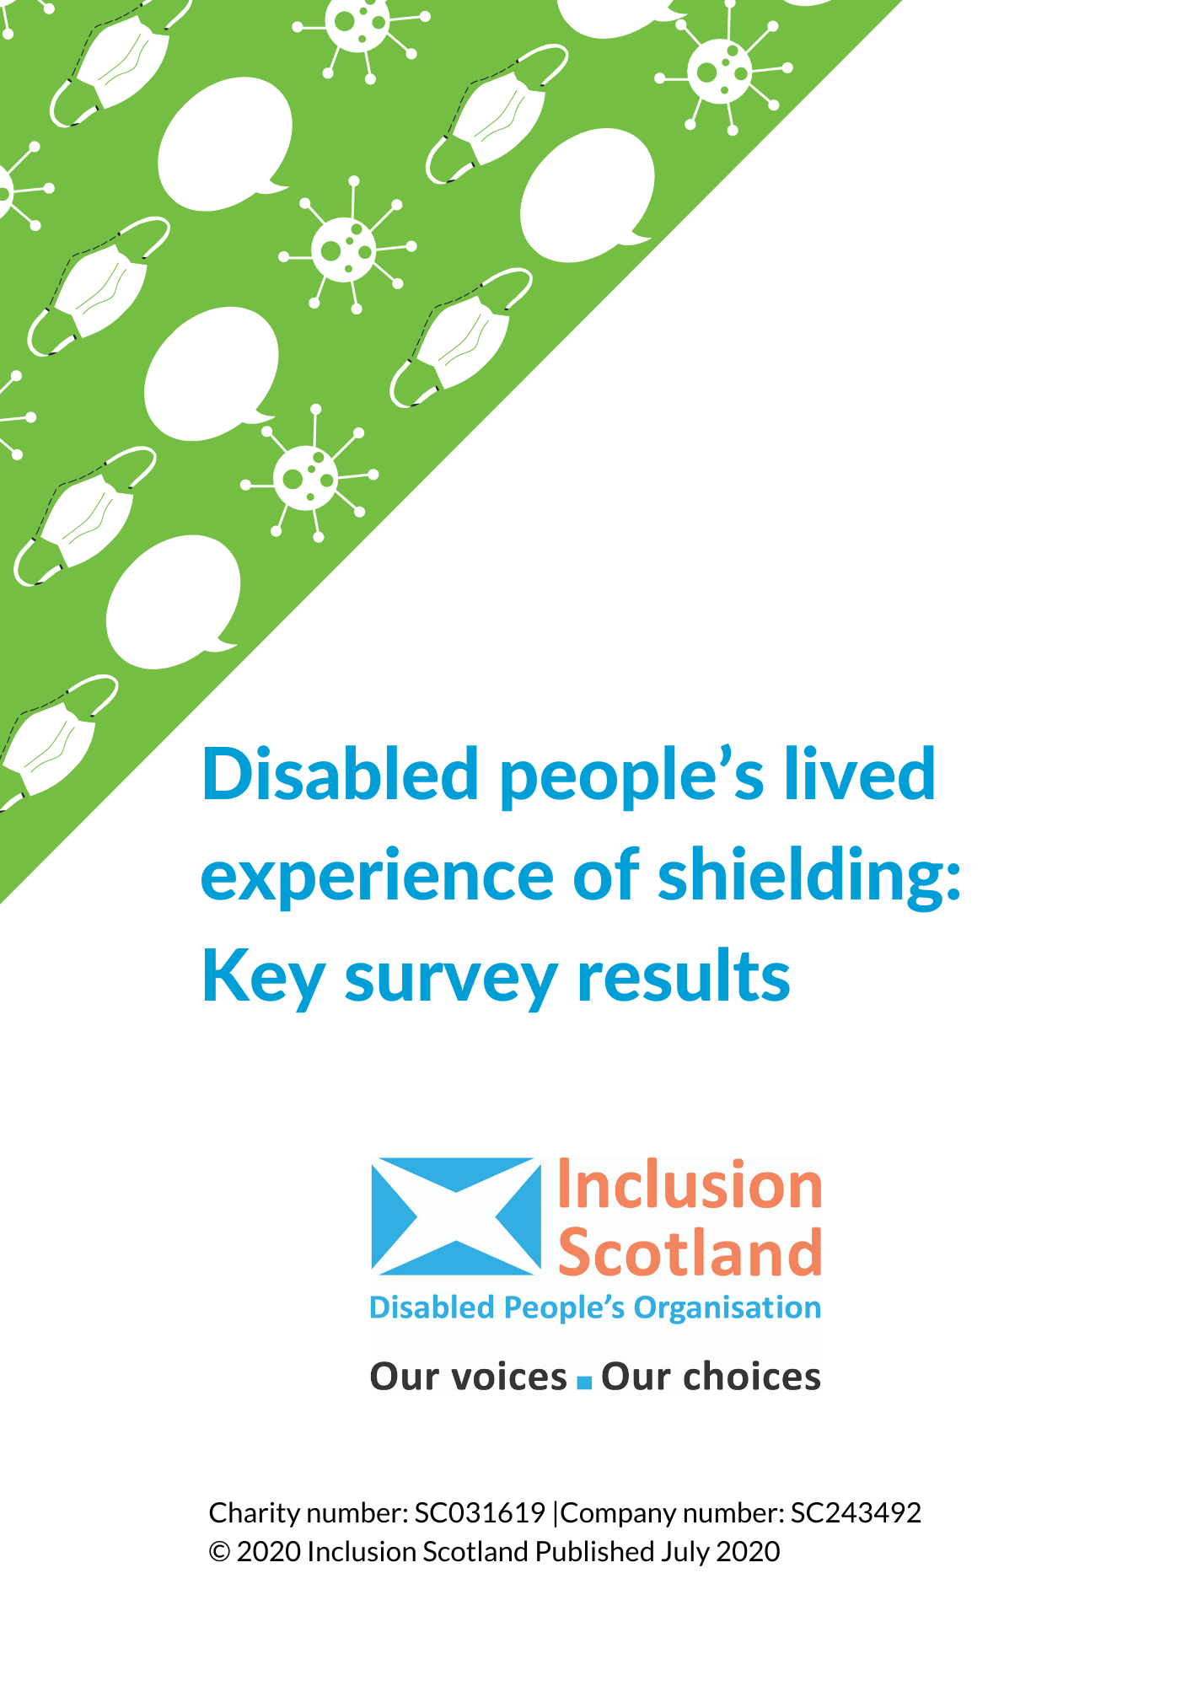

Between 19th June and 3rd July 2020 Inclusion Scotland surveyed disabled people to find out about their experiences of shielding.
Respondents to our survey have been deeply affected by their experiences of shielding during the pandemic. Many stated that they felt left behind or abandoned and that services which are supposed to be there to support people failed as a result of the crisis. There was also a feeling that people who are shielding could be left behind as restrictions are lifted for the general population.

135 people responded to our survey. Over half 55% were shielding without a Chief Medical Officer (CMO) letter, the remaining 45% had a CMO letter.
Almost all of the respondents who were shielding without a letter were doing so because of medical conditions including asthma, multiple sclerosis, fibromyalgia, kidney disease, cerebral palsy and others. Around a fifth of these respondents said that they had been advised by medical professionals to shield, yet they never received a CMO letter. This caused confusion and stress for people who can’t understand why they have been told to shield yet haven’t been acknowledged as requiring support to do so.

1. Some people who are shielding still aren’t getting the support they need

Over half of respondents who are shielding without a letter (56%) said that they have not had access to the support they need. For many respondents this has resulted in highly stressful experiences, particularly in the early days of the crisis, when they were trying to put support in place on their own.

People without a letter also report that they are still having issues accessing the food and medicine that they need because of difficulties such as getting delivery slots with supermarkets, and with keeping these slots, not being able to source foods for dietary requirements, and items being sent with short shelf-lives.

“Impossible to get to supermarket at 8am. Can't queue. Can't get shopping online.”

“I rely on my sick partner to get me special food as I have heart disease and need a special diet I also can’t eat gluten or I collapse unconscious and I’m allergic to cow’s milk also so it’s been and still is a nightmare.”

“Shopping can be difficult as major supermarkets have huge waiting lists for delivery service and I have nothing to prove that I would be benefit from that service or that I should be a priority. I am in a lot of pain at the moment so walking round a supermarket is not possible.”

People who have no access to official support and are relying on family members, friends or neighbours are worried about how long they can rely on this type of informal support, especially as restrictions are lifted and people begin to return to work:

“I have to rely on extra financial support from family to be able to move out of my shared accommodation and into somewhere safe. I have to rely on friends to bring me medications and groceries - all fine now but what happens when they all go back to work and I have no access to extra support?”

Over three quarters (78%) of respondents without a letter told us that they have not used the Scottish Government helpline for people needing additional support. For those who had used the helpline, more people reported having negative rather than positive experiences – the main issue appearing to be unclear messaging over who is entitled to support:

“I rang for some advice and the young man who answered said he didn’t really know the answer to the question, and said additional support didn’t apply anymore to those who needed the flu jag for medical reasons “it did at the beginning but not now”.

Our asks
- review the criterion and the limitations of the CMO letter so that those who need to shield can access the guidance and support to enable them to do so safely;
- issue guidance and advice which fully takes account of the needs of those who are continuing to shield to support them to make decisions about the need to continue and about how to access support;
- increase awareness of available helplines including the Scottish Government’s helpline;
- include disabled people and our organisations in contingency planning in the event of a second wave of the pandemic so that the Helpline and other official support is known about, accessible and meets needs;
- extend the range of support in place;
- put standards in place for this support, such as on quality of food and availability of special diets.

2. People who are shielding are very concerned about the long-term impact on their physical and mental health

People have been shielding for more than 3 months. The impact of this on people’s health has been significant. Many respondents spoke about the loss of health care appointments and treatments which is causing distress and concern about deteriorating health.

Shielding also means that people are unable to exercise in the ways they usually would and are experiencing the mental health impacts of long-term isolation from friends and family.
These factors all have the potential to result in declining physical and mental health for some people, and some people are already reporting to us that their mental and physical health has been negatively impacted as a consequence of shielding.
“My concerns are over gaining access to rescheduling cancelled hospital appointments and treatments. I have a progressive disease and feel further deterioration has occurred. I am worried about catching up within the NHS.”

“Initially filling each day about the house and garden but recently just being lazy & no energy, have had ongoing health issues throughout which I feel has been aggravated with not getting enough exercise & stimulation. Really missing my family now as time has gone on.”

“I have also struggled with all my specialist appointments being cancelled. The first couple at the beginning of the pandemic, in March and April, were made into Telehealth appointments, which I appreciated, but all my other appointments have just been canceled with no consultation. I’m also still on the wait list to other specialist departments and haven’t heard anything. It’s very frustrating having to continue putting up with symptoms and problems that should have been reviewed, and never knowing when is the right point to push for more help - since I don’t have a shielding letter I worry I won’t be offered the right support, and will just be told to go in to see my GP. I understand that NHS in incredibly overwhelmed, but that’s a problem entirely of our making. If we didn’t continually cut funding and de-prioritise health care, we would have a system that could cope. I struggled with waitlist times before this, now I know I’m going to be left dealing with some of my symptoms for an extra year or more.”

“No day service for me to go too. Not seeing family has been really hard but the worst has been not being able to see anyone from NHS to fix my broken wheelchair which has increased horrendous spasms for me.”

“Cannot get to swimming or the exercise groups i was doing before lockdown. this was improving my health mobility and fitness and now that i haven't been able to do it ive got stiff painful joints and put on weight and can hardly move around without getting so tired”

Our asks
- Inform people about the reopening of health care and treatment and what they need to do;
- ensure that people who continue to shield can safely access leisure and exercise facilities to help them to manage their condition;
- Issue guidance to clinicians about prioritising appointments and making reasonable adjustments for those who continue to shield.

3. People who are shielding are worried about going back to work.

As restrictions are lifted and people start to go back to work, those who are shielding are worried about how their job will be impacted. Concerns include: people don’t know when it will be safe for them to return to work; some people have been unable to work from home – can their jobs be secured if they cannot return?; finding work if they are shielding; family members returning to work which could put them at risk; the financial burden of potentially losing work as a result of shielding.

“I'm fortunate that I've continued working from home but not ideal. I've no idea when I can go back. When will it be 100% safe? I cannot risk getting Covid because I'm high risk in many categories. My job could be at risk if it goes on for long time.”

“My partner has to return to work as a bartender on the 15th and with bars being high risk places due to handling of glasses etc, and a tight area for staff behind the bar, putting my life in the hands of drunk people choosing to follow guidelines is terrifying for me.”

For those shielding without a letter, there are real concerns that not having proof in the form of a letter will mean that they will be unable to negotiate with their employer.

“I am starting to feel very anxious about the confrontation I know is coming regarding returning to pre-covid working.”

“I had a difficulty with my employer. I initially had agreement to work from home. Then, as a key worker, I was told to return to work. I had to refuse. Finally, home working was agreed again, with support from my husband's nurse. I have now put in my notice and am retiring to avoid going through this again.”

“A shielding letter would have been more helpful I do have understanding employer however I didn't have any proof that I needed to shield, if I had been asked to return to work I had nothing in situ to recognise that I had to shield.”

Our asks
- Clear advice to employers on how they can further protect shielding workers and workers who live or care for with people who are continuing to shield, and their jobs;
- work with the UK Government to ensure that the furlough scheme does not discriminate against disabled people and those who care for them;
- ensure that advice and support organisations have the capacity to support these groups.

4. Coming out of shielding is not going to be easy.

We asked people about how they felt about new government guidance for people who are shielding. Responses were mixed, with some respondents telling us that they did not feel it was safe enough to go out yet, and others telling us they would still be very cautious about doing so. A small number of people told us there were barriers preventing them from taking the advice. This included things like needing assistance to leave the house, and not having enough money to take taxis to visit family members as public transport was no longer an option.
“It is progress, but we need to able to have close family visit, I am not physically fit enough to go outside apart from in a wheelchair, so it makes everything very difficult for me.”

The main thing people told us that they need to be able to make an informed decision to stop shielding is the level of risk. People want reliable information about what the rate of infection is, how many people are still dying and specific information about risks associated with their own condition(s). A small number of respondents told us they won’t stop shielding until there is a vaccine. People have been told they are at high risk if they contract Cvoid-19 and they rightly want evidence that these risks are reducing before they will feel safe to stop shielding.

“The R-number being as low as possible for a long enough period that it is safe, my medics agreeing that I can return to community safely.”
“Vaccine, more widespread testing, knowledge about where people have been over lockdown and if they have 100%been shielding.”

Respondents noted the need for support and guidance for people to be able to stop shielding safely. This includes things like the reinstatement of social care support; advice for carers on how to support people who are stopping shielding; advice about specific medical conditions; advice on how to minimise risk; information on how to access to PPE especially when out and about.

Respondents also told us about their worries about going outside and the general population not following physical distancing rules. This is impacting on people’s decision about whether it’s safe to stop shielding.

“I also don’t trust the general public to keep 2 meters distance from me - it’s not like they can magically tell I’m shielding, but also even just watching from my window I can see people making less and less effort to follow distancing advice. I worry that people think it’s just business as usual now.”

Our asks
- urgently reinstate social care support that was reduced or taken away during Covid-19;
- provide specific advice and guidance to unpaid carers on how to support someone coming out of shielding;
- provide guidance on how to minimise risk if you have been shielding;
- provide accessible information and guidance about, and reliable and consistent access to, Personal Protection Equipment (PPE)

5. People with and without letters have been deeply affected by their experiences during the pandemic

Respondents told us they felt left behind or abandoned and that services which are supposed to be there to support people failed as a result of the crisis. There is also a feeling that people who are shielding could be left behind as restrictions are lifted for the general population. Some respondents also talked about their fears of the possibility of a second wave and potential reoccurrence of the significant issues they experienced

“I have found it hard, but worry we might have to do this on a regular basis. As a high risk person, terrified of needing to go to hospital where I believe I will not receive equal care, based on my health status.”

“The plight of disabled people and unpaid carers has been largely ignored...the devastating cuts in social care, what happens to disabled children..the fact that nothing has really been done to support family carers who are doing far more. We feel abandoned...as if we dont matter.”

“What happens when Scotland returns to semi-normal? Will we be forgotten about?”

“This is a terrible time for us all but more so if your disabled been locked away like an animal it's felt like it's been awful especially if you also have depression.”

“Still concerned that if I get the virus then I will be a burden. Feel that the criteria for those recommended to shield, and receiving letters, should have been broader. Not just myself, but many people seem to have been left off the list. Luckily I had the energy and determination to sort out what was needed.”

Our asks
- Involve disabled people and our organisations in contingency plans for a second wave (and other potential future disasters and emergencies);
- Keep people informed about when respite centres and supported short breaks will resume, and take steps to prioritise the re-opening of these, and interim steps to provide alternatives to respite breaks

