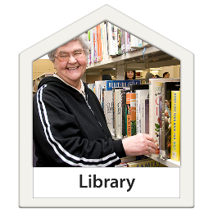  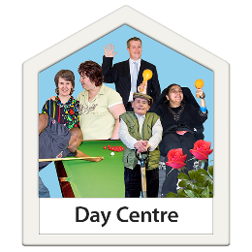 | Cuts to council services – disabled people’s experiences
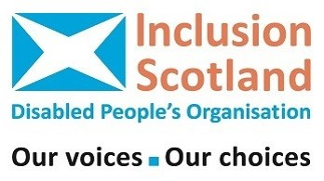   | Report by Inclusion Scotland  May 2023
     | Council services are very important for disabled people. This includes things like social care support, day centres, swimming pools and libraries,  We have heard that council services that disabled people use are being cut.  This is very worrying because disabled people are already having lots of problems because of the cost of living crisis. Many disabled people are finding it difficult to meet their basic needs.
    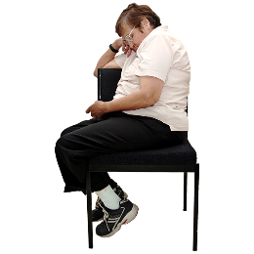  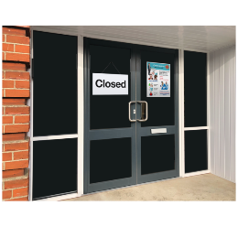  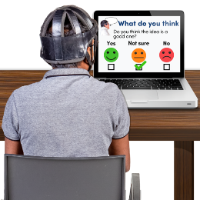     | Inclusion Scotland did an online survey from 30 January 2023 until 8 February 2023.  The survey asked disabled people about what council services have been cut in their area.  42 people answered the survey questions.      This report is a short summary of what people told us:  - Disabled people who answered the survey are having problems getting the council services they need.    - Disabled people who answered the survey said there are barriers that stop them accessing council services.    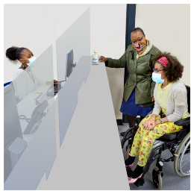  - Disabled people who answered the survey said the coronavirus pandemic has made it harder to get access to council services.
 | - Disabled people who answered the survey are having problems getting the council services they need.
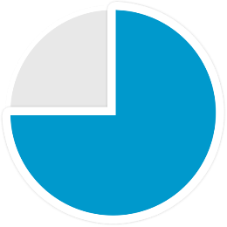   | Most people (71%) answering the survey said that they are having problems accessing services from their local council that support them as a disabled person.  People said there were different services that they were struggling to access including:  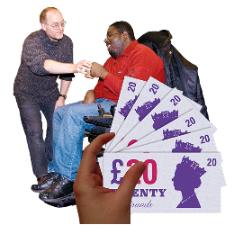  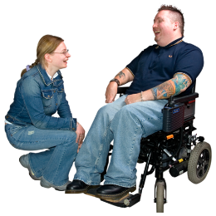  • Support services  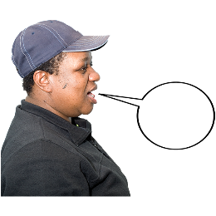  Someone said: “I’ve been fighting cuts to my SDS support for months now with legal support.”  • Day centres, swimming pools and libraries  Someone said: “Access to day centre”  Someone said: “Library services in our area are too far away and not well served with parking.  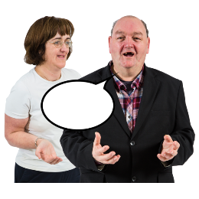  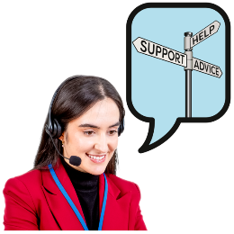  • Advice and advocacy  Someone said: “My family have been waiting two years for the Advocacy Service. They do not have staff or money to meet demand so cannot support us.”
 | - Disabled people who answered the survey said there are barriers that stop them accessing council services.
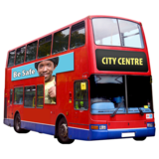   | People said these things stopped them accessing council services:  Service has shut down – 5 people said this  Service has reduced operating hours – 7 people said this  Not able to get transport to go to the service – 5 people said this  Not able to get in contact with the service – people said this  Something else – 22 people said this
   | People said there were other things that stopped them being able to get access to council services:  • Cuts to services  Someone said: “They have cut face to face appointments to a few hours once a week in Troon. Then you have to make an appointment before hand. They used to be open for face to face stuff 5 days a week and you could just "walk in" without making an appointment.”  • People providing services don’t know enough  Someone said: “I don’t think social work know what SDS is. I think they think it means personal care. I want so much more than that. I want to live. I want to be able to take part in the world. I want to contribute. I want to do things I love.”  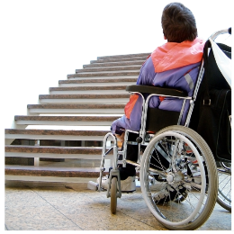  • Services are not accessible  Someone said: “All services are now online and most people cannot access them as they do not use any online service.”  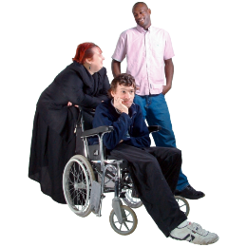  • Staff have poor attitudes  Someone said: “Nothing much other than to say accessing council services can be made more difficult by council workers failing to meet the needs of disabled people.”
 | - Disabled people who answered the survey said the coronavirus pandemic has made it harder to get access to council services.
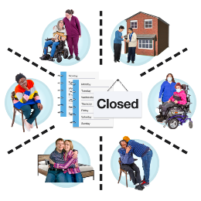 | Most people said that the coronavirus pandemic had made it even harder to access council services.  Some people said that the pandemic is being used as an excuse for cutting services.  Someone said: “Made worse as I feel a lot of the time Covid is made as an excuse for people not to do anything for you or to provide a satisfactory service.

 | Contact us
     | If need this report in another format you can visit our website – www.inclusionscotland.org  If you have any questions or comments you can phone us on 0131 370 6700 or email us at research@inclusionscotland.org
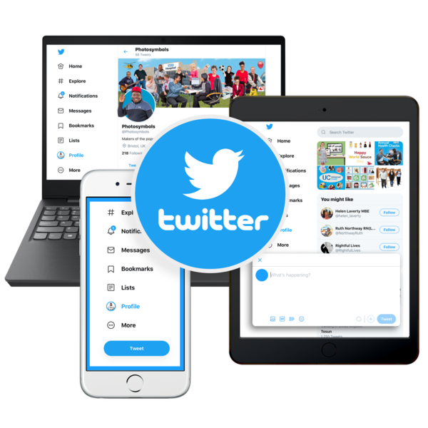     | You can follow us on social media:  www.twitter.com/inclusionscot  www.facebook.com/inclusionscot  www.Instagram.com/inclusionscotland
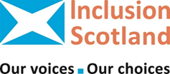 | You can keep up to date with Inclusion Scotland’s work by becoming a member, it’s free!  Visit our website for more information.

