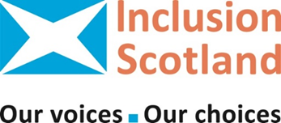  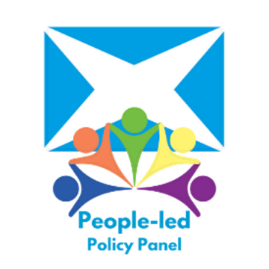 | Volunteers needed!  Inclusion Scotland runs a group that speaks to the Scottish Government about the future of social care support.  The group is called the People Led Policy Panel (PLPP).  The PLPP is looking for new members.
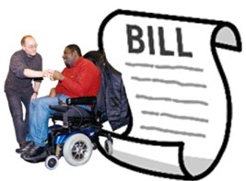  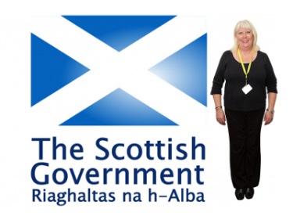 | The PLPP has been working with the Scottish government on the National Care Service Bill.
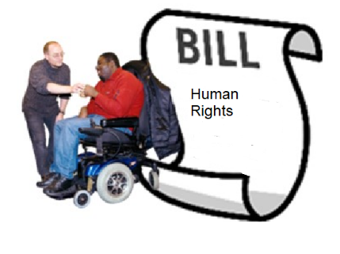 | The PLPP want a new social care support system based on human rights and equal citizenship.
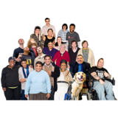 | We are looking for 15 people to join the group who use social care support or care for someone else who uses social care support.
 | We need more members to make sure we have people with different experiences of social care support on the PLPP.
  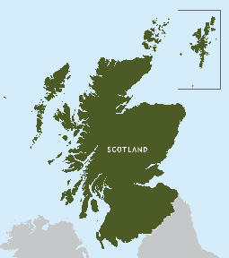 | We are looking for a mix of people from all over Scotland.
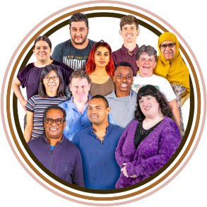 | We are looking for Black, Asian or Minority Ethnic (BAME) supported people or carers.
   | We would like you to apply if you are a Deaf, Deafblind, deafened, hard of hearing or visually impaired and need or use social care support.
    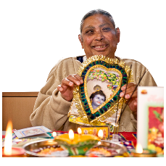  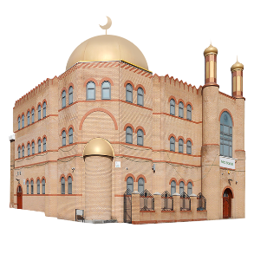 | We are looking for supported people or carers from different faiths.
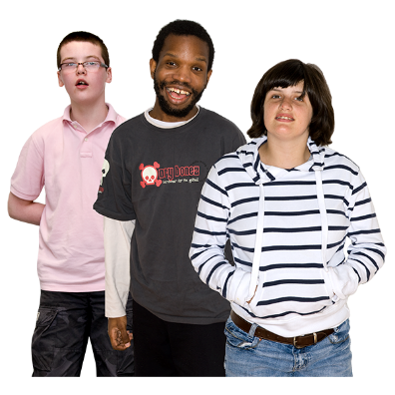 | We are looking for young people aged 18 to 28 who have experience of using adult social care support.
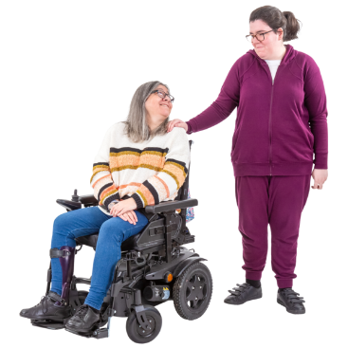 | We are looking for young carers aged 18 to 28 who have experience from a young age of providing unpaid care for a friend or family member who uses adult social care.
   | We would like people who have experience of Dementia to apply.  This can be as a person who has Dementia or an unpaid carer of someone with Dementia.
 | We would like people to apply if they a supported person and also lesbian, gay, bisexual or transgender.
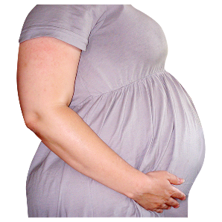  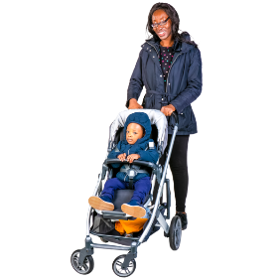 | We would like supported people to apply who have recent experience of pregnancy or maternity.
 | We would like supported people to apply if they live in the Western Isles, Orkney, Shetland or another island community
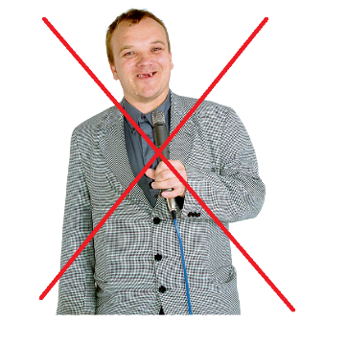 | You do not need to have any experience of talking in public.
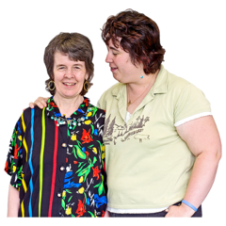 | We will give you support.
 | We will give you training.
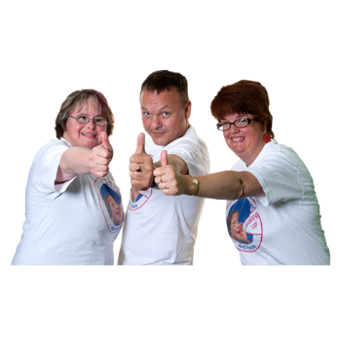 | You will get peer support from other members of the Panel.
 | You will need to listen to other people’s views and respect them.
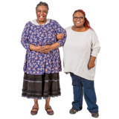 | We can then make everyone feel safe and respected.
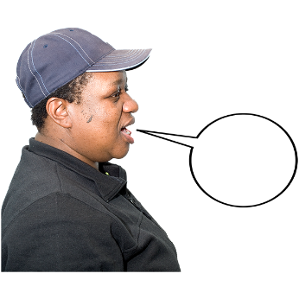 | The main purposes of this voluntary role are to:  - Share your experiences of using or trying to use adult social care support in Scotland
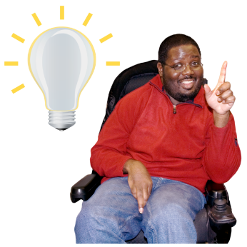 | - Put forward ideas and solutions to improve adult social care support
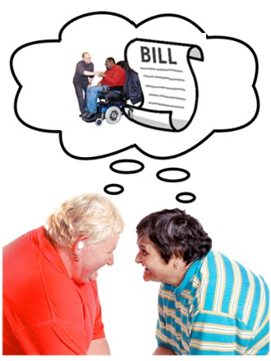 | - Provide feedback to the Scottish Government about its National Care Service plans.
   | - Help us promote this way of working together, called co-production.  Co-production is when people work together as equals to make something.
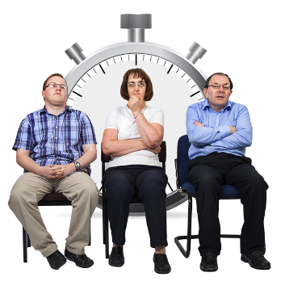     | How much time will this take?  The Policy Panel meets every 6 – 8 weeks for about 2 hours.  You may sometimes be asked for your views or ideas at other times.
 | There may also be additional meetings to attend for training.
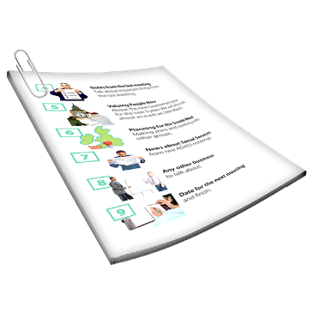 | There will be papers to read between meetings.  These can be provided in accessible formats.
 | We can support you to go through the papers before and after meetings.
   | The PLPP is meeting on zoom at the moment,  but we may have some face to face meetings in the future.
 | You will need a computer, tablet or smart phone.
 | We have some money to pay for costs to help you access and take part in meetings.
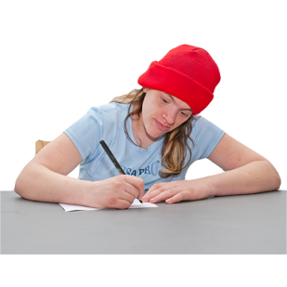  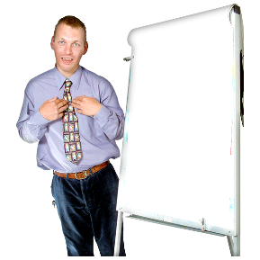 | What now?  If this sounds good to you, please fill in an application form.
   | We can email you the form and you can download it and email it back to us.  or you can download the form on Inclusion Scotland’s website.
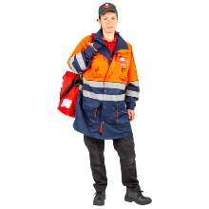  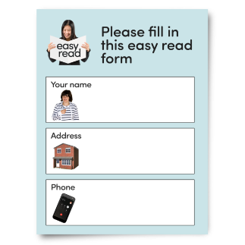 | We can also send you an application by post.
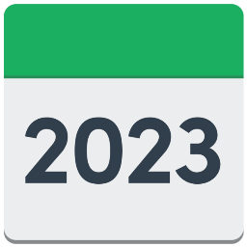   | We need your applications by  Wednesday 4 October 2023.
   | Please get in touch if you would like a form sent to you, want support to fill in the form or if you want to find out more about the role.
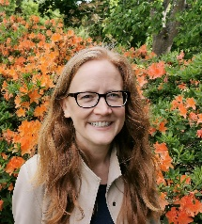   | The people to talk to at Inclusion Scotland are:  Lisa Ehlers  People Led Policy Officer  Telephone  0131 370 6719  Email  lisa@inclusionscotland.org
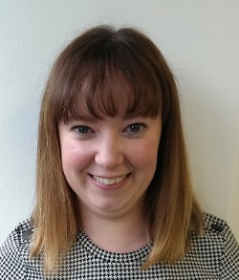 | April O’Neil,  Leadership and People-led Policy Worker.  Telephone 0131 370 6718  Email  april@inclusionscotland.org
 | Inclusion Scotland  22-24 Earl Grey Street  Edinburgh  EH3 9BN
  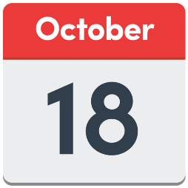 | We will let you know within 2 weeks of the closing date if you are chosen.  Wednesday 18 October 2023
 | If you are not selected it will just be because we have a limited number of places available.
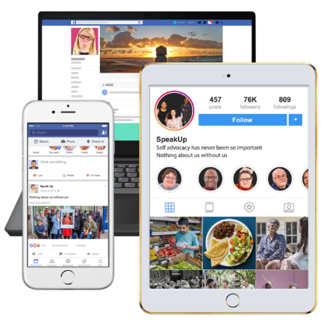 | Inclusion Scotland has other chances for you to take part.  You can find out more by becoming a member for free or follow our social media accounts.
 | Made by Inclusion Scotland using Photosymbols.

