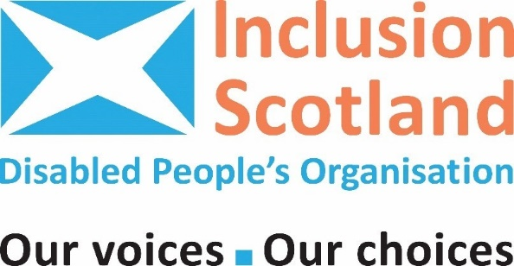
Programme

Inclusion Scotland’s Annual General Meeting 2022 and Conference

The Annual General Meeting and Conference are on Thursday 2 February 2023

We will call the Annual General Meeting the “AGM” in this Programme.

Our Conference in the afternoon is called
“Stacked Against Us”
The Conference is about disabled people, poverty and the cost of living crisis.

Contents

- About the AGM and Conference

- Agenda for the AGM 2022

- Agenda for the Conference “Stacked Against Us”

- Inclusion Scotland is 21 years old

- Tell us what you think about the AGM and Conference

- Help with coming to the AGM and Conference
Do you need to claim money to help you come to the event? Do you need help to use the Zoom? Do you use captions or British Sign Language? Look in this section for help.

- Where to get advice and support about money

- How to get in touch with Inclusion Scotland

- About the AGM and Conference
Welcome to Inclusion Scotland’s AGM and Conference.

The AGM is where we carry out all the business we must do as a charity.
We will write a note of the AGM.

The Conference is called “Stacked Against Us.”
At the Conference we will hear about disabled people's poverty and the cost of living crisis.

The cost of living crisis means how much things cost and how much prices are rising.
It is a crisis because people cannot afford to pay for the things they need.

We will talk about this and think about things that we can ask Scottish Government to do.
We will write a report about the Conference.

When is the AGM and Conference?
Inclusion Scotland AGM and Conference is on Thursday 2 February 2023.

The AGM is from 11.00 to 12.00.
There will be a break for lunch from 12.00 to 12.45.
The Conference is from 12.45 to 16.00.
There will be a break in the middle of the Conference.

Where is the AGM and Conference?
The AGM and Conference will be held online.
You have been sent a link to join the meeting. The link is also in Section 6.
You can find information to help you join the meeting in Section 6.
Do you use British Sign Language or captioners? You can find out how to see the BSL interpreter or the captions in Section 6.

The #hashtags we will use at the Conference
We will post messages about the Conference on social media.
We use hashtags on social media. Hashtags help us to link up with other messages with the same hashtag.
You can see what Inclusion Scotland says on social media. Look at the details on the last page of this Programme.

We will use these hashtags -
#InclusionScot because we are Inclusion Scotland.
#StackedAgainstUs because this is the name of our Conference.
You can use these hashtags on social media to talk about the Conference.

Agenda for the AGM 2022

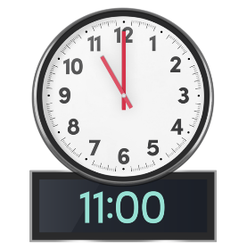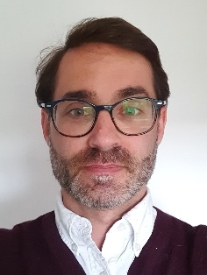 | Welcome from Leo Starrs-Cunningham, Convenor and  Michelle Cook, Interim Deputy Chief Executive Officer, Inclusion Scotland.  Leo will chair the meeting.
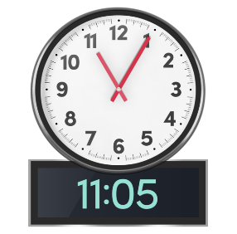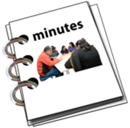 | Agree minutes from 2021 AGM and any matters arising.
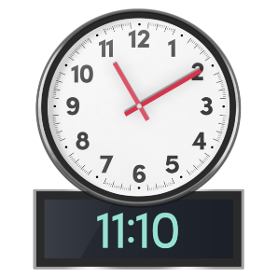 | Report from Inclusion  Scotland’s Convenor,  Leo Starrs-Cunningham.
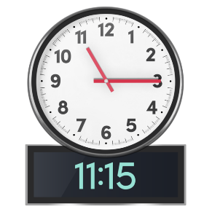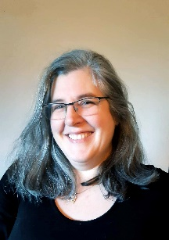 | Report from Inclusion Scotland’s Interim Deputy Chief Executive Officer, Michelle Cook.
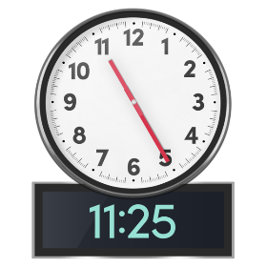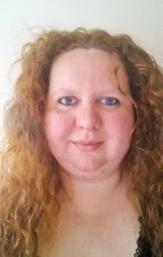 | The Annual Accounts. Inclusion Scotland’s Treasurer, Kim Dams.  The Annual Accounts were sent to you before the AGM.  You can also see them on our website https://inclusionscotland.org/about-inclusion-scotland/agm-and-conferences
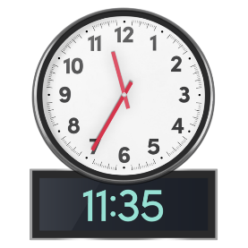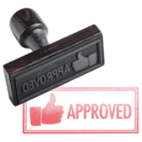 | We will agree who will be our auditors for next year 2023.
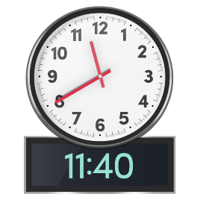 | We will elect new Directors to the Board.
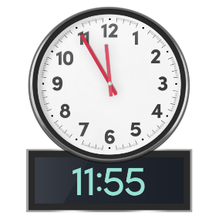 | Any Other Business
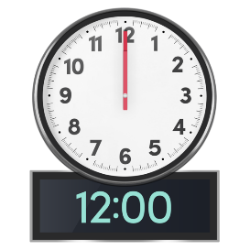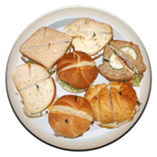 | End of AGM.

12.00 to 12.45 Time for lunch.

3. Agenda for the Conference “Stacked Against Us”

The Conference is called “Stacked Against Us”.
It is about disabled people, poverty and the rising cost of living.

The Conference starts at 12.45.
The Conference is on the same Zoom link as the AGM.

12.45 – 12.55 Welcome
Michelle Cook, Deputy Chief Executive Officer will Chair the conference.
We will learn about help to take part in the Conference.
Michelle will tell us about what we will do today.

12.55 – 13.15 What is happening to disabled people in Scotland today?
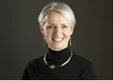
Lindsay Graham OBE is the Deputy Commissioner for the Poverty and Inequality Commission. She will talk to us about disabled people, poverty and the cost of living crisis.

13.15 - 13.30 What work is Inclusion Scotland doing on poverty and the cost of living crisis?
We will talk about the work that Inclusion Scotland is doing.

13.30 – 14.00 Ben Macpherson Minister for Social Security and Local Government
The Minister will speak to us about what Scottish Government is doing and answer questions.
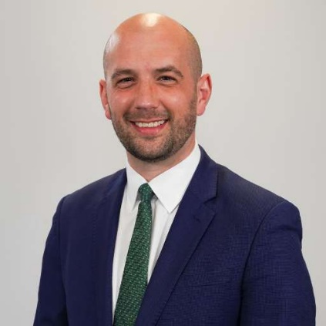

14.00 – 14.05 Break
There will be a short break. We will be moved into a workshop group. Stay on the Zoom link.

14.05 to 14.45 Workshop 1 – Stacked Against Us
We will talk about poverty and the cost of living crisis and what it means for you.
You will be put into a workshop group on Zoom. You do not need to do anything.
Each workshop will have someone to help lead the discussion.
Each workshop will have someone to take notes.
If you need a British Sign Language interpreter or a captioner they will be in your workshop too.

Here are questions to talk about in workshop 1 -
- What is happening to you because of the cost-of-living crisis?

- Is it difficult to pay for things you need help with because of your impairment or health condition?

- Can you get the advice and support you need?

- What are you most worried about for winter?

14.45 to 15.00 Break
We will have a 15-minute break. Stay on the Zoom link.

15.00 to 15.45 Workshop 2 – What needs to be done?

We will talk about what needs to change to help disabled people through the cost of living crisis.
You will be put into a workshop group on Zoom. You do not need to do anything.

Each workshop will have someone to help lead the discussion.
Each workshop will have someone to take notes.
If you need a British Sign Language interpreter or a captioner they will be in your workshop too.

Here are questions to talk about in workshop 2 –
      - What do you think about the ideas we have spoken about?

      - What other ideas do you have?

15.45 – 16.00 Inclusion Scotland is 21 years old!
Michelle will tell us about what Inclusion Scotland has done in our first 21 years.
We will talk about what Inclusion Scotland will do next.
Tell us your ideas!

16.00 The end of the Conference
Michelle will tell us about what happened at the Conference.
Goodbye and we look forward to seeing you at next year’s conference.

4.Messages of support for Inclusion Scotland from our friends and people we work with (Autumn 2022)
Inclusion Scotland is 21 years old. We asked our friends and members what they thought about us. This is what they told us.

Dr Ann Wilson is the Chair of DGVoice. Ann helped to set up Inclusion Scotland.
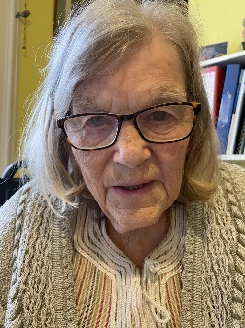
“Inclusion Scotland started when Etienne d’Aboville (GCIL) suggested a plan to start a national organisation adhering to the social model of disability run by disabled people themselves.
It would not have succeeded without the dedication and hard work of many people. I am so happy that the tradition of enabling disabled people to be included in every aspect of society has continued.
Best wishes on this important anniversary!”

Pam Duncan-Glancy is a Member of the Scottish Parliament for the Labour Party
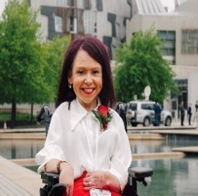
“Disabled people’s rights don’t come by accident, they are hard won. So I want to say a massive thank you to all at Inclusion Scotland past and present, for 21 years of having our backs and fighting our corner. Happy birthday and many, many happy returns.”

Jeremy Balfour is a Member of the Scottish Parliament for the Scottish Conservatives Party. He is the Convenor of the Cross Party Group on Disability
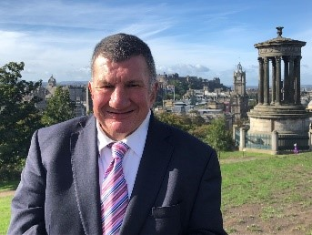
“Inclusion Scotland has been an amazing advocate for the Disabled Community over the last two decades. They have worked tirelessly to ensure that the voices of Disabled people in Scotland are heard. I look forward to many more years of following their essential work. Happy 21st Birthday!”

Emma Roddick is a Member of the Scottish Parliament for the Scottish National Party
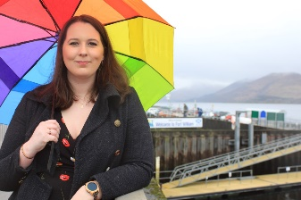
“While Parliaments are becoming more diverse, this is a painfully slow process. It’s vital all legislators hear lived experience. The work of Inclusion, as a disabled peoples’ organisation, in promoting disabled voices and ensuring concerns are heard and acted upon at the highest level is extremely valuable and important.

Morven Brooks is the Chief Executive Office of Disability Equality Scotland
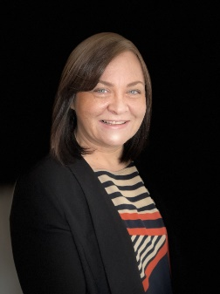
“Happy 21st Birthday Inclusion Scotland. It has been an absolute pleasure working alongside Inclusion Scotland for many areas now, from Inclusive Communication to Access to Politics. The work you do is so important and equally important for us and other DPOs’ and disability organisations to work with you to break down the barriers for disabled people to live independent lives. Here is to the next 21 years!”

Tony Slaven is the Vice Chair of the Scottish Trades Union Congress Disabled Workers Committee
“'Inclusion Scotland have made an impact on key political figures ensuring that disability representation is increasing, working with trade unions and grassroot organisations, Inclusion Scotland are successfully creating change in a system that demonstrated that Disabled people have been ignored for far too long.”

Jill Wood is the Policy Manager at Engender

“Engender is proud to have partnered with Inclusion Scotland over the years, working to tackle the multiple discrimination experienced by disabled women and girls on issues such as reproductive health, social security, and social care support.”

Peter Kelly is the Director of the Poverty Alliance
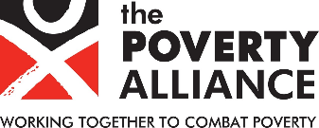
“Too many disabled people in Scotland are living on low incomes. That is why Inclusion Scotland and the Poverty Alliance have worked so closely over the last 21 years. We are proud to work alongside Inclusion Scotland as they continue to make a real difference to disabled people’s lives across Scotland.”

Tim Hopkins, Director, Equality Network

“The Equality Network really values our partnership with Inclusion Scotland, which began with 2014 research on the needs of disabled LGBT people, and has continued since, most recently on the new Hate Crime Act. Congratulations on your 21st birthday, and we look forward to many more years of partnership.”

5. Tell us what you think about the AGM and Conference
After the Conference we will ask you what you thought about the Conference.
We will send you a form.
This will help us to make next year’s AGM and Conference better.
Please send the form back to us. If you come to the AGM and the Conference, you only need to fill in one form.

6. Help with coming to the AGM and Conference

Costs to Attend

People attending an online event will not have the same costs if they went to an event in person.
If you need help to pay for something or someone to help you to take part in this online event you can make a claim to Inclusion Scotland.
You have to send us receipts.
Get in touch and tell us about your claim. Tell us how much you think it will cost. We will send you a form. Fill the form in and send it back to us. Contact Janice on 0131 370 6725 or janice@inclusionscotland.org.

Joining the Zoom meeting
The AGM and Conference is being held online. We will use Zoom.

We will use the same Zoom link for both the AGM and the Conference.

The Zoom link has been sent to you in an email and it is copied below. If you tap this link, you will get into the meeting online.
https://us02web.zoom.us/j/83837623963

If you are using a mobile phone you dial into the meeting using this number +44 131 460 1196 United Kingdom. You might need this meeting ‘ID’ number: 838 3762 3963.

How to use Zoom
You can get more information about how to use Zoom on this link. https://support.zoom.us/hc/en-us/articles/203650445-Using-in-meeting-chat

How to see the British Sign Language Interpreter on Zoom
We will set Zoom to make sure that you can always see the BSL Interpreter. You will also be able to see the speaker and any slides.

When the BSL interpreters swap over we will show you one that is interpreting.

You can make the BSL interpreter bigger on your screen so you can see them better.

To do this –
At the top of your screen click 'Gallery View'
Pick the screen with the BSL interpreter
Look for the icon that says 'Pin' and click it. It looks like a drawing pin.
When the interpreters swap over you will need to unpin them and then pin the new interpreter.
You can find out more by looking at this website –
https://support.zoom.us/hc/en-us/articles/201362743-Pinning-participants-videos

How to use captions with Zoom
There are two ways to do this.
You can read the captions like ‘subtitles’ at the bottom of the Zoom screen.
To do this you will need to click the “Closed Captions” icon (it looks like two CCs in a box). Then chose the ‘subtitles’ link.

If you have told us you want to use the captions on another screen or window, we will send you a link before the event.
We will share this link during the meeting in the “chat” box too. To find the 'chat' box click the 'chat' icon at the bottom of your screen. It looks like a speech bubble.

If you choose this option you will need to split your screen so that you can see the Zoom window (with speakers) as well as the captions at the same time.

To do this you will need look at the top bar on your Zoom window for the icon with 2 squares. If you click it the screen look smaller.

Do the same for the caption window. Now both windows do not fill the full screen and you can move them around and make them bigger or smaller to suit yourself.

Get more help during the meeting
One of our staff will help you. They can help you with the zoom call or the captions.
To contact us for help -
Telephone – 0131 370 6707 (Sarah Glover)
Email – sarah@inclusionscotland.org
Chat – to send a message on Zoom use the 'chat' button and change the “To:” to “sarah@inclusionscotland.org” or “janice@inclusionscotland.org” then type your message.

7. Where to get advice and support about money
We know that lots of disabled people are worried about the cost of living and poverty.
This section tells you about organisations who might be able to help you. It tells you how to contact them.
There are other organisations you can find out about on the internet and through services like your local library.

Scottish Government
The Scottish Government has pulled together signposts to help you find out about sources of help.
https://costofliving.campaign.gov.scot/

Money Advice Scotland
Money Advice Scotland is Scotland’s money charity.
It offers support to people in debt.
You can chat to an adviser via webchat, WhatsApp, Facebook Messenger and email.
You can find links to contact advisers on the website.
Money Advice Scotland also has tools you can use to make sure you are getting all the benefits and grants you are entitled to.
To access the resources visit the Money Advice Website.

Welfare Rights.net
www.welfarerights.net is a website where you can find information about benefits, including the new Scottish benefits. There is also a helpline number and email address which you can use to contact them.
Helpline number - 01387 266 888
Email – info@welfarerights.net

Citizens Advice Scotland –
Citizens Advice Scotland give advice. They have a help page on their website called Our Advice Adds Up about help with the cost of living.
You can also talk to your local Citizens Advice Bureau. Find your local Citizens Advice Bureau here.

Crisis Grants
You may be able to get a Crisis Grant to help you in an emergency.
This includes things like food and heating, if there is a fire or flood, or if you’ve lost money.
You need to apply for a Crisis Grant through your Local Authority. To find out more information and for links to your Local Authority's application page visit the Scottish Government website.

8. How to get in touch with Inclusion Scotland
Our address is
Inclusion Scotland
22 – 24 Earl Grey Street,
Edinburgh,
EH3 9BN

Our email is info@inclusionscotland.org

Our telephone number is 0131 370 6700

Visit our website: inclusionscotland.org

Follow us on Social Media:
Twitter: @InclusionScot
Facebook: @InclusionScotland
Instagram: @inclusionscotland

