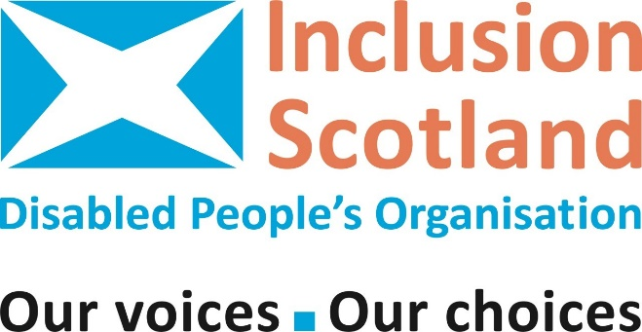
News Release

EMBARGO: Not for publication before 09:00am Tuesday 04.10.22
Disabled Scots worried about dying this winter due to cost-of-living crisis
Disabled people across Scotland are ‘worried sick’ that they will not survive the winter according to leading disabled people’s organisation (DPO) Inclusion Scotland.
In a survey of members on the impact of the cost-of-living crisis, the organisation has found that rising energy and food costs, inadequate social security and the burden of meeting social care costs has meant many disabled people are already rationing food, how often they use oxygen concentrators and respirators and are turning off the heating—even in cases where a disabled person is unable to regulate their own body temperature. Inclusion Scotland says the consequences could be ‘catastrophic.’
Disabled people are fearful that they will be hospitalised or will die at home this winter. They are worried they cannot afford to maintain well-heated homes necessary for their own health and wellbeing, or electricity usage for vital medical equipment such as ventilators, feeding pumps, and dialysis machines.
Over 75% of respondents to this survey were currently going without or cutting back on essentials like food or heating, with many disabled people also cutting back on energy use essential to living with a disability such as powering oxygen machines, the charging and operating of powered wheelchairs, mobility scooters, through floor lifts, hoists, or electric shower-toilets.
Disabled people talked of staying in bed all day in cold houses to try and stay warm, going without baths and showers to save money, cutting back on social care support they pay for like help to cook, wash themselves or socialise, or going without paid for medication like pain-killing injections. Many respondents said their quality of life had already plummeted and that they were ‘worried sick’ about winter approaching.
Inclusion Scotland, who are holding a conference with members this week about the cost-of-living crisis, say more targeted financial support is necessary if we are to avert the tragedy of avoidable deaths of disabled people this winter.
As Leo Starrs-Cunningham, Convenor of Inclusion Scotland explains:
“Disabled people, already much more likely to be living in poverty in Scotland, are caught in the middle of this cost-of-living crisis and are facing this on top of the extra costs many already experience from simply living as disabled people. As disabled people many are at significant risk of financial hardship, fuel poverty, food insecurity and destitution as inflation, energy, and food costs rise.
“Policy makers must engage with the reality of disability-related energy costs and the need to protect life. Disabled people need further help with energy bills through action on prices or targeted cost-of-living payments. The devastating and intensifying levels of poverty faced by disabled people in Scotland must be met with robust, immediate action by the UK and Scottish Governments if we are to avert a humanitarian crisis for disabled people this winter.”
ENDS
Notes to editors:
- Inclusion Scotland is a ‘Disabled People’s Organisation’ (DPO) – led by disabled people ourselves. Inclusion Scotland works to achieve positive changes to policy and practice, so that we disabled people are fully included throughout all Scottish society as equal citizens.

- Inclusion Scotland carried out a survey with disabled people between the 7th – 23rd September 2022 on the impact of the cost-of-living crisis which received 168 responses. Headline findings are below:
- 77% of respondents were currently going without or cutting back on essentials like food and heating
- Of those who said they were going without or cutting back on essential; 83% mentioned heating; 57% mentioned food. Other items included: Travel expenses, including fuel for a car (50%) and clothing (51%)
- 64% of respondents were currently going without or cutting down on items or services they used to manage their impairment or health condition including heating to manage pain; food for special diets; electricity to charge equipment like electric wheelchairs, stairlifts, hoists and supplementary oxygen machines, therapy, and exercise classes, paid for medication and Items for personal hygiene, cleaning and washing.
- When asked what was most worrying them about winter, Inclusion Scotland received the following responses:
- ‘If I can’t heat my home properly, I could die.’
- ‘I'm terrified we won't be able to effectively heat our home this winter. I have a chronic illness that is severely affected by cold temperatures.’
- ‘That I could potentially experience damage to my hands and feet because I won’t be able to afford to switch the heating on.’
- “Not being able to afford heating. Part of my condition means I struggle to regulate my body temperature I can be prone to hypothermia. I also rely on how showers and hot water bottles to manage pain and am worried about how to afford that. I could die.’
- ‘Affording heating as my medical condition can be severe or even fatal in the cold.’
- ‘Easy question, freezing to death or becoming so unwell because of the cold and being unable to afford using medical equipment I end up in hospital.’
- ‘I am worried disabled people will die this winter.’

For further information contact:
Susie Fitton, Inclusion Scotland
Policy Manager
Susie@inclusionscotland.org
Inclusion Scotland, 22-24 Earl Grey St, West End, Edinburgh,
EH3 9BN
www.inclusionscotland.org
Facebook: @InclusionScotland Twitter: @inclusionscot
Charity Number: SC031619 Company Number: SC243942

