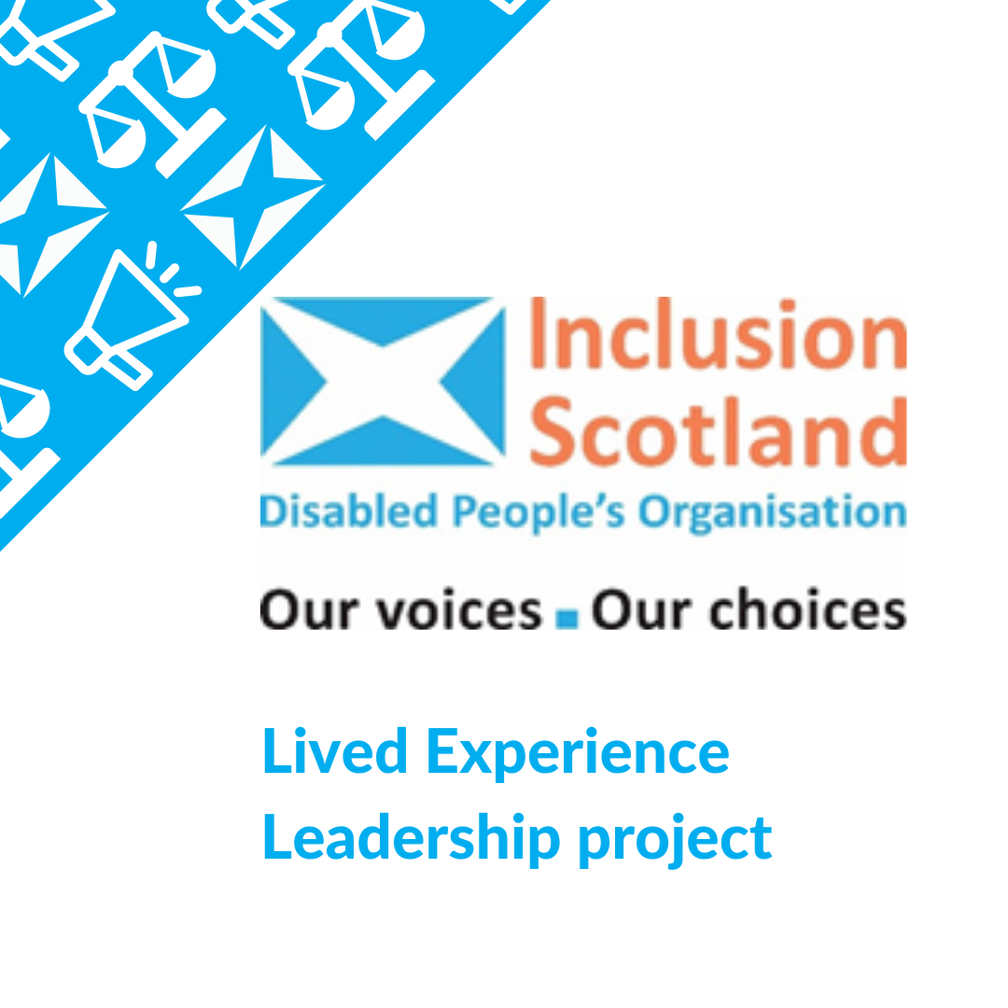
End of project Report 2019 - 2021

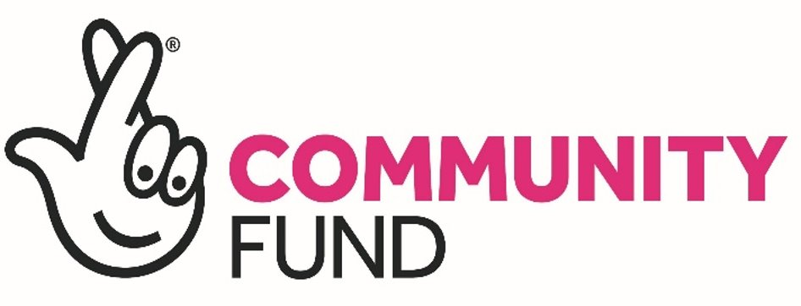
This project was funded by

​

Lived Experience Leadership (LEL) project
End of Project Report (DRAFT)
Contents

1. Introduction and Methods 3
2. Background to the project 3
3. Evidence Informing the Project 4
Findings from surveys of members 4
External research 6
4. Aims and activities of the project 8
Partners and Supporters in Delivery 10
5. Key achievements 11
6. Challenges 12
Relationships 12
Accessibility 13
Pandemic 13
Supporting the co-production group 13
7. Evaluation and learning 14
Importance of group learning 15
Shadowing other leaders was the most successful element 16
The unexpected importance of mentoring 17
Working in partnership with training providers and organisations 17
The glass cylinder 17
8. Future legacy 18
Promote the outcomes of the project 18
Continue to support LEx leaders 18
9. Recommendations for future work 19
10. Conclusion 21
Appendix 1 - Definitions & Abbreviations 22
Appendix 2 - Document list 22

1. Introduction and Methods

This report charts the achievements, challenges, learnings and potential legacy from Inclusion Scotland’s National Lottery-funded Lived Experience Leadership pilot project which ran from 2019-2021.
The report was compiled and drafted by an external consultant following a short review of internal and external literature, after the project had been completed and closed. Key sources include:
- Project documentation
- Written reflections of the project advisory group, which were shared with the Inclusion Scotland board
- Evidence used by the project at design phase, including external research
- Conversation and feedback with available staff
A full literature review was not possible within the time available. The report was compiled after the departure of the project officer and closure of the advisory group, using notes they had left behind.

2. Background to the project

In 2019 Inclusion Scotland received £50,000 from the Big Lottery Fund (now National Lottery Community Fund) Lived Experience Leadership Pilot fund to run a year-long pilot project on developing lived experience leadership. After the project was impacted by the Coronavirus pandemic, this was extended for 6 months with £12,493 additional salary funding provided to enable delivery and completion. The pilot ended in March 2021.
The pilot fund from National Lottery Community Fund made funding available to voluntary and community organisations which had been set up by or were run by leaders with lived experience of the challenges they sought to address. The purpose of the funding was to:
- pilot and learn about different ways the Fund could develop leaders with lived experience
- support work to change the way lived experience is viewed and valued in decision making
- encourage innovative examples of how to develop lived experience at all levels of an organisation.

Following the pilot, the Fund launched a full funding round on the same themes, which has now closed. Successful applicants for the pilot funding were not eligible for subsequent funding.

3. Evidence Informing the Project

In developing the pilot, Inclusion Scotland used internal survey data (to understand what its members who are lived experience leaders would find most useful) and external research.

Findings from surveys of members

The initial idea was developed by staff working on the Inclusion Scotland internships programme, who believed that former disabled interns and those who had accessed the Access to Politics and Elected Office programmes could benefit from a formal network with resources on lived experience leadership. An initial survey was conducted which led to the creation of the Disabled Leadership Network, providing communications in the form of regular newsletters, arranging training and recruiting a steering group made up of self-identifying disabled leaders.
Potential participants in the Disabled Leadership Network were surveyed again in 2018 showing clear appetite for a Lived Experience Leadership programme:
- 180 individuals responded
- 87% were interested in the idea of the ‘Disability Leadership Network’
- Top interests in learning included:
  - Support to challenge negative attitudes and discrimination – 86%
  - Information on how to influence decision making and promote change - 84%
  - Tips of building confidence on leadership ability – 73%
  - Understanding my rights as a disabled person -70%
  - Learning about past and present disabled leaders - 61 %
  - The qualities needed to be a good leader - 60%
In addition, Inclusion Scotland’s 2019 survey of its member organisations showed that leadership development would be valued by Disabled People’s Organisations. Half of organisations who responded felt their organisation had a gap for leadership development, and three quarters felt that leadership development training would be useful.

External research

In July 2019 as the project was in development, Clore Social Leadership published a summary of interviews and insights collected from Lived Experience Leaders. This research, “Lived Experience [LEx] Leadership: Rebooting the DNA of Leadership” by Baljeet Sandhu, was an important source of evidence for the project. The key findings are summarised below (definitions and abbreviations from this research drove the work of this project, are used throughout this report and are set out in Appendix 1).
“A LEx leader is someone who has:
» Lived experience: direct, first-hand experience of social issues and/or injustices; and has… » Activated the knowledge, perspectives, insights, and understanding gathered through their lived experience (lived expertise) to inform, shape and lead their social purpose work (often in combination with their learned and practice experience) to… » Directly benefit the communities they share those experiences with.
“Unique leadership strengths and challenges
Some elements of the sector continue to pay lip-service to the value of LEx leadership, evidenced by the growth of initiatives seeking to ‘give voice’ to LEx leaders, without fully understanding the unique leadership strengths, competencies and skills that LEx leaders bring to the social sector. The lack of research, data and evidence in this field contributes to ongoing systemic, structural and cultural barriers that LEx leaders face in the sector.
“Social Sector systems change is necessary
Developing L&D initiatives and interventions alone will not address the systemic, structural and cultural barriers LEx leaders currently face in the social sector. Current operating conditions in the sector are ‘unhealthy’, ‘harmful’ and creating a ‘damaging disconnect’ between social leaders with and without LEx, the communities they serve, and civil society... By addressing the barriers, progressive interventions, collaborations and innovations can be deployed to help LEx leaders thrive so that they can effectively address evolving social issues and injustices their communities face.
“Multi-layered approaches to [Learning & Development (L & D)] provision
LEx leaders have L&D needs like any other social leader, but also require tailored approaches to support their development ... All LEx leaders will benefit greatly from L&D provision that centres both lived and learned experiences in design; takes a networked approach; addresses wellbeing and helps support communication and systems thinking and practice.
- Early stage and aspiring LEx leaders require a hands-on approach to their development through bespoke L&D interventions and experiential learning, support and/or mentorship opportunities.
- Emerging and experienced LEx leaders require targeted and collective L&D opportunities such as fellowships and residencies that combine skills development; coaching; mentoring and action-based approaches to development.
- Senior LEx leaders are keen to ‘give back’ and support the development of emerging and experienced LEx leaders, while benefitting from mentorship from senior leaders with technical expertise across the sector (including the private sector and government).

4. Aims and activities of the project

The aims of the project were to:
- Facilitate a core group of disabled leaders to co-produce the development of the pilot, reviewing and applying learning from a lived experience leadership programme aimed at disabled people.
- Work with an initial pilot recruitment group of disabled people who would pilot the programme and strands within it, including relevant leadership training, two-way mentoring and shadowing, and exposure to Inclusion Scotland’s networks, People-led Policy Panels, etc.
- Offer specific individually tailored training and opportunities where participants influence decision-makers to see the value in lived experience decision making.
- Consolidate learning into a lived experience leadership programme for disabled people, with a suite of tested resources and opportunities which could be widely promoted and rolled out.
The project was co-produced with an advisory group recruited from Inclusion Scotland’s previous Disabled Leaders Network advisory group. The group held its first meeting in November 2019. The project was re-designed with the advisory group in April 2020 to reflect the impact of the Covid-19 pandemic. In January and February 2021 the group met to evaluate the project and reflect on learning; their reflections are included in this report.
Nine project participants were recruited through an application process, with an emphasis on creating a diverse group of disabled leaders with intersectional experience. Active support was provided to meet individual access needs and ensure each participant was able to access and use the technology.
Project activities took place between August 2020 and February 2021, and included:
Project design and evaluation | 6 advisory group meetings to design, review and evaluate the activities
Facilitation training | 2 sessions designed in partnership with Tripod Training
Coaching | Two sessions, half of group in each session, designed with an independent coach, to explore participants’ individual leadership ambitions and outcomes for the project
Microsoft Teams training | Session delivered by Microsoft (offered in partnership with Inclusion Scotland’s Employment Practice team)
121’s to identify training options from a fixed selection. | Nine formal (one each) plus approx.  15 additional informal sessions as required
Peer networking sessions | Five x two hour sessions
Open University (OU) study group sessions | Nine x two hour sessions (including two guest sessions with OU course authors)
Courses completed | - OU/Centre for Voluntary Sector Leadership ‘Developing Leadership in the Third Sector’ – all nine participants (online), with study group sessions as above  - Thinking Digitally with LEAD Scotland (three participants)  - OU Political ordering course (online)
Shadowing | - Introductory meetings with shadowee leaders (9)  - Setup meetings with shadowing pairs (1 for each pair=9)  - Informal check-ins with leaders and participants as required (8-10)  - Shadowing sessions varied, but averaged 4-6 meetings per pair

Partners and Supporters in Delivery

Microsoft provided free training on using accessibility tools in the Microsoft Teams platform. This was offered to interns, staff and project participants due to Inclusion Scotland’s good existing relationship arranging disability internships with Microsoft.
Lead Scotland contributed the equivalent of £850 by giving a discount to their group training course Thinking Digitally.
Open University course providers met with the project officer and then provided input to the learning group as well as inviting the project officer to speak to their team on lived experience leadership, which was an area they had not previously worked on through the course. A PhD student then accessed the learning group who allowed her to follow up with them after the end of the project.
Nine Shadowees contributed time and expertise to the shadowing programme. These were busy established leaders who had several meetings with their shadows and often allowed them to join them for work meetings with preparation and follow-up time for each meeting.

5. Key achievements

The design of the project included three aims for the pilot (co-production; recruitment; tailored opportunities) plus one follow-up aim for scaling up using lessons from the pilot. The first three aims were successfully achieved, as discussed below; plans for the post-pilot follow-up are discussed further in sections 8-9.

The project was successfully co-produced with a steering group of disabled leaders. A diverse range of participants was recruited, supported and retained. A method for reviewing each stage of co-production with the group was devised together with them and implemented. This involved holding quarterly informal meetings and surveying the group on ideas from each by way of follow-up. That way everyone had opportunity to feed in to decision making.

By the end of the project, out of nine participants recruited:
- Eight participants had completed several different strands
- all had completed coaching
- all had completed the Open University Voluntary Sector Leadership project as part of a learning group
- facilitation training and most shadowing had been completed with a range of leaders from different sectors
- One participant had joined Inclusion Scotland’s Board of Directors.

In addition, different participants undertook other training opportunities such as use of MS Teams and LEAD Scotland’s Thinking Digitally Course (see above). Each opportunity was evaluated by participants. The participants were also invited to review and influence Inclusion Scotland guidance documents (such as the Civic Participation accessing politics guidance).

Findings from survey and other evaluation data have been summarised in section 7.

6. Challenges

Relationships

There were some inter-personal difficulties at the start and three advisory group members left the project. This was actively managed and feedback from advisory group members and participants improved considerably as time went on. Additional members were added to the co-production group and a new plan of how best to work together was agreed with co-production group members and staff. Additionally, the project kept the advisory group up to date with ‘you said, we did’ reports.

Accessibility

Ensuring the project was accessible to all was complex and time consuming. It was important to provide information to participants about what support was available, not just to ask them what they wanted, since some participants were not aware of support that could be useful to them. Although accessibility needs had been budgeted as far as was possible without knowing the needs of participants, there was a relatively high cost in providing quality communications support. The project would not have been able to support two participants with the same requirements to, for example, do different training courses. High communications support costs were covered by an underspend on planned events (which had been cancelled due to the pandemic). This cost needs to be appropriately factored in for future development support projects to be fully inclusive.

Pandemic

The Coronavirus pandemic of 2020-21 had significant impact on project delivery. The planned face to face launch day for participants was due to take place just as the first lockdown began and had to be cancelled. Plans were adapted in discussion with the advisory group, and the funder was asked to support a funded extension of the project to ensure successful completion.

Supporting the co-production group

Significant staff input was required to ensure advisory group members could participate in co-production in a meaningful way. This meant building the capacity of the group as it worked on the project. There were differing understandings of the experience of disability and the value of the social model. The group had not been involved in the original funding application, which created some planning challenges. Although these issues could be foreseen at the pilot design stage, staff capacity turned out to be lower than expected due to long term sickness of a related role, meaning that the pilot’s project officer had less support than expected. In addition, group members and project participants needed extra input from staff to ensure they could access the project digitally once all activities were moved online.

7. Evaluation and learning

Within the original plan for evaluating the pilot, it had been expected that participants would complete a baseline self-evaluation to set personalised outcomes (‘Outcomes Star’) and to measure their progress at the end of the pilot. Unfortunately, the external coaching provider who was to support this process did not complete this aspect of the contract and most participants did not develop a baseline outcomes star.

Nonetheless each individual intervention was evaluated via post-activity questionnaire and a holistic questionnaire at the end of the project. Learning was then discussed and captured by the advisory group. Each activity received very high scores for ‘usefulness’ in post-activity questionnaires and overall the project was highly rated by participants.

The following key learning points have been drawn from the questionnaires and the reflections of the advisory group:

Importance of group learning

A key part of the programme was the group process and learning from other participants. Reflections from the facilitator identified that some saw the learning group and the peer networking sessions as continuing conversations. In these sessions participants were able to discuss past experiences/barriers to leadership and experiences with training within a safe space and provide each other with support.
The peer support within the group was essential to the learning experience. For example, language used on the Open University course was considered inaccessible and it was thought that without the learning group at least one person would not have been able to complete it. This was fed back to the Open University, which have been very open to feedback and exploration of the value of lived experience (due to the uniqueness of the group).
One of the OU Learn course authors, Dr Owain Smolivic-Jones, accepted an invitation from the Project Officer to attend two learning group sessions. Dr Smolivic-Jones engaged with participants on how they thought the COVID-19 pandemic had affected their own and others’ leadership practices, and on how future iterations of the course could be improved to better aid lived experience leadership development. Group participants also explained how some leadership models can be discriminatory towards disabled people by failing to perceive that disabled people can be leaders, which can often lead to a lack of leadership opportunities in practice. The Project Officer received positive feedback on this engagement from Dr Smolivic-Jones, who hopes to incorporate some of this thinking into future versions of the course.

Shadowing other leaders was the most successful element

The shadowing opportunity was, at the end of the project, considered the most useful of all the elements of the project, with seven participants rating it as very useful. In addition, the leaders being shadowed were mostly extremely positive about their experience, with some having learnt much more about the value of lived experience and gaining a reflection on their own leadership styles. One leader being shadowed said they would do this again, another said that they would like to continue the shadowing in order to “develop the confidence, capability and opportunity available to delegates”, while others wished to keep in touch with their shadowees. Another suggested that:
“It will be important to know what legacy the shadowing has for the shadowee, what they do next and how/ if the shadowing helped them or made a difference. The same would presumably go for people being shadowed.”
For shadowees who were able to complete the shadowing, the entire experience was positive. They felt listened to, they learnt about leadership and different leadership styles, and their own confidence was increased. One person said that this experience had encouraged them to go back into formal employment, whilst others found it motivated them to continue their leadership journey and seek out new opportunities.

The unexpected importance of mentoring

Although the literature on LEx and initial research for the pilot had shown the value of mentoring for LEx leaders, the advisory group had chosen not to design this into the pilot. They felt, with justification, that it would not be possible to source and train appropriate mentors within the short lifespan of the project. In retrospect, however, mentoring was needed by participants, and this should certainly be included in longer term projects. In practice the project officer provided informal mentoring support to fill the gap, taking them away from other activities. And while the peer support group was a useful source of peer mentoring, it did not fill the gap of one-to-one mentoring that the participants appeared to need.

Working in partnership with training providers and organisations

The project helped to make existing opportunities more accessible, avoiding segregation. It was not always easy to build partnerships. One supplier did not complete the agreed brief, which led to baseline information being incomplete. Another was not forthcoming about their training courses after initial enthusiasm (though this is likely because of the impact of COVID-19 on live meetings).

The glass cylinder

The project increased skills and confidence of the LEx leaders involved. However, in reflections, it was agreed important to beware of the ‘glass cylinder’ of disabled leaders leading disability organisations and not being expected to occupy other leadership roles. It was interesting to note that not all leaders being shadowed identified as disabled people.

8. Future legacy

On completion of the project, the co-production group made some legacy recommendations which were put to the Inclusion Scotland board and will be fed into future work planning:

Promote the outcomes of the project

- This report should be widely promoted, with particular audiences targeted via e.g., Employers from different sectors, Council newsletters; LinkedIn and Trade Body websites.
- Continue to encourage/ support existing leadership training providers to include Lived Experience in their leadership courses
- Continue working with partner organisations e.g.
Open University Centre for Voluntary Sector Leadership, LEAD Scotland
- Invite participants to use social media to communicate their learning within their networks, sharing stories, experiences and role models to promote the value of Lived Experience.

Continue to support LEx leaders

- Continue to share resources and invite review of guidance documents from disabled leaders and encourage them to promote them via their own networks
- Reinstate the Leadership shadowing programme for aspiring disabled leaders, and open it up to established disabled leaders, including making sure it is in the mainstream (different sectors).
- There were some different suggestions on continuing to support peer networking for disabled leaders, including ‘more of the same’, and ‘Set up a platform and network to champion it with proactive communications, best practice and key learning shared – support this with an ambassador programme and recognition scheme’.
- On continuing to offer support to lived experience leaders and aspiring leaders, the co-production group advocated more of the same through other existing Inclusion Scotland projects; to share best practice with professional and trade bodies; and continued training and workshops and an established network to exchange ideas and experience.

9. Recommendations for future work

It is clear that there could be scope to develop aspects of the project if new resources were made available. For instance, mentoring, peer support for lived experience leadership and shadowing of leaders could all be useful to other leaders. The training courses were also considered of high value, and one recommendation for a participant’s own development from the course was to get practical experience of leadership. Another suggested that a menu of options should be developed for things they could do next; this was provided, although only one participant was able to follow up and engage with other Inclusion Scotland activities.
Leadership development is relevant to achieving a range of Inclusion Scotland priorities, not least to disabled people becoming influential in policy making. Disabled people may desire to use their LEL for very different purposes, for example:
- To campaign for change
- To start an organisation
- To get a better job or return to the workplace
- To have their voices heard effectively.

Inclusion Scotland could build on the pilot learning in a number of areas of existing work:
- Membership and partnership development
- Employment support and development
- People-led Policy Panels and communities of practice
- Staff or Board development (since many individuals are, or could become, lived experience leaders through these routes)
- Wider shadowing or mentoring programmes, e.g. in the context of access to politics (shadowing policy-makers?), or with Inclusion Scotland staff (who are often recognised as LEx leaders)
- Reviving, and integrating development into, the ‘access all areas’ network for former interns and other project participants.

For this to be successful, additional income will be required. Funding options could include:
- Seeking funding to develop a future similar project (if a funder with relevant priorities can be identified)
- Incorporating aspects of the project into funding applications for other connected activity
- Exploring whether some activities could become potential streams for income generation.

10. Conclusion

It is clear that the pilot project was successful, achieving its aims and providing valued development support to a small cadre of Lived Experience Leaders. While it is disappointing that the project could not continue, the learning and relationships built during the pilot can be integrated into Inclusion Scotland’s work in a range of useful ways. It will be important to share this learning with other organisations in this field, to encourage pilot participants to share their experiences, and to seek to include Lived Experience leadership development into plans going forward.

Appendix 1 - Definitions & Abbreviations

For this project, and in this report, we have used definitions of Lived Experience, Lived Expertise and Lived experience leadership from “Lived Experience Leadership: Rebooting the DNA of Leadership” by Baljeet Sandhu, 2019.
Lived Experience Leader- Change-makers, innovators and leaders who have activated their lived expertise to inform, shape and lead their social purpose work (often in combination with their learned and practice experience) to directly benefit the communities they share those experiences with.
Lived Experience Leaders - LEx Leaders
Leader without Lived Experience Non-LEx Leader
Lived Expertise - Knowledge, perspectives, insights, and understanding gathered through lived experience.
Lived Experience- Direct, first-hand experience, past or present, of a social issue(s) and/or injustice(s)
Lived Experience People With Lived Experience PWLEx

Appendix 2 - Document list
Application to Big Lottery Fund (2018)
Big Lottery Fund Lived Experience Leadership Pilot website (programme now closed)
Paper to Inclusion Scotland board (18.03.21) summarising learning and potential next steps
Internal summary of project activities
Evaluation summaries
Survey findings from Disabled Leaders’ Network surveys 2018 and Inclusion Scotland members’ survey 2019
Project officer’s notes for report
“Lived Experience Leadership: Rebooting the DNA of Leadership” by Baljeet Sandhu, 2019 https://lexmovement.org/wp-content/uploads/2019/07/LEx-Report-Final-2.pdf [accessed 17.5.21]

Quoted from Lived Experience [LEx] Leadership: Rebooting the DNA of Leadership”, Sandhu, Baljeet, 2019, pp8-9 https://lexmovement.org/wp-content/uploads/2019/07/LEx-Report-Final-2.pdf
Outcomes Star devised by Triangle Consulting https://www.outcomesstar.org.uk/about-the-star/what-is-the-outcomes-star/

