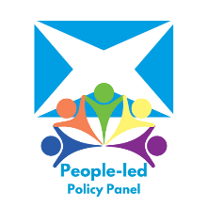  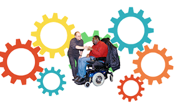   | People-Led Policy Panel,  Inclusion Scotland  A National Care Service for Scotland - Consultation Response  Recommendations
 | We strongly support a National Care Service.
  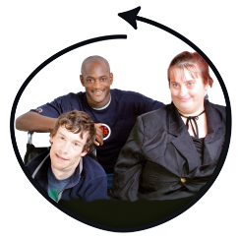  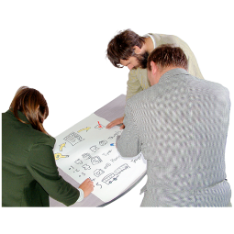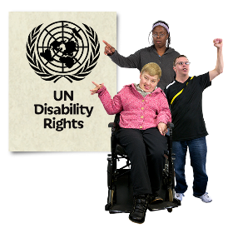      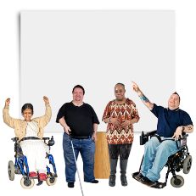    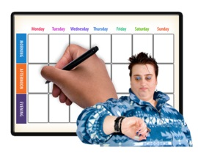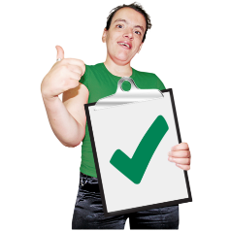 | For this to happen we recommend:  - A full understanding of and commitment to our right to Independent Living. It should be built into the National Care Service.  Independent living means you can have the same freedom, choice, and control as other people.  It means a right to the practical help you need to take part in your community and to live an ordinary life.  - Preparing to put United Nations Convention of the Rights of Disabled People (UNCRPD) and other human rights conventions into law.  - Taking a PANEL approach to co-production. This will mean disabled people and unpaid carers are able participate equally as partners. You can find the Easy Read description here.  Co-production means all the people working together from the start.  - The role of the PLPP and other lived experience groups in the co-design and governance of a NCS will be very important.  Governance means how an organisation is controlled or run.  - This must be carefully planned and discussed with Disabled Peoples’ Organisations as soon as possible.  - Easy Read and BSL versions of consultations must be good quality.  - They must be available in enough time for people to meaningfully engage with the issues.
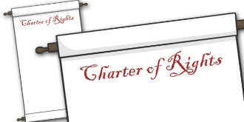   | - A charter of rights should be created. This should be like the Social Security Scotland one.  - This is an example of how equality and human rights can be built into policy and decision-making
  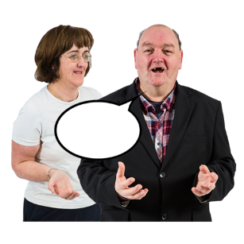 | - A duty to coproduce with people who use social care services should be put into the law for the NCS. This was suggested by the Equality and Human Rights Commission.  A duty is a responsibility.  - A right for everyone using the NCS to access independent advocacy, both individual and collective must be written into the law.  Independent Advocacy supports people and groups to speak up and demand human rights.
 | Chapter 1 Recommendations
 | Improvement
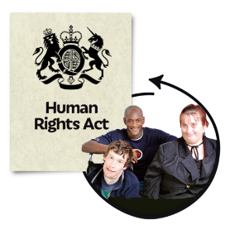    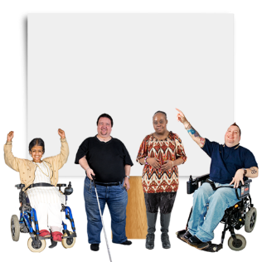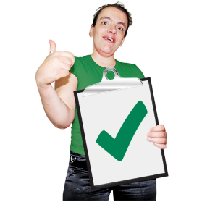  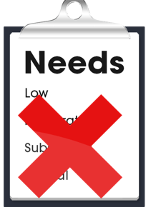    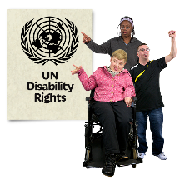 | - Taking an Equality and Human Rights-Based Approach to all aspects of a NCS, including improvement.  - Improvement should be measured against the PANEL principles.  - People with lived experience must be supported to participate meaningfully in policy decisions.  - Eligibility criteria must be removed.  - Eligibility Criteria means you must have high needs before you can get support.  - Standards need to be met and those responsible need to make sure this happens.  - The laws for a NCS must be closely linked to laws for the UN convention of Rights of Disabled People (UNCRPD).
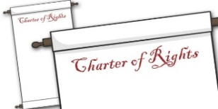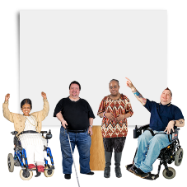  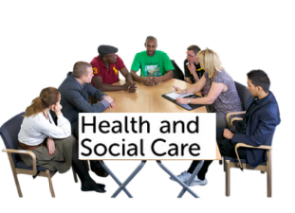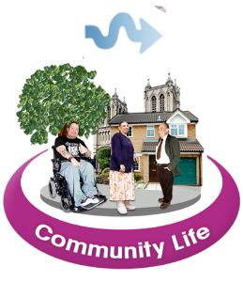  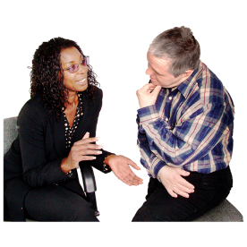   | - Creation of a “Charter of Rights”, co-produced with disabled people and unpaid carers.  - The new Community Health and Social Care Boards should have a duty to look at changing attitudes and way things are done. This is called a Culture Change.  - Respect and space should be given for people to talk about the trauma and abuse they have experienced because of the current system.
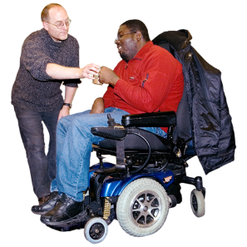 | Access to Care and Support  Recommendations
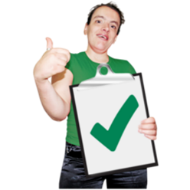 | - Using the internationally recognised definition of Independent Living in support planning, Getting it Right for Everyone and laws.
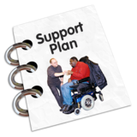    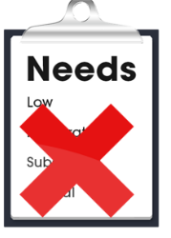  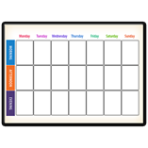  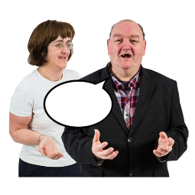 | - Supported Decision Making to be part of every aspect of a NCS including assessment and support planning. This is a human right.  Supported decision making means that people can support you to make your own decisions.  - Eligibility criteria must be removed and a clear timetable for this given.  - A clear timetable for reopening the Independent Living Fund Scotland (ILFS).  - A right to independent advocacy, individual and collective, for everyone using the NCS.
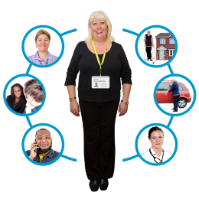 | Coordinating Care and Support Recommendations
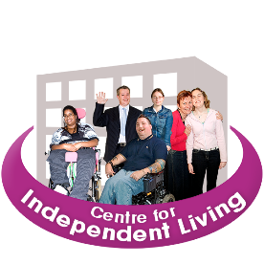  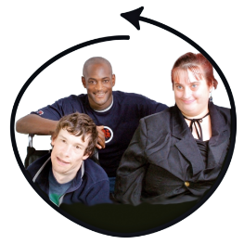 | - A central role for Centres for Inclusive Living and more funding.  - A right to independent advocacy and/or supported decision making for everyone using the NCS.
 | Support Planning
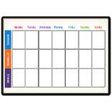    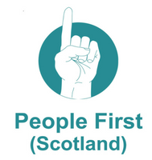 | - A clear timetable for reopening Independent Living Fund Scotland for new applicants.  - A semi-structured interview (or ‘good conversation’) should replace box-ticking.  - Speak with People First (Scotland) to make sure Supported Decision Making is at the heart of support planning and GIRFE.
 | Rights to Breaks from Caring
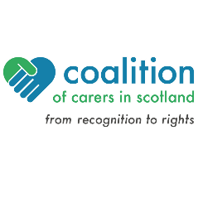   | We support key recommendations from the Coalition of Carers in Scotland that:  - The law should extend to provide a right to breaks for unpaid carers.
  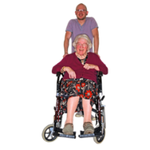     | - This situation needs to be looked at now.  - Unpaid carers are struggling and cannot wait for the new law. We must begin to invest now and move towards a right at a later date.  - The right to breaks from caring cannot be delivered unless other system wide problems in the social care support system are fixed.  This includes valuing and increasing the social care support workforce and commissioning services which meet people’s needs.
 | Complaints to Putting Things Right
  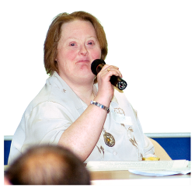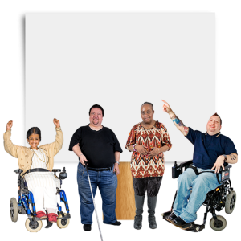   | We recommend:  - Any complaints system must be independent, and decisions must be enforced.  - Any Commissioner put in place should have lived experience. They must be accountable to Disabled People’s Organisations as argued by People First Scotland.  - A right to Independent Advocacy for everyone complaining or appealing a decision.
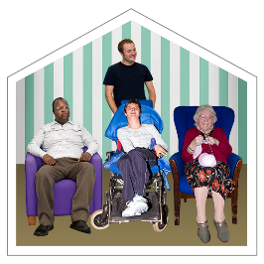 | Residential Care Charges
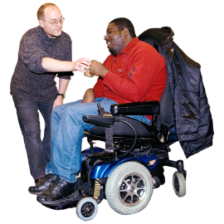 | We recommend:  - All care charges are scrapped, and social care support is free at the point of delivery.
 | Chapter 2: National Care Service
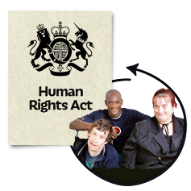    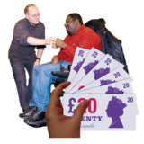  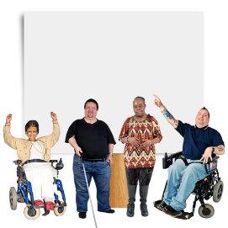  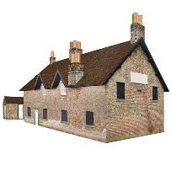    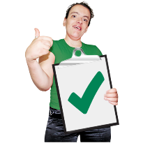 | We recommend:  - The NCS must be firmly based on principles of Independent Living, Equality, and Human Rights.  - It must be free at the point of delivery.  - It must have ring-fenced funding. This means that money must only be spent on social care support.  - Every part of the NCS must be co-designed and co-produced by disabled people and unpaid carers.  - A national system still flexible enough to ensure local conditions (such as rurality) are accounted for.  - Re-open the Independent Living Fund for new applications.  This is the ideal model for a NCS based on dignity, equality and human rights.
 | Chapter 3- Scope of the National Care Service
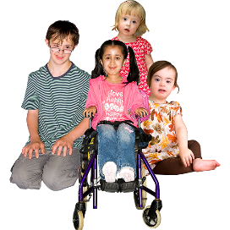  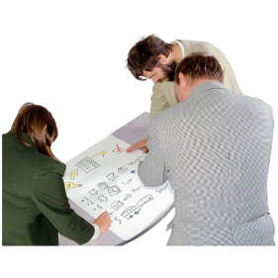      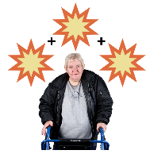  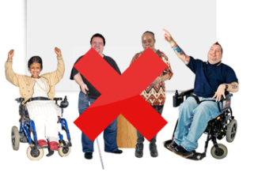  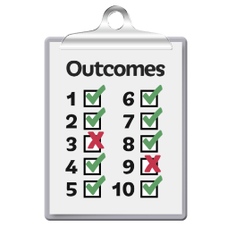  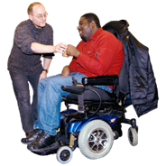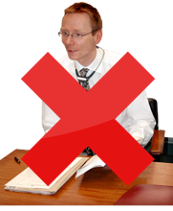 | We recommend:  - Including children’s social care support and social work could help address the “cliff edge” of transitions.  - Involve each group with lived experience on planning the detail of these proposals.  - This is to make sure nothing unplanned for goes wrong.  - This is important as there was little time to look in-depth at how inclusion of the range of services proposed would impact on delivery.  - Panel members felt they did not have the lived experience to comment on all areas.  - There must be a focus on improving outcomes for people and not just on changing structures.  - Social Care support should not be medicalised, even if people using social care support also use community and other health services.
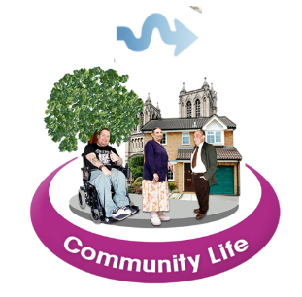   | - Make sure money for social care support is ringfenced for that purpose and not lost in providing the range of services under consideration.  - Keep focus on culture change, rather than just system wide change.  - Everyone using the new National Care Service should have the right to independent advocacy, both individual and collective.  - This needs to be appropriately funded and supported.
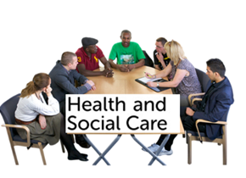 | Chapter 4: Reformed Joint Boards: Community Health and Social Care Boards.
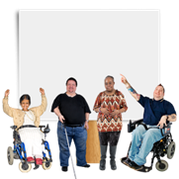    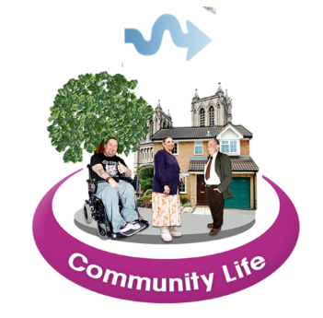  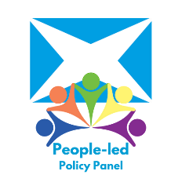    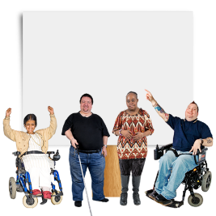  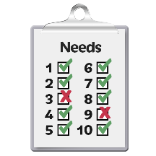      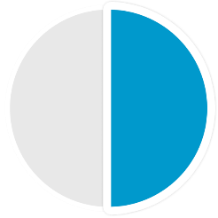  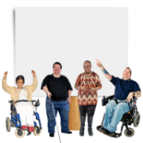  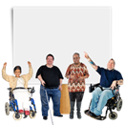 | We recommend:  - Radical change is needed for disabled people and unpaid carers to have power and equal representation in the governance of the NCS.  - All members should have a vote.  - There needs to be system wide changes in governance to achieve the change in culture we want to see.  - The role of the PLPP and other lived experience groups, will be important in the creation and running of NCS governance.  - Training and capacity building should be provided for all involved, in Independent Living and co-production.  - Disabled people need to represent other disabled people. They need to be supported and have enough time and money to do this.  - We must be empowered through having our access needs met and being treated equally.  - Fairer representation of disabled people and unpaid carers/supporters on both CHSCBs and the national board of the NCS.  We should have enough time and money to make well considered decisions.  - There could be a rule that at least half of the members on the CHSCB should have lived experience.  - We should pay people with lived experience to be part of these boards.
 | - Build in a Supported Decision-Making Framework for full and equal participation of disabled people. This is recommended by People First (Scotland).
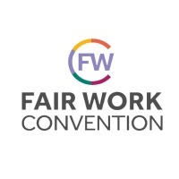   | Chapter 7: Valuing People who work in care.  Recommendations.  - Urgently put in place the Fair Work Convention  - Look for ways to deal with the impact of losing the EU social care support workforce on disabled people’s independence.
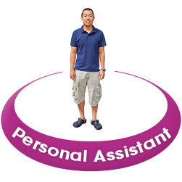    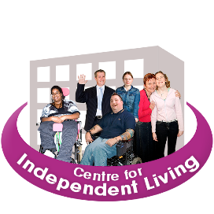 | Personal Assistants  We recommend:  - If any form of central registration of Personal Assistants goes ahead, it is optional.  - Programme of support and funding for Centres for Inclusive Living
 | Made by Inclusion Scotland using Photosymbols.

