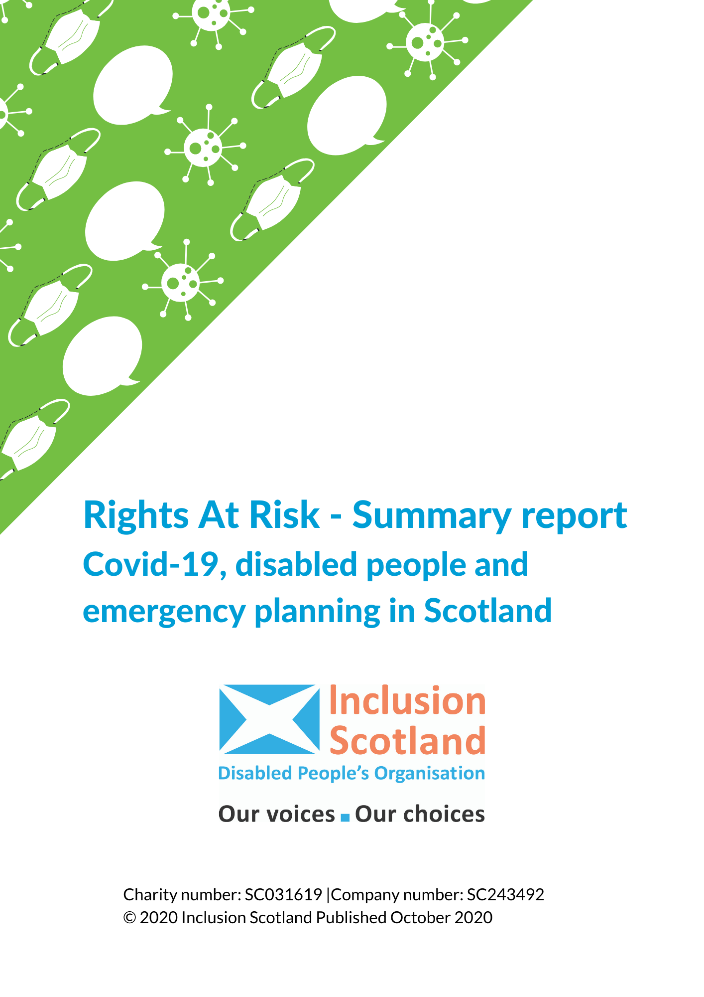

Rights at risk – Covid-19, disabled people and emergency planning in Scotland – a baseline report from Inclusion Scotland. Summary Report

Introduction
The Covid-19 crisis and the responses to it have had a huge impact on disabled people - creating new inequalities, exacerbating existing ones and putting our human rights at risk. When lockdown began in March 2020 it quickly became apparent that the structures in place to support disabled people were failing and that emergency planning did not take disabled people’s lived-experience and our needs into account. The Covid-19 crisis is far from over and, while we recognise that responses have been developing at a rapid pace, disabled people are experiencing consequences which are likely to continue far into the future.
The pandemic has highlighted just how excluded disabled people are from society and the consequences of this when a crisis strikes. It is therefore vital that society (including government, local authorities, service providers and others) starts to listen to disabled people and involve us so that the responses to the pandemic and future planning of any ‘new normal’ works for us too.

About our survey
Inclusion Scotland carried out an online survey throughout April 2020 to find out what impact the Covid-19 (coronavirus) pandemic was having on disabled people. Over 800 disabled people and their carers and supporters responded. This summary report provides some key points from our analysis of what the situation was like for disabled people before the pandemic, what happened to disabled people the first months of the pandemic, what the long-term impact of the crisis might be on disabled people and what needs to happen now.

Findings

3.1 Right to independent living
What was the situation prior to the crisis? In the face of Local Authority budget cuts, tighter eligibility criteria, and rising demand for social care that is fast outstripping investment, prior to the crisis many disabled people were only getting life and limb support and not the support they needed to meet their basic rights. In addition, most people in receipt of social care support pay towards it, often from private income and benefits.
What has happened since the start of the crisis? Around 30% of respondents to our survey said that the social care support that they receive was either stopped completely or reduced at the start of the pandemic. People were left in desperate situations as a result of this, with respondents telling us they had been forced to sleep in their wheelchair or were left unable get out of bed. Others told us they were unable to wash and dress themselves, and keep up with basic household chores.
“I have gone from 20 hours of care (seven hours of which were personal care) to ZERO. I am now bedbound completely because of this.”
What could the long-term impact be? Some disabled people’s lives changed dramatically and almost instantaneously when the country went into lockdown. People who have spent years organising and managing their own care and support (and often fighting for access to it) lost it overnight as authorities had little or no backup plans in place.
This has had a considerable emotional impact on people who felt abandoned by services at a time when they were most needed. It is likely that some disabled people will require more social care and other types of support as a consequence of their experiences throughout the crisis. This will consequently result in further increases in demand for services.
What needs to happen now? An independent review of social care support, announced in the Scottish Government’s Programme for Government 2020-2021, will report in January 2021. Any new system of social care support needs to enable people to access the resources and support they need, with genuine choice and control over who provides it and how they use it to live their lives, to achieve independent living, equal citizenship and fulfil their human rights. It is imperative that emergency funding for social care support finds its way to those it is supposed to benefit. One way of ensuring this immediately would be for the Scottish Government to reopen the Independent Living Fund (ILF) to new applications and extend what funds can be used for.

3.2 Rights of disabled children
What was the situation prior to the crisis? Disabled children and young people have lower levels of educational attainment throughout their school life. Children with Additional Support Needs (ASN) are both less likely to achieve qualifications (Scottish Government, 2020d) and more likely to be excluded from school than their non-disabled peers (Scottish Government, 2019c).
What has happened since the start of the crisis? Parents of children with ASN told us that they felt ‘abandoned’ and noted the lack of support for disabled children who were not attending school. Parents and carers were often dealing with the additional strain of having to educate children. This was more difficult for parents of children with additional support needs who felt that they do not have the skills or tools to teach or who could not find suitable resources online
Respondents reported that children and young people they care for were experiencing increased anxiety which sometimes resulted in violent behaviour, self-harm or other behavioural changes. Much of this was attributed to the removal of structure, daily activity, routine, face-to-face contact with friends, and access to the outdoors, and no help was provided to replicate these features at home.
“Son has ASD and self-harms/has suicidal thoughts. He is also really volatile and can hit out. He has no support at all now, as his main support was a school counsellor. I don't know how he will cope if this lasts much longer. I can’t get out the house at all, as he won’t come with me and can’t be left alone.”
What could the long-term impact be? The loss of essential services and educational support has had a major impact on disabled children and their parents, with particular impacts on mental health and wellbeing. It remains to be seen what impact the closure of schools will have on disabled children’s educational attainment. It is also highly likely that young disabled people, particularly those leaving school, college and university over the coming years will be disproportionately affected by the recession and increasing unemployment.
What needs to happen now? Action is needed to support disabled children and young people and their families, both practical and emotional, to recover from the impact of the initial lockdown phase. Local authorities must ensure that they are actively identifying and providing additional support to children with “complex additional support needs” who lost out on support to meet their needs because of school closures. The Getting It Right For Every Child (GIFREC) policies and guidance should be future-proofed to ensure that they support any further sudden changes to circumstances resulting in loss of support, such as we saw with the onset of the pandemic. Schools should ensure that they ‘access proof’ their alternative ways of working for use during any future lockdown situation, including taking steps to provide support for online education, so that it is accessible and inclusive, as well as alternatives to it for those without access to the internet.

3.3 Right to an adequate standard of living
What was the situation prior to the crisis? Households with at least one disabled adult are more likely to live in relative poverty and experience material deprivation, and households containing a disabled person have higher levels of child material deprivation (Scottish Government, 2019b). Over the last ten years, disabled people have been greatly impacted by UK Government cuts to benefits labelled ‘welfare reforms’ with over half of all the cuts made falling on disabled people and their families. There is ample evidence to show that disabled people have suffered catastrophic consequences as a result of the UK Government’s ‘welfare reform’ agenda.
What has happened since the start of the crisis? Over half (53%) of respondents experienced difficulties accessing food for themselves or those that they care for. Over a quarter of respondents reported having difficulty in obtaining the medicines needed to maintain their health. 1 in 8 people at high risk from Covid-19 reported not being able to effectively shield or isolate themselves because they did not have other support to access food and or medication.
“I have had to break [shielding] to buy food, putting myself at risk. Medicine pre-ordered online now needs 7 days’ notice to allow GP surgeries/chemists to cope with demand. Also, I usually collect my medicines from local chemist, it's proving difficult to change this to have it delivered during Covid-19 pandemic. Again, I’ve had to break [shielding] to queue and collect my meds.”
What could the long-term impact be? The incoming recession, leading to rising prices and increasing unemployment, makes it is almost certain that more and more disabled people will have to rely on social security for their income. In turn, we will most probably see more disabled people pushed into poverty, debt and homelessness. The last financial crisis and resulting austerity measures had a catastrophic impact and disabled people are rightly worried about the economic downturn, how it is going to affect the welfare state and the level of benefits for disabled people in the future.
What needs to happen now? It is vital that the social security system provides a realistic safety net which prevents more disabled people from falling into poverty. Claims for disability entitlements, particularly Personal Independence Payment (PIP) must be dealt with quickly – indications suggest that people are struggling to make claims and are facing significant delays in getting their claims processed. The Scottish Government must set out its revised timescales for launching the new disability benefits which have been delayed as a result of the pandemic. In addition, the Scottish Government needs to start a fundamental review of disability assistance to ensure adequacy and support for independent living.

3.4 Right to employment
What was the situation prior to the crisis? Disabled people in Scotland are more likely to be unemployed than non-disabled people (Scottish Government, 2020a). The barriers disabled people face in getting ready for, getting into, staying in and getting on in work are many, varied and complicated. They include stigma, poor attitudes, inaccessible application processes and discriminatory practices.
What has happened since the start of the crisis? A greater proportion of disabled people are employed in public administration, education and health, as well as the distribution, accommodation and catering sectors, compared with the non-disabled population (Scottish Government, 2020a). These sectors have been hit hard by the Covid-19 crisis and could see many jobs lost, with a disproportionate impact on disabled people.
In addition, these are industries where workers are likely to come into contact with other people. Around one fifth (22%) of respondents to our survey (disabled people and people supporting/caring for disabled people) told us that either they, or family members worked in a job that puts them at risk of coming into contact with the virus. Many told us that they or family members were key workers. Disabled people may therefore be at greater risk than non-disabled people of coming into contact with the virus in the workplace.
What could the long-term impact be? Official statistics continue to show increases in unemployment (Scottish Government, 2020b) which are likely to continue for some time, particularly when the furlough scheme ends in October 2020. To date, the pandemic has had more of an impact on the labour market status of particular groups including disabled workers. The fears about employment of those disabled people who responded to our survey are far from groundless. During the 2008 financial crisis and the recession which followed it disabled people were more likely to lose work than their non-disabled peers. This suggests that any negative impact on the overall employment rate arising from the Covid-19 emergency is likely to be disproportionately felt by disabled people and to be of a more prolonged nature.
What needs to happen now? Specific labour market measures must be taken now, and the Fairer Scotland for Disabled People Action plan urgently overhauled, both to protect the jobs of disabled people still in work and to increase the skills and employment opportunities of those who become unemployed. Effective and accessible employability support must be made available to disabled people. If the Scottish Government’s current employability service, Fair Start Scotland, is to improve on its current poor success rate with disabled job-seekers, both the leaders of the programme and the individual providers need to work in partnership with DPOs who could provide insights into their experience and practice in supporting successful work experience placements. The Covid-19 crisis has also shown just how easy it is for employers to make adjustments to ways of working. This must continue as the country moves out of lockdown.

3.5 Right to health
What was the situation prior to the crisis? Disabled people are less likely to report good or very good health and more likely to report poor mental wellbeing than non-disabled people (Scottish Government, 2019b). Many disabled people rely on regular appointments with a wide variety of health professionals to receive medication and treatments. Others rely on exercise, such as swimming, or peer support networks through weekly clubs or classes, to look after and maintain their physical and mental health.
What has happened since the start of the crisis? Disabled people told us that they have lost access to health services and support for both physical and mental health. 7% of people responding to our survey said that their medical appointments and/or routine health services had been cancelled or reduced since the start of the crisis.
“Physio services are suspended. Wound dressings supplied to apply personally (no medical assessment). Follow up X-ray/dietician delayed.”
15 disabled people with existing mental health problems reported to us that they were feeling suicidal at the time they responded.
“I am so lonely and feel so depressed. I feel suicidal.”
Many hundreds of others told us about the stress and anxiety that they have experienced due to a number of issues. People told us they were anxious about their own health, the health of those they care about and many were very fearful for the future.
What could the long-term impact be? The cumulative impact of many of the other issues raised in this report have understandably caused a significant amount of stress and uncertainty which has resulted in serious detrimental impacts on mental health. Furthermore, the long-term impact of cancelled medical appointments, as well as the impact of shielding with little or no physical exercise, remains to be seen. Disabled people are worried that these will result in declining physical and mental health, some of which they are already experiencing.
What needs to happen now? NHS Scotland must inform people about the reopening of health care and treatment and what they need to do to reschedule appointments including remote appointments. It must also be acknowledged that if people have experienced deteriorating health since the start of the pandemic they may require changes to their health care and treatment and their social care support. The Scottish Government must monitor the health outcomes of disabled people to understand the long-term impacts of the pandemic, particularly on those who have been shielding and those whose social care support packages were cut.
If there is a second wave of the virus the Scottish Government needs to expand shielding policies and support. This support cannot simply apply to those disabled people with a limited number of medical conditions who previously received an official shielding letter.
The Scottish Government must ensure that statistics on the number of disabled people dying from Covid-19 in Scotland are published urgently. Such data is essential to inform decisions on future prevention and planning and to ensure the needs of disabled people are fully taken into consideration.

Core asks
In addition to the recommendations set out in our report, we have identified 5 core asks which are the principal actions that need to be taken by Scotland’s policy and decision-makers, service providers, employers, retailers, academics, funders, broadcasters, and wider society to address the concerns raised in this report:
1. Stop stigmatising disabled people as vulnerable and problematic
2. Promote, don’t diminish, our human rights as disabled people by ensuring human rights-based approaches to policies and practices are the standard including by taking action to incorporate the United Nations Convention on the Rights of Disabled People (CRPD) into Scots law
3. Involve us, the experts in our own lives, both now and when we build the ‘new normal’
4. Support our national and local disabled people’s organisations so that we can be involved
5. Communicate with us and inform us in ways that are accessible to us

5. Conclusion
Our survey results show that the risks posed by the Covid-19 crisis go much further than simply a risk to health for disabled people who contract the virus. The risks posed by the crisis and the responses to it are risks to disabled people’s human rights. Although exclusion, discrimination and interferences with our human rights have long been everyday occurrences for many disabled people, the Covid-19 crisis has aggravated these in ways which will have consequences far into the future.
The core asks Inclusion Scotland has identified, as set out in the section above, apply not just to those policies or services specifically about disabled people, but across all the policy areas that affect us. By taking these actions we believe that the risks posed to disabled people’s human rights by the Covid-19 crisis can be minimised and mitigated. We also believe that these actions are key to shaping what happens next and to ensuring we do not return to the pre-Covid-19 situation which did not work for disabled people and which ultimately left us exposed at a time when we most needed our human rights to be protected.
Contact Us
Inclusion Scotland
22 – 24 Earl Grey Street,
Edinburgh,
EH3 9BN
info@inclusionscotland.org
Office number: 0131 370 6700
Visit our website: inclusionscotland.org
Follow us on Social Media:

twitter.com/inclusionscot
Facebook.com/InclusionScotland
Instagram.com/inclusionscotland




