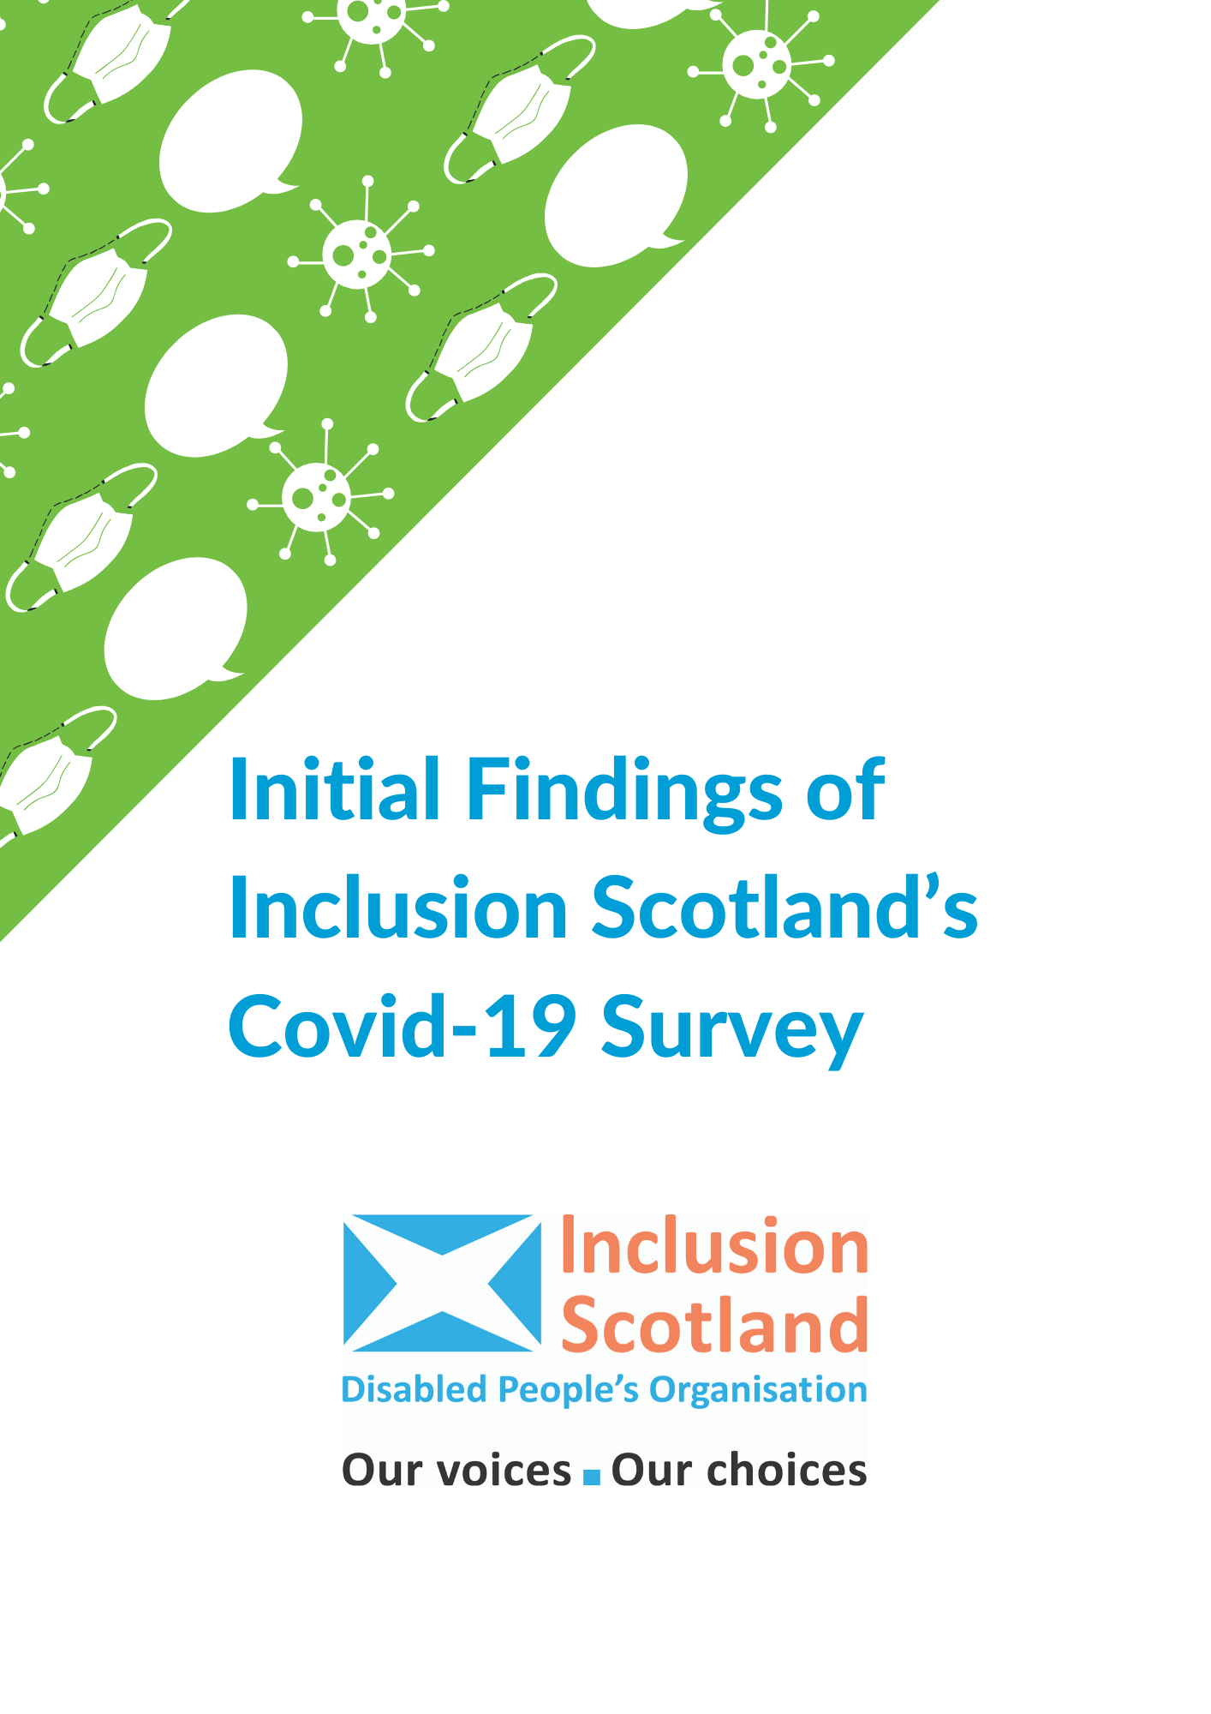

Introduction
Inclusion Scotland carried out an online survey throughout April 2020. Over 800 disabled people and their carers responded. This paper provides a summary of the key findings and an insight into disabled people’s experience.
Our survey, which covers a number of issues, quickly recognised that the Covid-19 crisis is having a significant impact on the mental health of disabled people and their carers. Around 15% of all respondents told us explicitly that their mental health has been negatively affected by the current crisis. Many hundreds of others told us about the stress and anxiety that they are experiencing at this time due to a number of issues.
Disabled people and their carers are under significant pressure because:
- Social care support has been stopped or reduced: Almost half of people responding on this issue told us that said that the Covid-19 pandemic has had an impact on the social care support they get, formal and informal. Around 30% of respondents told us their support had either stopped completely or had been reduced.
- People have new or increased caring responsibilities: Around 40% of people who responded to this question are experiencing challenges with caring for children/family members since the start of the pandemic.
- Disabled people are struggling to get access to the food and medicine they need: Around two thirds of those responding to this question (64%) said that the crisis has had an impact on getting the food or medicine that they need for themselves or the person they care for.
- People are being asked to sign Do Not Resuscitate (DNR) notices: Though we didn’t ask a specific question about DNR, 4 respondents told us that they or someone they know had been asked to sign DNR notices or informed that they would not be ventilated should they contract Covid-19.
- People are concerned that they will lose their job: Around one in ten respondents to this question (11%) were concerned that they could lose their job as a result of the pandemic.
- Social distancing and isolation is proving extremely challenging: Disabled people with and without pre-existing mental health conditions are finding everyday life under lock-down extremely stressful. Significant numbers of disabled people (15) with existing mental health problems told us that they are feeling suicidal at this time.

Our Survey
This is a very challenging time for disabled people, their families and organisations. Covid-19 and the anti-virus measures brought in to respond to it have changed all our lives in dramatic ways. There has never been a more important time for disabled people to have a voice.
We want policy and decision-makers in Scotland to know what is really happening to disabled people on the ground, what changes are needed and to recognise disabled people are experts in our own lives. Involving us, which includes taking into account the lived experience set out in this report, is crucial to making the right decisions.
Our survey went live on the 1 April and closed on the 30 April. We received 822 responses. This is the report of our initial findings. We will be publishing more Statements on the different issues we touch on in this report. These will set out the actions that are needed based on the results of our survey and other lived experience which we continue to gather. Please look out for these on our website and social media. Details on How to contact Inclusion Scotland, are at the end of this document.
We want to continue to hear from disabled people and those that support a disabled person about the impact Covid-19 is having on them and we will be issuing polls and calls for lived experience evidence through our social media campaign #OurVoicesCovid19.

Key findings

1. Social care support has been stopped or reduced
Almost half of respondents (45%) who answered our question on social care support said that the Covid-19 pandemic is having an impact on the social care support they get. A further 12% of respondents said that it might have an impact in the future.
What are the key issues?
Around 30% of respondents who answered this question said that the social care support they receive has either been stopped completely or reduced.
“My son was in Residential care but they sent him home and now [he] gets no support.”
“Support has all but stopped other than a few phone calls a week. This has meant me (his sister) and our elderly parents are picking up his care.”
Some respondents have worries in relation to not being able to access medical appointments or routine health services which have been cancelled as a result of the crisis.
“All medical clinics cancelled …, and he has been discharged from vital services until further notice. Not acceptable for those with complex medical issues and needs. My son is only 4 years old.”

2. People have new or increased caring responsibilities
Around 40% of people who responded to our question on caring told us that they have experienced changes or challenges with caring for children or other family members at home since the start of the pandemic. A further 10% of respondents told us that they thought they might experience changes or challenges in the future.
What are the key issues?
Some respondents are now either acting as carers to family members, or having to rely on family members to care for them. Although some people may have already provided care to their family member pre-Covid-19, the current situation is placing a greater strain on carers.
“We are all at home now. 2 adults with depressive illnesses, 1 adult with ASD, 1 adult with ASD, ADHD and anxiety and a teenager and a 2 year old with suspected ASD. We have no respite at all.”
“Not Ideal for me having to be back staying with my parents it is pressure on me and also on them.”
The loss of services and provisions due the pandemic is having a big impact on carers. Many parents spoke of their children losing vital services that are normally provided through school and the additional strain of having to educate children at home.
“Autistic son is very active outdoors, needs sensory stimulation and being in the house is strained. He has specialist teaching in ASN school that we cannot provide, his routine is disrupted.”
A number of comments refer to an increase in violence and self-harm due to services being suspended.
“Son has ASD and self-harms/has suicidal thoughts. He is also really volatile and can hit out. He has no support at all now, as his main support was a school counsellor. I don't know how he will cope if this lasts much longer. I can’t get out the house at all, as he won’t come with me and can’t be left alone.”
Respondents reported increased anxiety and poor mental health due to the increased strain of caring for children or family members at home.
“I care for my son, I also have Bipolar Disorder, Borderline Personality Disorder and Anxiety. This has sent them out of control.”

3. Disabled people are struggling to access the food and medicine they need
Around two thirds of respondents to our question on food and medicine (64%) said that the current crisis is having an impact on getting the food and/or medicine that they need for themselves or the person they support/care for. A further 16% of respondents said that getting access to food and medicine might be an issue for them in the future.
What are the key issues?
Respondents who considered themselves at high risk from Covid-19 reported difficulties in obtaining food or medicines. Some have no way of obtaining food or medicines unless they, or someone else at risk, goes out to the shops/pharmacy.
“We have not received an official 'extremely vulnerable' person letter and my condition is not specifically named in the extreme vulnerability category - my condition is Duchenne Muscular Dystrophy, not COPD [Chronic obstructive pulmonary disease]. We have had contact with my Respiratory Consultant’s team who have stated that obviously I am included and need to be shielding but that is still not official proof. As I live in Scotland I cannot get prioritised delivery slots as I cannot prove my vulnerability.”
Many respondents reported difficulties in accessing food because they are not prioritised for home deliveries by supermarkets and when they do go shopping their impairments are not taken into account by supermarket staff.
“Can’t get any slots for online shopping. Can’t get up early for the elderly/vulnerable hours at supermarkets due to the medication I take to help me sleep. Can't stand in queues for long periods of time due to disability and mental health issues. I have no family members near me who can help. I have no idea what help is available to me as I am not in the highest risk group.”
Some of those responding live in rural areas where bus services have been withdrawn causing additional issues.
“The buses aren't running to my area anymore. We only have a corner shop in walking distance and they don't have essential items like toilet roll. We usually do our shopping online but there are no delivery slots.”
“Waiting for parcel delivery from government but been hungry a few nights. A friend from 15 miles away has driven through with emergency supplies and I have let him in…”

4. People are being asked to sign Do not resuscitate (DNR) notices
Although we didn’t ask a specific question about DNR, 4 respondents told us that they or someone they know had been asked to sign a DNR notice or informed that they would not be ventilated should they contract Covid-19.
What are the key issues?
People reported that their mental health was being impacted by the worry that they might be denied treatment because of their impairments.
“I have been told already that I would not be ventilated. I was in hospital last week with suspected Covid-19 and the Doctor stated I would not be treated. There is no DNR in file but this was put in my discharge letter. I feel written off before I start.”
“I am extremely anxious about the impact of C-19 and my greatest fear is that, if I were to experience complications from the virus and require admission to hospital, as a disabled person I would not receive the same care that I would as an able-bodied person. I am worried that my life is viewed as less valuable because I'm a wheelchair user…”
“I was contacted by my GP who was making sure I was aware that I was at very high risk and following guidelines. I was also asked to give permission to DNR medical files. I agreed to this without realising it could mean that I wasn't offered treatment. This has impacted negatively on my mental health.”
“Constant worry about my son’s worth - disabled and old people seem to be treated like second hand life worthless people. My friend had first hand experience of this last week when her disabled son died of covid. He was written off in the first few minutes by doctors - and he is a healthy disabled person like my son - both have [cerebral palsy].”

5. People are worried that they will lose their job
Around one in ten respondents to this question (11%) are concerned that they could lose their job in the future as a result of the pandemic.
What are the key issues?
A proportion of people who said that they had not yet completely lost their job told us that they were either self-employed or contract workers, and have lost work as a result of the crisis.
“I’m self employed working from home as that’s the only way I’m able to work. I currently have no work at all and don’t qualify for the government schemes as I’ve been building my business up …and hadn’t so far earned enough to qualify for help.”
Some respondents noted the challenge of working at the same time as having new or increased caring responsibilities.
“I am self employed but cannot work at all because I am now caring from 5am -9pm everyday with no break. My son has 2 to 1 in other care settings.”
“I just have to suck it up. Certainly can’t work from home with a doubly incontinent child with profound learning disabilities.”

6. Social distancing and isolation is proving extremely challenging
Disabled people with and without pre-existing mental health conditions are finding everyday life under lock-down extremely stressful. Significant numbers of disabled people (15) with existing mental health problems have reported to us that they are feeling suicidal at this time.
What are the issues?
Respondents to this question told us they are anxious about their own health, the health of those they care for and are very fearful for the future.
“It’s incredibly traumatic since I have a mental illness as a direct result of multiple traumas, including forced isolation. It’s so triggering.”
“The person I care for is feeling stressed and anxious about being in a small flat with 5 people, with no room to escape from the situation.”
Parents of young or adult children with additional support needs reported very stressful experiences of being in lock-down at home, particularly lone parents of one or more disabled children.
“My son had to move back with us as his residential care centre closed. All the progress he has made over the years with independent living seems to have evaporated overnight. He’s anxious, lonely, self-harming, watching tv all day and very depressed. We all are.”
Significant numbers of disabled people and those that support them are struggling or unable to abide by social distancing rules when in or out of the home. For example, because they themselves need personal care, or provide such to another disabled person.
“I cannot follow these measures. I received the letter to tell me I was in the most vulnerable position medically and to use different towels, bathroom, eating alone etc... my wife brings me my food. I am bedbound. I cannot control who eats where. I have no access to running water for hand washing and I’m onto my last hand sanitiser bottle...”
“As his mum/carer social distancing doesn’t happen. As personal care, feeding and medication requires me to be near him”




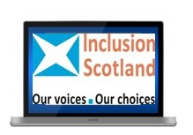
Contact Us
Please note, we are currently unable to access post.
Inclusion Scotland
22 – 24 Earl Grey Street,
Edinburgh,
EH3 9BN
info@inclusionscotland.org
Office number: 0131 370 6700
Visit our website: inclusionscotland.org
Follow us on Social Media:

Twitter: @inclusionscot
Facebook: @InclusionScotland
Instagram: @Inclusionscotland
Contact the author Rebecca at rebecca@inclusionscotland.org







